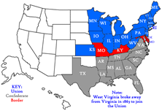 | THE HISTORY HERALD  January 5th, 2026  AP US History  www.schoolrack.com/DuncanHistory

RETURN WEEK  Monday 5th ADMIN Day/ No School  Tuesday 6th Chap 21: Ordeal of Reconstruction pg 473 - 482  Wednesday 7th Chap 21: Ordeal of Reconstruction pg 482 - 492  Thursday 8th Chap 21 / Chap 23  Friday 9th Chap 23: Political Paralysis in the Gilded Age  NEXT WEEK  Monday 12th Chap 23: Political Paralysis in the Gilded Age  Tuesday 13th Chap 23/ Chap 22  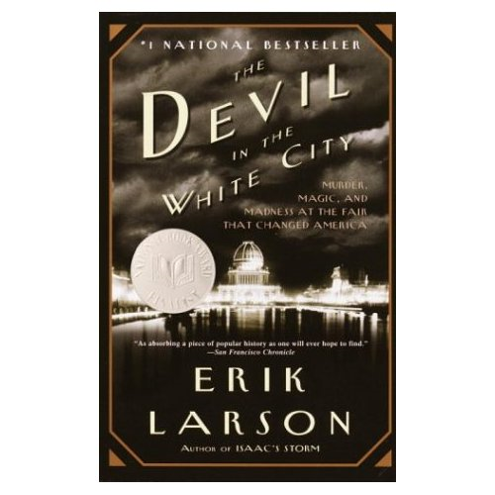  Wednesday 14th EXAM – Reconstruction and Politics  of the Gilded AGE  Thursday 15th Chap 22: Industry Comes of Age  Friday 16th Devil in the White City Test / Chap 22  THE NEXT WEEK HOMECOMING  CHAPTER 20 The Furnace of Civil War, 1861–1865  1. How successful was McClellan as commander of the Army of the Potomac?  2. What are some of the pivotal battles of the Civil War and what was the outcome of each?  3. What did the Emancipation Proclamation do and how did it affect the Union cause?  4. How successful was Lee as commander of the Confederate army?  5. Once he was put in charge of the entire Union army, how did Grant prosecute the war until its end?  6. What was the political situation as the election of 1864 approached, and how did Lincoln win a reelection?  7 What were the costs of the Civil War?  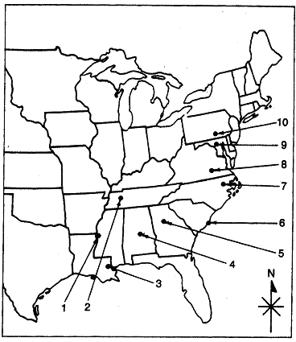 | Chapter 20  1.Clement L. Vallandigham  2.Andrew Johnson  3.John Wilkes Booth  4.Robert E. Lee  5.Thomas J. Jackson  6.Ulysses S. Grant  7.George B. McClellan  8.William T. Sherman  9.George B. Meade  10.Salmon P. Chase  11.David G. Farragut  12.George Pickett  13.Edward Everett Hale  14.Merrimack (the Virginia)  15.Monitor  16.Emancipation Proclamation  17.Thirteenth Amendment  18.Copperheads  19.Union party  20.First Battle of Bull Run  21.Second Battle of Bull Run  22.Battle of Antietam  23.Peninsula Campaign  24.Battle of Fredericksburg  25.Battle of Chancellorsville  26.Battle of Gettysburg  27.Battle of Vicksburg  28.Gettysburg Address  29.Congressional Committee on the Conduct of the War  30.Ford's Theater  31.The Man Without A Country  MAP WORDS  32. _____ Vicksburg  33. _____ Gettysburg  34. _____ Fort Sumter  35. _____ Atlanta  36. _____ Antietam  37. _____ Montgomery  38. _____ Richmond

chapter 20 summary
The Union defeat at Bull Run ended Northern complacency about a quick victory. George McClellan and other early Union generals proved unable to defeat the tactically brilliant Confederate armies under Lee. The Union naval blockade put a slow but devastating economic noose around the South.
The political and diplomatic dimensions of the war quickly became critical. In order to retain the Border States, Lincoln first deemphasized any intention to destroy slavery. But the Battle of Antietam, in 1862, enabled Lincoln to prevent foreign intervention and turn the struggle into a war against slavery. Blacks and abolitionists joined enthusiastically in a war for emancipation, but white resentment in part of the North created political problems for Lincoln.
The Union victories at Vicksburg in the West and Gettysburg in the East finally turned the military tide against the South. Southern resistance remained strong, but the Union victories at Atlanta and Mobile assured Lincoln’s success in the election of 1864 and ended the last Confederate hopes. The war ended the issues of disunion and slavery, but at a tremendous cost to both North and South.


Textbook --> Chap 19 and 20
- What was President Lincoln's initial dilemma concerning the growing tensions over Fort Sumter in the early spring of 1861?
- Why did Jefferson Davis choose to go to war?
- What was the response of the border states to the outbreak of Civil War?
- Fill out the CHART analyzing the advantages and disadvantages that both sides had in terms of their readiness for war in 1861.
- What were the general military strategies adopted by each side?
- What did the Battle of Shiloh show about the future course of the Civil War?
- Explain the significance of the Union's success at New Orleans.
- By 1862, what had Union General Grant and Admiral Farragut accomplished?
- Why was General Grant a more effective leader than General McClellan?
- How was General Robert E. Lee's military style and personality different from General McClellan's?
- Why was the Battle of Antietam considered a turning point in the Civil War?
- Do you think that Lincoln's decision to fire McClellan was a good one? Explain your position.

Textbook --> Chap 20 The Emancipation Proclamation.
- What was the position of Great Britain and other European countries to the American Civil War?
- How did the Trent incident and the Alabama claims create serious tensions between the United States and Great Britain during the Civil War?
- What were Lincoln's views of slavery at the beginning of the Civil War?
- How did his views evolve or change while the war progressed?
- What were the provisions of the Emancipation Proclamation? Describe Northern, Southern, and European responses to this document.
- How was the Emancipation Proclamation a part of Lincoln's military strategy?
- Why was compromise between the North and the South no longer possible after the issuance of the Emancipation Proclamation?
- Define the term writ of habeas corpus. Analyze Lincoln's suspension of the writ during the Civil War.
- Explain the Supreme Court's decision in the case Ex parte Milligan.
- How did Lincoln deal with dissent? Did Jefferson Davis use similar tactics?
- Identify the important pieces of law enacted by Congress between 1862 and 1863 and explain how each of these laws strengthened the authority of the central government.
- Why did conscription become a problem for both the North and the South?
- What factors played a part in the 1863 draft riot in New York City?
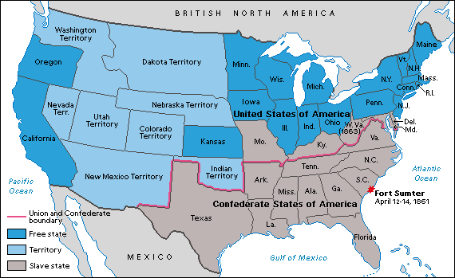

 | ADVANTAGES | DISADVANTAGES
N
O
R
T
H

S
O
U
T
H

CHAPTER 21 FOCUS QUESTIONS  What where the different plans for Reconstruction?  Who gets to control the Peace?  Lincoln or Wade- Davis or Johnson or Radical Republicans or Military?  Why are the 13th, 14th, and 15th Amendments called the Civil War Amendments? What were there purposes and effects?  What happened to freed African-Americans after the Civil War? What was purposed? What actually happened?  Homestead Act, Freedman’s Bureau, Election,  Black Codes, Ku Klux Klan  CHAPTER 21  The Ordeal of Reconstruction, 1865–1877  Focus Questions  1. How did blacks respond to freedom, and what black organizations flourished?  2. How had Lincoln hoped to accomplish Reconstruction, and what modifications did Johnson make to Lincoln’s original plan?  3. In what ways was Congressional Reconstruction different than Presidential Reconstruction?  4. After gaining suffrage, how successful were blacks politically?  5. What circumstances led to the impeachment and trial of President Johnson and what was the outcome?  Chapter 21 Themes  Theme: Johnson’s political blunders and Southern white recalcitrance led to the imposition of congressional military Reconstruction on the South. Reconstruction did address difficult issues of reform and racial justice in the South and achieved some successes, but was ultimately abandoned, leaving a deep legacy of racial and sectional bitterness. | CHAP 21  Jefferson Davis  Reconstruction.  Freedman’s Bureau  Oliver O. Howard  Andrew Johnson  Abraham Lincoln  Ten Percent Plan.  Radical Republicans  Wade-Davis Bill,  Black Codes,  Morrill Tariff  Pacific Railroad Act  Homestead Act,.  Civil Rights Bill  13th Amendment  14th Amendment  Alexander Stephens  Charles Sumner  Thaddeus Stevens,  moderate/radical Republicans  Reconstruction Act  of March 2, 1867  ”Exodusters”  sharecropping  “swing around the circle”  15th Amendment  Ex parte Milligan  Union League.  Hiram Revels  Blanche K. Bruce  Redeemers  “scalawags”  “carpetbaggers”  freedmen  “radical” regimes  Ku Klux Klan  Force Acts  Tenure of Office Act  Edwin M. Stanton,  William H. Seward  “Seward's Folly”

Theme: During Reconstruction, the Constitution was strengthened with the Fourteenth (citizenship and equal protection of the laws) and Fifteenth (black voting rights) Amendments, but it was also tested with the conflicts between the president and Congress that culminated in an impeachment process.
Theme: Southern resistance to Reconstruction began immediately with the sending of ex-rebels to be seated in Congress and continued with the creation of violently oppressive groups like the Ku Klux Klan. Although forced to make some concessions, Southern Redeemers successfully outlasted the congressional Reconstruction efforts.

chapter 21 summary
With the Civil War over, the nation faced the difficult problems of rebuilding the South, assisting the freed slaves, reintegrating the Southern states into the Union, and deciding who would direct the Reconstruction process.
The South was economically devastated and socially revolutionized by emancipation. As slave-owners reluctantly confronted the end of slave labor, blacks took their first steps in freedom. Black churches and freedmen’s schools helped the former slaves begin to shape their own destiny.
The new president, Andrew Johnson, was politically inept and personally contentious. His attempt to implement a moderate plan of Reconstruction, along the lines originally suggested by Lincoln, fell victim to Southern whites’ severe treatment of blacks and his own political blunders.
Republicans imposed harsh military Reconstruction on the South after their gains in the 1866 congressional elections. The Southern states reentered the Union with new radical governments, which rested partly on the newly enfranchised blacks, but also had support from some sectors of southern society. These regimes were sometimes corrupt but also implemented important reforms. The divisions between moderate and radical Republicans meant that Reconstruction’s aims were often limited and confused, despite the important Fourteenth and Fifteenth Amendments.
Embittered whites hated the radical governments and mobilized reactionary terrorist organizations, such as the Ku Klux Klan, to restore white supremacy. Congress impeached Johnson but failed narrowly to convict him. In the end, the poorly conceived Reconstruction policy failed disastrously.
CHAPTER 23 FOCUS QUESTIONS  1. Why were the times so prone to political corruption in the post–Civil War Era?  2. What were the main issues surrounding the election of 1876? Did the Compromise of 1877 resolve those issues?  3. What were the biggest challenges facing the post–Reconstruction South?  4. What were the main reasons for Chinese immigration in the second half of the nineteenth century?  5. What were some of the reasons for the depression of 1893 and how did Cleveland deal with it?  Chapter 23 Themes  Theme: Even as post–Civil War America expanded and industrialized, political life in the Gilded Age was marked by ineptitude, stalemate, and corruption. Despite their similarity at the national level, the two parties competed fiercely for offices and spoils, while doling out “pork-barrel” benefits to veterans and other special interest groups.  Theme: The serious issues of monetary and agrarian reform, labor, race, and economic fairness were largely swept under the rug by the political system, until revolting farmers and a major economic depression beginning in 1893 created a growing sense of crisis and demands for radical change.  Theme: The Compromise of 1877 officially ended reconstruction, and white Democrats resumed political power in the South. Blacks, as well as poor whites, found themselves forced into sharecropping and tenant farming; what began as informal separation of blacks and whites in the immediate postwar years evolved into systematic state-level legal codes of segregation known as Jim Crow laws.  chapter 23 summary  After the soaring ideals and tremendous sacrifices of the Civil War, the post–Civil War era was generally one of disillusionment. Politicians from the White House to the courthouse were often surrounded by corruption and scandal, while the actual problems afflicting industrializing America festered beneath the surface.  The popular war hero Grant was a poor politician and his administration was rife with corruption. Despite occasional futile reform efforts, politics in the Gilded Age was monopolized by the two patronage-fattened parties, which competed vigorously for spoils while essentially agreeing on most national policies. Cultural differences, different constituencies, and deeply felt local issues fueled intense party competition and unprecedented voter participation. Periodic complaints by “Mugwump” reformers and “soft-money” advocates failed to make much of a dent on politics.  The deadlocked contested 1876 election led to the sectional Compromise of 1877, which put an end to Reconstruction. An oppressive system of tenant farming and racial supremacy and segregation was thereafter fastened on the South, enforced by sometimes lethal violence. Racial prejudice against Chinese immigrants was also linked with labor unrest in the 1870s and 1880s.  Garfield’s assassination by a disappointed office seeker spurred the beginnings of civil-service reform, which made politics more dependent on big business. Cleveland, the first Democratic president since the Civil War, made a lower tariff the first real issue in national politics for some time. But his mild reform efforts were eclipsed by a major economic depression that began in 1893, a crisis that deepened the growing outcry from suffering farmers and workers against a government and economic system that seemed biased toward big business and the wealthy. | CHAPTER 23  Ulysses S. Grant  “waving the bloody shirt,”  Horatio Seymour  Era of Good Stealings  Jim Fisk and Jay Gould.  “Boss” Tweed  Samuel J. Tilden  Hamilton Fish  Credit Mobilier  Whiskey Ring  William Belknap  Liberal Republican Party  Horace Greeley  Jay Cooke  Resumption Act of 1875  Bland-Allison  Greenback Labor Party  Gilded Age,  Mark Twain  Roscoe Conkling  James G. Blaine  Rutherford B. Hayes  Compromise of 1877  Civil Rights Act of 1875  Denis Kearney  Chinese Exclusion Act,  James A. Garfield,  Chester A. Arthur  Winfield S. Hancock,  Charles J. Guiteau  The Pendleton Act of 1883  Civil Service Commission.  Mugwumps.  Grover Cleveland  laissez-faire

