World War I
- THE ROAD TO WAR
  - CAUSES
    - Nationalism
      - Countries proud of their heritage and culture
      - Ethnic groups of similar heritage wanted to free their oppressed brethren and unite their people into one country
      - Germany wanted to expand its culture and political influence throughout Europe.
      - Assassination of Franz Ferdinand
        - Garvillo Princip, a Serbian nationalist assassinated the Archduke.
        - He was trying to gain allowances for his fellow Serbs who lived under Austrian rule.
    - Imperialism
      - France, Great Britain, Germany and Russia established colonies in Africa and Asia
    - Militarism
      - European nations began an arms race as they competed for colonies around the world
    - Alliances
      - Europe formed military alliances with one another to maintain a balance of power.
Triple Alliance Triple Entente
Central Powers Allied Powers
Germany Great Britain
Austria-Hungary Empire France
Bulgaria Russia
  - GERMAN INVASION OF BELGIUM
    - German invasion in August of 1914, through Belgium to conquer France.
    - Belgium puts up a strong fight and gave French and British militaries enough time to mobilize their army
    - 1st Battle of the Marne River, France and Great Britain stop Germany from capturing Paris.
    - France, England and Germany involve itself in trench warfare from 1914 to 1918
  - STALEMATE & WARFARE
    - Stalemate
      - By September 1914, the war had reached a stalemate, a situation in which neither side is able to gain an advantage.
      - When a French and British force stopped a German advance near Paris, both sides holed up in trenches separated by an empty “no man’s land.” Small gains in land resulted in huge numbers of human casualties.
      - Both sides continued to add new allies, hoping to gain an advantage.
    - Modern Warfare
      - Soldiers nor officers were not prepared for the new, highly efficient killing machines.
      - Machine guns, hand grenades, artillery shells, and poison gas killed thousands of soldiers who left their trenches to attack the enemy.
      - As morale fell, the lines between soldiers and civilians began to blur. The armies began to burn fields, kill livestock, and poison wells.
  - AMERICAN NEUTRALITY
    - President Wilson distanced America from WWI by issuing a proclamation of neutrality.
    - Was consistent with America's traditional policy of avoiding European entanglements.
    - Wilson insisted that all belligerents respect American neutral rights on the high seas.
  - EFFECTS OF ALLIED BLOCKADE
    - 1914, $70 million in trade with Central powers
    - 1916, trade reduced to $1.3 million
    - Allied trade grew from $825 million to $3.2 billion in same time period
    - WWI transformed the US from a debtor to a creditor nation
  - THE GERMAN CHALLENGE TO AMERICAN NEUTRALITY
    - Faced with a stalemate in the trenches across France and a British blockade that was exhausting its ability to continue fighting, Germany launched a campaign of unrestricted submarine warfare with U-Boats in early February 1917.
    - Warns they would sink any ship they believed was carrying contraband to Great Britain.
  - SINKING OF THE LUSITANIA
    - May 7, 1915, the Germans sunk the Lusitania, which was British passenger liner.
    - Germans believed it was carrying contraband (weapons) to the British.
    - Killed 1,198 civilians including 128 Americans.
    - U.S. and other countries outraged because of “unrestricted submarine warfare”.
    - US believed the Germans had violated international law of targeting civilians
    - After the Lusitania was sunk, opinion of most Americans was to go to war with Germany.
    - Germany promised they would not sink anymore ships unless warning them first and providing safety for civilians but, President Wilson was able “keep us out of war”
  - ZIMMERMAN TELEGRAM
    - In late February 1917, the German foreign secretary, Arthur Zimmerman, sent a secret telegram to the German minister in Mexico.
    - Intercepted by British intelligence, it asked Mexico to join a military alliance against the US.
    - In return, the Germans promised to help Mexico recover territories it had lost following the Mexican War.
  - WILSON'S WAR MESSAGE
    - Wilson accused the Germans of violating freedom of the seas, killing innocent Americans, and interfering with Mexico.
    - Wilson galvanized public opinion by calling on America to launch a noble crusade "to make the world safe for democracy."
    - Protection of economic interests:
      - Shipping, loans, business, agriculture

    - Support of British
    - Principle of Neutrality
- WORLD WAR I AT HOME AND ABROAD
  - COMMITTEE ON PUBLIC INFORMATION
    - The government relied heavily on the Committee on Public Information (or Creel Committee) led George Creel, which fanned patriotism
    - Organized groups such as the Four Minute Men
    - Promoted Liberty Loans (bond drives) that raised over $20 billion
  - WAR INDUSTRIES BOARD
    - Bernard Baruch
    - To build weapons for the war, US industry would undergo a massive change.
    - US government set prices and determined what goods produced by private industry.
    - Stimulates and coordinates the contributions of U.S. businesses to the war effort.
  - FOOD ADMINISTRATION
    - Herbert Hoover heads effort to conserve food and boost agricultural output
    - US feeds the world from the farms and ranches in the Great Plains.
    - Prohibition of alcohol was approved by Congress in December 1917 as a conservation and anti-German measure, as well a response to the temperance movement.
    - Liberty and victory gardens
    - Meatless and wheatless days
  - RAILROAD ADMINISTRATION
    - William McAdoo
  - NATIONAL WAR LABOR BOARD
    - William Howard Taft
  - EFFECTS OF WORLD WAR I ON US
    - Unemployment virtually disappeared.
    - Expansion of “big government.”
    - Excessive government regulations in economy.
    - Some gross mismanagement overlapping jurisdictions.
    - Close cooperation between public and private sectors.
    - Unprecedented opportunities for disadvantaged groups.
  - FINANCING THE WAR
    - Sale of war bonds.
    - Liberty and victory loans raised $21 billion.
    - Raised income taxes
  - SELECTIVE SERVICE ACT
    - May of 1917, President Wilson and Congress pass into legislation a draft or conscription.
    - 21 to 30 yrs. and later extended to 40 yrs. of age.
      - 24,000,000 men registered for the draft by the end of 1918.
      - 2,810,296 drafted and served in WWI
      - 3.7 million men served in WW1 (2,000,000 saw active combat)
    - Volunteers and draftees
      - 400,000 African-Americans served in segregated units.
      - 15,000 Native-Americans served as scouts, messengers, and snipers in non-segregated units.
  - ATTACKS ON CIVIL LIBERTIES
    - Espionage Act – 1917
      - Forbade actions that obstructed recruitment or promoted insubordination in military.
      - Ordered the Postmaster General to remove Leftist materials from the mail.
      - Provided for up to $10,000 in fines and 20 years in prison for interfering with the war effort or using disloyal language.
      - US arrested at least 1,597 persons, and 41 received prison sentences; newspapers criticizing the government lost mailing privileges.
      - Congress and President Wilson enacted this law to promote patriotism, nationalism and protect the National Security of the US during WWI.
    - SCHENK V UNITED STATES, 1919
      - Charles Schenk, a member of the Socialist Party, handed out leaflets condemning the war and urging young men to resist the military draft.
      - Arrested and convicted for violating the Espionage and Sedition Act of 1917.
      - Schenk took his case to the U.S. Supreme Court arguing that the law violated his constitutional right to freedom of speech
      - Supreme Court ruling disagreed with Schenk
      - Majority opinion
        - BUT, every act of speech must be judged according to the circumstances in which it was spoken.
        - The most stringent protection of free speech would not protect a man in falsely shouting fire in a theater and causing a panic.
        - "Words can be weapons . . .The question in every case is whether the words used in such circumstances are of such nature as to create a clear and present danger that they will bring about the substantive evils that Congress has the right to prevent."
      - Normal circumstances, his actions would have been protected by 1st Amendment
      - The country was at war, Schenk's freedom of speech was not protected.
      - Supreme Court ruling meant there were limits to freedom of speech in wartime.
      - From the ruling, the Court established the "clear and present danger" principle to decide whether or not certain kinds of speech are protected.
  - THE BLACK MIGRATION
    - Causes of the migration:
      - Jim Crow laws denied African Americans their rights as citizens and forced them to endure poverty and systematic discrimination.
      - Beginning with World War I, the wartime demand for labor attracted African Americans to cities in the North and West.
    - Exodus from the rural South
      - In 1915, the overwhelming majority of African Americans lived in the rural South.
      - Attracted by the wartime demand for labor, African Americans migrated to urban centers in the North and West.
  - WOMEN’S PARTICIPATION
    - New Jobs
      - Many worked on the assembly lines of factories, producing trucks and munitions.
      - For the first time, department stores employed African American women as elevator operators and cafeteria waitresses.
      - The Food Administration helped housewives prepare more nutritious meals with less waste and with optimum use of the foods available.
      - Women’s morale remained high, as millions joined Red Cross as volunteers to help soldiers and their families, and with few exceptions, women didn’t protest the draft.
    - Women’s Suffrage
      - 19th Amendment
      - Women won the right to vote.
      - Called the “Susan B. Anthony” amendment.
  - PATRIOTISM (or XENOPHOBIA)
    - Patriotism was promoted with patriotic music by composers such as Irving Berlin and George M. Cohan and through movies
    - Discourage organizations from other countries and use of languages other than English, performances of German music, and use of German names and words for foods
      - Sauerkraut became liberty cabbage
      - German measles became liberty measles
      - Hamburgers became liberty sandwiches
      - Schools stopped teaching German, libraries removed German authors
    - Programs to “Americanize” immigrants were begun.
    - Historic and cultural ties between the United States and Great Britain were emphasized.
    - One Hundred Percentism
      - Political stance that urged the complete assimilation of immigrants and unwavering loyalty to the United States
- TREATY OF VERSAILLES
  - THE FOURTEEN POINTS
    - Wilson's Fourteen Points included a call for the following:
      - Open diplomacy or no secret treaties.
      - Freedom of the seas.
      - Free trade.
      - Countries reduce colonies and weapons
      - International control of colonies
      - Formation of new countries with self-government as a goal (Democracy)
      - A “league of nations” to guarantee peace among nations. (Collective Security)
    - Wilson's Fourteen Points did not include the following:
      - Recognition of Allied economic and territorial agreements made during the war
  - LEAGUE OF NATIONS
    - One of Wilson’s ideas.
    - Designed to bring the nations of the world together to ensure peace and security.
    - Collective Security of larger nations to keep world peace.
  - TREATY OF VERSAILLES
    - Germany disarmed and forced to pay reparations of $53 billion
    - Germany loses colonies were given to Allied victors.
    - New countries form democracies based on ethnic groups
    - League of Nations Organization of larger nations to maintain world peace
  - REASONS THE UNITED STATES DID NOT JOIN THE LEAGUE OF NATIONS
    - Wilson refused to compromise on the issue of America's unconditional adherence to the charter of the League of Nations. This hardened Senate opposition to the Treaty of Versailles.
    - Opponents believed that the League would lead to further involvement in foreign wars.
    - Removed the power of Congress to declare war.
    - Senator Henry Cabot Lodge was a skillful opponent of the League. The personal and political rivalry between Wilson and Lodge precluded any chance of a compromise.
- THE "RED SCARE" OF 1919-1920
  - Russian Revolution
    - CAUSES
      - Food and fuel shortages
      - Striking workers
      - Terrible loses in WWI
      - Czar was a weak ruler
      - Marxist (communist) propaganda spread by Lenin
    - EFFECTS
      - Czar Nicholas and the Romanov Family would be overthrown by Lenin who eventually would start the first Communistic state
      - Russia pulls out of the war
      - Russia becomes a communistic country
      - Germany sends Zimmerman Note to Mexico

1920s
- United States in the 1920s
  - ECONOMIC CONDITIONS
    - SIGNS OF PROSPERITY
      - During the 1920s, the standard of living rose, and people moved to urban centers.
      - All of the following provided evidence of economic prosperity during the 1920s:
        - Larger numbers of women and men working in office jobs
        - Increased emphasis on the marketing of consumer goods
        - Growing investment in the stock market
    - The assembly-line production of Henry Ford's Model T enabled average American families to purchase automobiles.
    - Beginning in 1920, the number of children aged ten to fifteen who were in the industrial workforce began to decline.
    - SIGNS OF TROUBLE
      - The least-prosperous group in the 1920s consisted of farmers in the Midwest and South.
      - For American farmers, the years 1921 to 1929 were a period of falling prices for agricultural products.
  - THE AUTOMOBILE INDUSTRY
    - Auto makers stimulate sales through model changes, advertising
    - Auto industry fostered the growth of other businesses
    - Autos encourage movement and more individual freedom.
  - FIRST IN FLIGHT
  - RADIO
    - Westinghouse Radio Station KDKA was a world pioneer of commercial radio broadcasting.
    - KDKA first broadcast was the Harding-Cox Presidential election returns on November 2, 1920.
    - 3,000,000 homes had them by 1922.
    - Radio sets, parts and accessories brought in $60 million in 1922…
      - $136 million in 1923
      - $852 million in 1929
    - Radio reached into every third home in its first decade.
    - Listening audience was 50,000,000 by 1925
- THE CULTURE OF MODERNISM: THE ARTS AND MASS ENTERTAINMENT
  - THE ARTS
    - The "Lost Generation of the 1920s"
      - Key writers included Sinclair Lewis and F. Scott Fitzgerald
      - Called the “Lost Generation” because they were disillusioned with American society
      - Writers criticized middle-class materialism and conformity. For example, Sinclair Lewis criticized middle-class life in novels such as Babbitt and Main Street.
  - JAZZ
    - Black musicians such as Joseph ("Joe") King Oliver, W C Handy, and "Jelly Roll" Morton helped create jazz.
    - Popular among the youth because it symbolized a desire to break with tradition.
  - MASS ENTERTAINMENT
    - Movies were the most popular form of mass entertainment.
    - Led by baseball, sports became a big business.
    - During the 1920s, technological innovations made long distance radio broadcasting possible. National radio networks reached millions of Americans.
- RESPONSES TO MODERNISM: RELIGIOUS FUNDAMENTALISM AND NATIVISM
  - URBANIZATION IN AMERICA
    - Rural Americans identify urban culture with Communism, crime, immorality
    - Sex becomes an all-consuming topic of interest in popular entertainment
    - Communities of home, church, and school are absent in the cities
    - Conflict: Traditional values vs new ideas found in the cities.
  - RELIGIOUS FUNDAMENTALISM
    - Origins
      - Modernism began in the 1870s as an attempt by liberal Protestants to make Christianity more relevant to contemporary life.
      - Fundamentalism began to grow (conservative Protestants who tried to counter Modernism):
        - Fundamentalists wanted a return to fundamentals of Christian faith, e.g., resurrection of Jesus, literal reading of Bible.
        - Fundamentalists rejected modern science, particularly Darwinian evolution, as inconsistent with revealed word of God.
      - Ideas that appeared to threaten biblical faith and religion included Darwinism, science, relativism of moral values, and psychology.
      - Rural and small-town Americans felt threatened by urban, secular culture.
      - The Ku Klux Klan appealed to “traditional” Protestantism; anti-Catholicism, anti-Semitism; argued it was protecting traditional Protestantism and morality.
      - Anti-Catholicism and anti-Semitism made an appearance in larger society:
      - Resorts and fraternal organizations prohibited Jews and Catholics.
      - Catholics created their own schools and colleges.
    - Outcomes
      - Ku Klux Klan grew in the 1920s; it tried to institute compulsory Bible reading in schools and restrict parochial schools.
      - Some southern states attempted to prohibit teaching of evolution: by 1925 five southern states had passed laws restricting such teaching.
      - The Scopes Trial was an important test case.
        - John T. Scopes was a high school biology teacher in Tennessee who was indicted for teaching evolution.
        - Illustrates the cultural conflict in the 1920s between fundamentalism and modernism.
        - The right to teach and protect Biblical teachings in schools.
        - The acceptance of science and that all species have evolved from lower forms of beings over billions of years.
      - Fundamentalism remained a force in United States religion:
        - Fundamentalists created their own independent subculture, with radio ministries, missionary societies, periodicals, and newspapers.
  - RED SCARE
    - Red Scare, 1919 to 1921, was a time of great upheaval…U.S. “scared out of their wits".
    - "Reds” as they were called, "Anarchists” or "Outside Foreign-Born Radical Agitators” (Communists).
    - Anti-red hysteria came about after WWI and the Russian Revolution.
    - The Palmer Raids of 1919-1920
      - The Palmer Raids were caused by the fear of communism and radicalism.
      - These raids were conducted against suspected communists and anarchists.
      - The Palmer Raids disregarded basic civil liberties. For example, government agents in 33 cities broke into meeting halls and homes without search warrants. More than 4,000 people were jailed and denied counsel.
      - 600 people were deported.
  - IMMIGRATION
    - Origins
      - Increased immigration from southern and eastern Europe (“new immigrants”) between 1891 and 1920 (25 million between 1865 and 1915, more than four times the number in the previous 50 years.
      - Immigrants arrived with little money and little education; lived in tenements; clustered in ethnic communities;
      - Labor unions feared immigrants would act as strikebreakers.
      - Nativism prior to 1920 and in 1920 seen in the following:
        - Some Progressives favored immigration restriction as a way to solve urban problems.
        - Anti-foreign sentiment during First World War, particularly against German Americans; focus on “100% Americanism.”
        - Post–First World War depression blamed unemployment on increased immigration
        - Red Scare 1919–1920: fear of radicalism and association of immigrants with radicalism; fear of Bolshevik Revolution
        - Fear of southern and eastern Europeans grew.
        - Race-thinking and eugenics became popular.
      - Ku Klux Klan became more powerful in the 1920s:
        - Advocated “100 percent Americanism.”
        - Became a force in Democratic Party politics, particularly in Midwest and small-town United States.
        - Practiced systematic terror against blacks, Jews, Catholics, foreigners.
      - Anti-Catholicism and anti-Semitism were popular.
      - Many small-town and rural Americans feared urbanization.
    - Outcomes
      - Sacco and Vanzetti
        - Nicola Sacco and Bartolomeo Vanzetti were Italian immigrants charged with murdering a guard and robbing a shoe factory in Braintree, Mass.
        - The trial lasted 1920-1927. Convicted on circumstantial evidence, many believed they had been framed for the crime because of their anarchist and pro-union activities.
        - In this time period, anti-foreignism was high as well.
        - Liberals & radicals rallied around the two men, but they would be executed.
      - Immigration Act (Emergency Quota Act) of 1921 included the following:
        - Established overall maximum of 357,000 immigrants per year.
        - Established quotas based on national origins: 3 percent of each country’s nationals residing in United States in 1910.
      - National Origins Act of 1924:
        - Cut maximum to 164,000 and reduced European quotas to 2 percent of nationality in United States in 1890, thereby discriminating against southern and eastern Europeans.
        - Filipinos, Mexicans, Canadians (Western Hemisphere) exempted.
        - Allowed foreign-born wives and children of United States citizens to enter as nonquota immigrants.
      - KKK
        - Rise of the KKK was due to the ever changing of a traditional America.
          - 1925: Membership of 5 million
          - D. W Griffith's full-length film The Birth of a Nation glorified the KKK.
          - 1926: Marched on Washington.
        - Attack on urban culture and defends Christian/Protestant and rural values
        - Against immigrants from Southern Europe, European Jews, Catholics and American Blacks
        - Sought to win U.S. by persuasion and gaining control in local/state government.
        - Violence, internal corruption result in Klan’s virtual disappearance by 1930 but will reappear in the 1950s and 1960s.
      - United States Border Patrol was established in 1925; made border crossing from Mexico more difficult.
      - Mexicans were subjected to discrimination in employment and residence patterns:
        - Agribusiness interests tried to keep borders open, using racial stereotyping as their weapon (only Mexicans could perform physically demanding work).
  - PROHIBITION
    - Origins
      - Some Progressives supported prohibition; temperance was partly an expression of the belief that immigrants’ use of liquor had to be disciplined.
      - Anti-Saloon League supported by Methodist and Baptist clergy, worked for prohibition.
      - First World War saw no use of grain for liquor; brewing industry was connected to German immigrants.
      - Eighteenth Amendment took effect in January 1920
        - prohibited manufacture, sale, and transportation of alcoholic beverages;
        - supported by every state except Connecticut and Rhode Island (large Catholic populations).
      - Volstead Act of 1919
        - “no person shall manufacture, sell, barter, transport, import, export, deliver, or furnish any intoxicating liquor except as authorized.”
        - Did not prohibit the use of intoxicating liquors.
        - Defined intoxicating liquor as any beverage containing more than 0.5 percent alcohol by volume.
      - Prohibition as the “noble experiment” involved the following:
        - Arguments against drinking: family decline; liquor interests corrupted state legislatures and helped political machines; eroded workforce and business/labor efficiency; declining morals and religious values; poverty, crime, unemployment, bad labor conditions, unrestrained sexuality.
        - Arguments for Prohibition: moral reform to regenerate society.
        - Ku Klux Klan supported Prohibition.
        - Wets vs. Drys; small-town and rural Americans’ fear of urbanization, “wet” culture, and immigrant culture.
    - Outcomes
      - Fewer arrests were made for drunkenness; deaths from alcoholism declined.
      - As problems associated with drinking declined, its urgency as a social issue receded.
      - Drinking was still pervasive in United States society, but alcohol consumption was reduced by almost half.
      - Bootlegging grew (took in about $2 billion/year); rumrunners flourished,
      - Prohibition Bureau tried unsuccessfully to enforce it the law but had few employees and little federal money.
      - Organized crime rose: gang wars of Chicago; Scarface Al Capone; became a permanent part of United States society.
      - Eliot Ness and the FBI emerged as key figures in law enforcement.
      - In 1932 Franklin Roosevelt strongly urged repeal in their election’ campaign.
      - Prohibition was repealed in 1933 via the Twenty-first Amendment.

- THE STRUGGLE FOR EQUALITY: AFRICAN AMERICANS AND WOMEN
  - AFRICAN AMERICANS
    - The Harlem Renaissance
      - The Harlem Renaissance thrived during the 1920s.
      - The Harlem Renaissance was an outpouring of Black artistic and literary creativity.
      - Harlem Renaissance writers and artists expressed pride in their African American culture. They supported full social and political equality for African Americans.
      - Key figures in the Harlem Renaissance included James Weldon Johnson, Zora Neale Hurston, Langston Hughes and Josephine Baker.
    - The Great Migration
      - The migration of Black Americans from the rural South to the urban North and West continued during the 1920s.
      - The demand for industrial workers was the primary pull; the primary push came from the restrictions of Jim Crow segregation.
    - Marcus Garvey
      - Marcus Garvey was the charismatic leader of the Universal Negro Improvement Association.
      - Garveyism was identified with the following:
        - Black pride
        - Black economic development
        - Black nationalism
        - Pan-Africanism
      - Garvey was committed to the idea that Black Americans should return to Africa.
  - THE FLAPPER
    - Flappers
      - Flappers symbolized the new freedom by challenging traditional American attitudes about women.
      - Flappers favored short bobbed hair, smoked cigarettes and even wore the new one-piece bathing suits.
      - Teenaged children no longer needed to work and indulged their craving for excitement
    - Women and the Workforce
      - Although new jobs became available in offices and stores, the percentage of single women in the labor force actually declined between 1920 and 1930.
      - Women did not receive equal pay and continued to face discrimination in the professions.
      - Most married women did not seek employment outside the home.
    - Factors causing the decline of the feminist movement during the 1920s:
      - Passage of the Nineteenth Amendment granting women the right to vote
      - The inability of women's groups to agree on goals
      - The decline of the Progressive reform movement
- 1920 POLITICS
  - 1920s ELECTION
    - Wilson’s idealism and Treaty of Versailles led many to vote for Republican Warren Harding.
    - US turned inward and feared anything that was European.
    - The Ohio Gang
      - They used their power to gain money for themselves. They were involved in scandals that ruined Harding's reputation even though he wasn't involved.
  - TEAPOT DOME SCANDAL
    - Secretary of the Interior, Albert B. Fall leased naval reserve oil land in Teapot Dome, Wyoming, and Elk Hills, California, to oilmen Harry F. Sinclair and Edward L. Doheny
    - Fall received a $100,000 bribe from Doheny and about three times that amount from Sinclair.
    - Fall found guilty of taking a bribe, but Sinclair and Doheny were acquitted of charges.
  - Republican Policies and the end of Progressive Reforms in Regulation of Business
    - Return to "normalcy" (No Progressive Reforms or involvement in World Affairs)
    - Return to “isolation”
    - Spending cuts
    - Government-business cooperation
    - Red Scare discouraged economic reform (accusations of socialism/communism).
    - Economic boom and general prosperity inhibits calls for business regulation.
      - Coolidge: “The business of America is business. The man who builds a factory builds a temple. The man who works there worships there.”
    - Expansion of business/consumerism/mass production (e.g., Ford).
    - Republican presidential administrations (Harding, Coolidge, Hoover) tried to help business (“hands off” attitude toward regulation; ignored anti-trust laws).
    - Treasury Secretary Andrew Mellon: reduced corporate taxes and taxes on wealthy.
    - High tariff policies: Fordney–McCumber Tariff (1922) (38.5 percent rate); Hawley–Smoot Tariff (1930) (as high as 60 percent on some items; highest peacetime tariff in U.S. history).
  - Changes in Labor in the 1920s
    - Red Scare and reaction against labor organization as un-American.
    - Welfare capitalism is designed to stop independent trade unions;
      - Safe factories, glee clubs, baseball teams, cafeterias, health and safety insurance, representation for blacks, women, and immigrants.
      - Company unions (Kiss-Me Clubs), no real power.
    - AFL conservative and tied to craft unionism.
    - Open-shop movement: “American Plan” endorsed by National Association of Manufacturers (1920).
    - Union membership decreased from 5 million in 1920 to 3 million in 1929.
    - Supreme Court ruled labor laws unconstitutional:
      - Bailey v. Drexel Furniture Company (1922) struck down federal law regulating child labor
      - Adkins v. Children’s Hospital (1923) struck down minimum wage law for women in Washington D.C.
      - Supreme Court weakened labor provisions of Clayton Anti-Trust Act (1914) in 1921 and 1927
  - ELECTION OF 1928
    - Democrats nominate Governor Al Smith of New York
    - Smith was unable to win the South due to a combination of his Catholicism, opposition to prohibition, and liberal ideals.
    - Herbert Hoover won the election of 1928 in a landslide, becoming the first Republican in 52 years (except for Harding's Tennessee victory), to win a state that had seceded.
- 1920s Foreign Policy
  - Washington Naval Conference
    - Four-Power Pact (December 13, 1921).
      - Britain, France, Japan and the United States agreed to submit disputes among themselves over Pacific issues to a conference for resolution.
      - Pledged mutual respect for the possessions and mandates of other signatories (participants) in the Pacific.
    - Five-Power Naval Limitation Treaty (February 6, 1922).
      - The leading naval powers, Britain, France, Italy, Japan and the United States pledged adherence to limitations on the tonnage of capital ships and accepted a moratorium on new naval construction. 5-3-1 ratio
      - Britain could only have 1 ship for every 3 ships in Japan, and Japan could only have 3 ships for every 5 ships in the U.S. Britain, U.S. and Japan agreed to dismantle some existing vessels to meet the ratio.
    - Five-Power Naval Limitation Treaty (February 6, 1922).
    - Agreed on a series of rules for the use of submarines in future warfare and also outlawed the use of poisonous gases as a military weapon.
Nine-Power Treaty (February 6, 1922).
      - Big Four, plus Italy, Belgium, the Netherlands, Portugal and China endorsed the Open Door Policy and pledged mutual respect for Chinese territorial integrity and independence.
  - Kellogg-Briand Pact
    - Provided for outlawing war as an “an instrument of national policy,” and was further notable for the following:
    - The U.S. Senate Foreign Relations Committee studied the matter and issued a report that maintained that the pact did not impair the nation’s ability to act to protect the Monroe Doctrine. US Senate ratified this treaty.
    - Major problems with this treaty
      - No enforcement mechanism was provided for changing the behavior of warring signatories.
      - The agreement was interpreted by most of the signatories to permit “defensive” war.
      - No expiration date was provided.
      - No provision existed for amending the agreement was included.
    - In the 1930’s, the idealism of “ending all war” would be shattered when the Japanese, Italy, Germany and Soviet Union began WWII.
    - It is still this way today but we have the United Nations to promote world peace and “contain” aggressor nations.
  - Dawes Plan
    - The Dawes Committee was entrusted with finding a solution for the collection of the German reparations debt, set at almost $54 billion.
    - Germany had been lagging in payment of this obligation and the Dawes Plan provided a repayment schedule over 4 years to the Allies. The Germans would continue to lag behind in payments.

Why Did the United States Enter World War I? A Few Hypotheses:

The present German submarine warfare against commerce is a warfare against all mankind....Our motive will not be revenge or the victorious assertion of the physical might of the nation, but only the vindication of right, of human right, of which we are only a single champion....Armed neutrality, it now appears, is impracticable.
—President Woodrow Wilson’s War Message (April 1917)

Our object...is to vindicate the principles of peace and justice in the life of the world as against selfish and autocratic power.... We are glad...to fight...for the ultimate peace of the world and for the liberation of its peoples, the German peoples included: for the right of nations great and small and the privilege of men everywhere to choose their way of life and of obedience. The world must be made safe for democracy....
—President Woodrow Wilson’s War Message (April 1917)

…We have loaned many hundreds of millions of dollars to the Allies in this controversy. While such action was legal and countenanced by international law, there is no doubt in my mind but the enormous amount of money loaned to the Allies in this country has been instrumental in bringing about a public sentiment in favor of our country taking a course that would make every bond worth a hundred cents on the dollar and making the payment of every debt certain and sure.
—Senator George W. Norris in Opposition to President Woodrow Wilson’s War Message, (April 4, 1917)

We didn’t win a thing we set out for in the last war. We merely succeeded, with tremendous loss of life, to make secure the loans of private bankers to the Allies.
—Senator Gerald Nye of North Dakota, Chairman of the Senate Munitions Committee, (circa 1936)

Beginning in 1916, the Morgan negotiated a series of extremely large loans to France and to England, becoming their exclusive purchasing agent and financier in the United States.
—Notable American Volunteers of the Great War, Great War Primary Documents Archive

…through the instrumentality of others who have not only made millions out of the war in the manufacture of munitions, etc., and who would expect to make millions more if our country can be drawn into the catastrophe…
—Senator George W. Norris in Opposition to President Woodrow Wilson’s War Message, (April 4, 1917)

To what extent was America’s war a war for business? Did Woodrow Wilson lead America into war in order to serve the selfish interests of the few? The answer is determined by looking into the essential facts. In the first place, Wall Street wanted war. American participation in the war against Germany would constitute the most tremendous and profitable coup in the history of American finance… The war created 21,000 new American millionaires and during the war period, 69,000 men made more than three billion dollars over and above their normal income… It would have been quite impossible for President Wilson to have begun a war really intended to ‘make the world safe for democracy’ without facing the united opposition of Wall Street.
—John Kenneth Turner, Shall It Be Again? 1922

The failure to treat the belligerent nations of Europe alike, the failure to reject the unlawful “war zones” of both Germany and Great Britain is wholly accountable for our present dilemma.
—Senator Robert M. LaFollette in Opposition to President Woodrow Wilson’s War Message (April 4, 1917)

…a large number of the great newspapers and news agencies of the country have been controlled and enlisted in the greatest propaganda that the world has ever known to manufacture sentiment in favor of war.
—Senator George W. Norris in Opposition to President Woodrow Wilson’s War Message, (April 4, 1917)

That which has driven the masses of Europe into the trenches and to the battlefields is not their inner longing for war; it must be traced to the cutthroat competition for military equipment, for more efficient armies, for larger warships, for more powerful cannon. You cannot build up a standing army and then throw it back into a box like tin soldiers.
—Emma Goldman, from “Preparedness: The Road to Universal Slaughter”
Document 1
Source: Henry Cabot Lodge on the League of Nations, 12 August 1919

I will go as far as anyone in world service that the first step to world service is the maintenance of the United States. You may call me selfish if you will, conservative or reactionary, or use any other harsh adjective you see fit to apply. But an American I was born, an American I've remained all my life. I can never be anything else but an American, and I must think of the United States first. And when I think of the United States first in an arrangement like this, I am thinking of what is best for the world. For if the United States fails, the best hopes of mankind fail with it. I have never had but one allegiance; I cannot divide it now. I have loved but one flag and I cannot share that devotion and give affection to the mongrel banner invented for a league. Internationalism, illustrated by the Bolshevik and by the men to whom all countries are alike, provided they can make money out of them, is to me repulsive. National I must remain and in that way I, like all other Americans, can render the amplest service to the world.

The United States is the world's best hope, but if you fetter her in the interest through quarrels of other nations, if you tangle her in the intrigues of Europe, you will destroy her powerful good, and endanger her very existence. Leave her to march freely through the centuries to come, as in the years that have gone. Strong, generous, and confident, she has nobly served mankind. Beware how you trifle with your marvelous inheritance -- this great land of ordered liberty. For if we stumble and fall, freedom and civilization everywhere will go down in ruin.

Document 2
Source: Secretary of War Newton D. Baker on the League of Nations, 1919

Had there been a League of Nations then, could Sir Edward Grey have summoned into conference the authoritative representatives of the great civilized powers, and through them have focused the intelligence and the conscience of mankind on the Austrio-Serbian quarrel? There would have been gained the priceless moment of meditation which would have enabled the heady currents of racial and national passion to be allayed. Today there would be in all in the devastated countries of the world that calm progress which a continuation of peaceful civilization ensures. Billions of wealth, now utterly lost and destroyed, would still be in existence to comfort and enrich the life of nations, and millions of men, women, and children, gunned to death in battle, or carried away by famine and pestilence, would still be alive to enjoy the normal portion of human happiness and to contribute by their labor and their love to the making of a better world. The four horsemen of the apocalypse rode abroad in the world, taking their toll among the fairest and best of the children of men, only because their was no bridle, no League of Nations to restrain their wild and destructive force.
The question of this hour therefore is not whether a classically phrased and inerrant document has been drawn, but whether the fairest hope of men shall be realized. If we have but the goodness and the faith necessary to make any league of nations work, we can make this one work. The people will furnish the faith, if the statesmen will but stand aside. Thus only can we match our works with the devotion of our soldiers, and gather for their children the fruits of their sacrifice and their victories.

Document 3
Source: Senator William Borah on the League of Nations, November 10, 1919
In other words, Mr. President–and this comes to the question which is fundamental with me–we have forfeited and surrendered, once and for all, the great policy of 'no entangling alliances' upon which the strength of this Republic has been founded for 150 years.
There is another and even more commanding reason why I shall record my vote against this treaty. It imperils what I conceive to be the underlying, the very first principles of this Republic. It is in conflict with the right of our people to govern themselves free from all restraint, legal or moral, of foreign powers...I will not I can not, give up my belief that America must, not alone for the happiness of her own people, but for the moral guidance and greater contentment of the world, be permitted to live her own life. Next to the tie which binds a man to his God is the tie which binds a man to his country, and all schemes, all plans, however ambitious and fascinating they seem in their proposal, but which embarrass or entangle and impede or shackle her sovereign will, which would compromise her freedom of action I unhesitatingly put behind me....
Sir, we are told that this treaty means peace. Even so, I would not pay the price. Would you purchase peace at the cost of our independence?...
Document 1
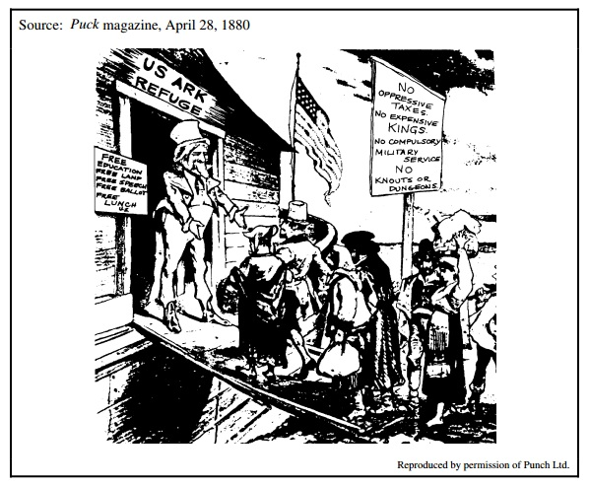
Document 2
Source: James Bryce, The American Commonwealth, 1888

A certain part of this recent immigration is transitory. Italians and Slovaks, for instance, after they have by thrift accumulated a sum which is large for them, return to their native villages, and carry back with them new notions and habits which set up a ferment among the simple rustics of a Calabrian or North Hungarian Valley. For the United States the practice has the double advantage of supplying a volume of cheap unskilled labour when employment is brisk and of removing it when employment becomes slack, so that the number of the unemployed, often very large when a financial crisis has brought bad times, is rapidly reduced, and there is more work for the permanently settled part of the laboring class. It is the easier to go backwards and forwards, because two thirds among all the races except the Jews, are men, either unmarried youths or persons who have left their wives behind.

Document 3
Source: National People's Party platform, 1892, Expression of Sentiments

Resolved, That we condemn the fallacy of protecting American labor under the present system, which opens our ports to the pauper and criminal classes of the world and crowds out our wage-earners; and we denounce the present ineffective laws against contract labor, and demand the further restriction of undesirable emigration.

Document 4
Source: Booker T. Washington, speech in Atlanta, Georgia, September 18, 1895

To those of the white race who look to the incoming of those of foreign birth and strange tongue and habits for the prosperity of the South, were I permitted I would repeat what I say to my own race, "Cast down your bucket where you are." Cast it down among the eight millions of Negroes whose habits you know, whose fidelity and love you have tested in days when to have proved treacherous meant the ruin of your firesides. Cast down your bucket among these people who have without strikes and labour wars, tilled your fields, cleared your forest, [built] your railroads and cities, and brought forth treasures from the bowels of the earth, and helped make possible this magnificent representation of the progress of the South . . . .

As we have proved our loyalty to you in the past, . . . we shall stand by you with a devotion that no foreigner can approach . . . .

Document 5
Source: Report of the Commissioner General of Immigration, 1908

In order that the best results might follow from an enforcement of the regulations, an understanding was reached with Japan that the existing policy of discouraging emigration of its subjects of the laboring classes to continental United States should continue, and should, by co-operation with the governments, be made as effective as possible.

Document 6
Source: Edward A. Ross, Century Magazine, 1914

In 1908, on the occasion of a "homecoming" celebration in Boston, a newspaper told how the returning sons of Boston were "greeted by Mayor Fitzgerald and the following members of Congress: O'Connell, Kelihar, Sullivan, and McNary—following in the footsteps of Webster, Sumner, Adams, and Hoar. They were told of the great work as Mayor of the late beloved Patrick Collins. At the City Hall they found the sons of Irish exiles and immigrants administering the affairs of the metropolis of New England. Besides the Mayor, they were greeted by John J. Murphy, Chairman of the Board of Assessors; Commissioner of Streets Doyle; Commissioner of Baths O'Brien . . . Police Commissioner O'Meara."

Document 7
Source: Madison Grant, The Passing of the Great Race, 1918

Whatever may be its intellectual, its literary, its artistic or its musical aptitudes, as compared with other races, the Anglo-Saxon branch of the Nordic race is again showing itself to be that upon which the nation must chiefly depend for leadership, for courage, for loyalty, for unity and harmony of action, for self-sacrifice and devotion to an ideal. Not that members of other races are not doing their part, many of them are, but in no other human stock which has come to this country is there displayed the unanimity of heart, mind and action which is now being displayed by the descendants of the blue-eyed, fair-haired peoples of the north of Europe.

Document 8
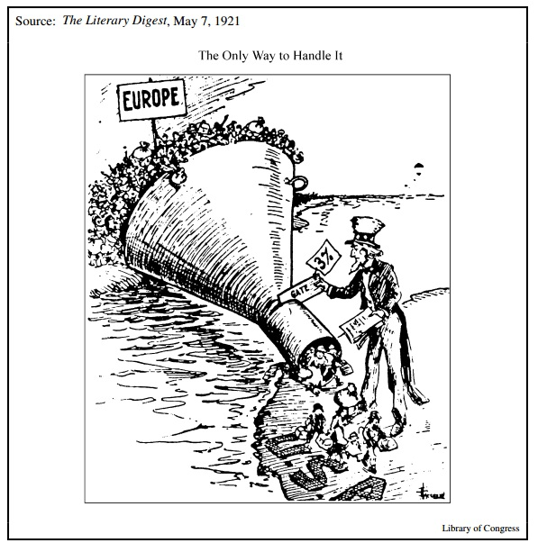
Unit 8: World War I and the 1920s
DBQs
- (2008B) #1 (a): Evaluate the extent to which tensions surrounding the issue of immigration led to a government response from 1880 to 1925.

- (2008B) #1 (b): Evaluate the causes and consequences of immigration tensions from 1880 to 1925.

Long Essays
- (2017) #3: Evaluate the extent to which the ratification of the NineteenthAmendment to the Constitution, which guaranteed women the right to vote, marked a turning point in United States women’s history. In the development of your argument, explain what changed and what stayed the same from the period immediately before the ratification of the amendment (1865–1920) to the period immediately after (1920–1940). (Historical thinking skill: Periodization)

- (2016) #3 Evaluate the extent to which United States participation in the First World War (1917-1918) marked a turning point in the nation's role in world affairs. In the development of your argument, explain what changed and what stayed the same from the period immediately before the war to the period immediately following it. (Historical thinking skill: Periodization)

- (2012) #4 (a): Explain the major causes and consequences for the cultural conflicts of the 1920’s in the United States.

- (2012) #4 (b): Evaluate the extent to which the 1920’s were a cultural turning point in American History.

- (2011) #4: Compare and contrast reactions of Americans to immigration in the 1840s-1850s with immigration in the 1910s-1920s.

- (2007B) #3: Evaluate the extent to which the mainstream American response to immigration reflected continuity as well as change between earlier immigration in the period 1830 to 1860 and later immigration in the period 1880 to 1930.

- (2007B) #5: Evaluate the effects of the First World War on the Home Front.

- (2006) #4: Evaluate the reasons for the loss of momentum of the Progressive Movement during 1920s.

- (2006B) #5: Evaluate the extent to which new technologies impacted American culture in the 1920's.

- (2004B) #4: Explain the major causes of the population shift from a rural to an urban environment in the United States between 1875 and 1925.

- (2001) #5: Evaluate the causes and consequences of nativism in American society from 1900-1930.

- (1999) #4 (a): “The 1920s represent a significant American cultural expression.” Support, modify, or refute this statement.

- (1999) #4 (b): Evaluate the extent to which the 1920s were a turning point of cultural and economic change?

Unit 8: World War I and the 1920s
Short Answer Questions

- Answer a and b. (AMSCO22)
  - Briefly explain ONE example of how the government mobilized industry of labor during WWI.
  - Briefly explain the impact of WWI on TWO of the following groups:
    - Women
    - African Americans
    - German Americans
    - Mexican Americans

- There were several significant changes on the home front during World War I. (FastTrackCH15)
  - Choose one of the following and describe how it created change in the United States during the war. Use historical evidence to support your answer.
    - Food conservation
    - Economic reforms
    - Schenck v. United States
  - Choose one other change from the list, and discuss why it was more or less significant than your first choice. Provide at least ONE concrete historical example to support your answer.

The League of Nations failed to take hold in America because the country was not yet ready for so global a role. Nevertheless, Wilson’s intellectual victory proved… seminal… For, whenever America was faced the task of constructing a new world order, it has returned in one way or another to Woodrow Wilson’s percepts. At the end of WWII, it helped build the United Nations on the same principles as those of the League, hoping to found peace on a concord of the victors. When this hope died, America waged the Cold Was… as a more struggle for democracy. When communism collapsed, the Wilsonian idea that the road to peace lay in collective security… was adopted by administrations of both major American political parties.
-Henry Kissinger, Harvard professor and Secretary of State under Presidents Nixon and Ford, Diplomacy, 1994

- Using the excerpt, answer a, b, and c. (AMSCO22)
  - Briefly explain ONE cause for the failure of the Treaty of Versailles in the U.S. Senate, in addition to the one given by Kissinger.
  - Briefly explain ONE example what the author meant in the excerpt by “Woodrow Wilson’s percepts.”
  - Briefly explain ONE reason for the influence of Wilson’s ideas on U.S. foreign policy over time.

- Two technological advances of the 1920s created great social and cultural change. (FastTrackCH16)
  - For both of the following, discuss at least one example of how it affected people’s daily lives in the 1920s.
    - Cars
    - Radios
  - Discuss ONE example of how the changes brought by these items led to backlash during the decade.

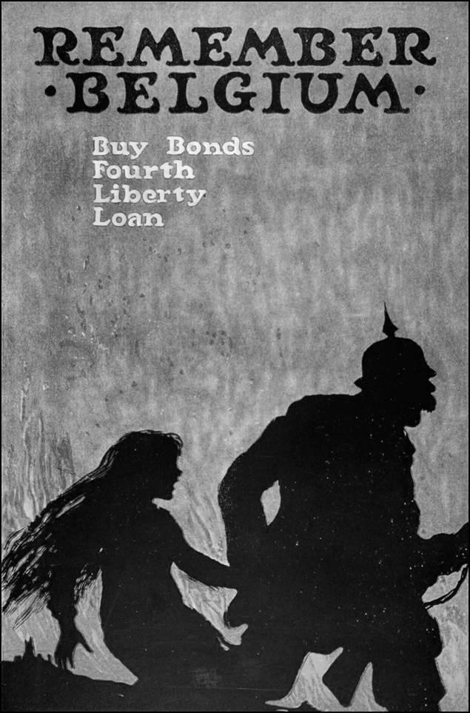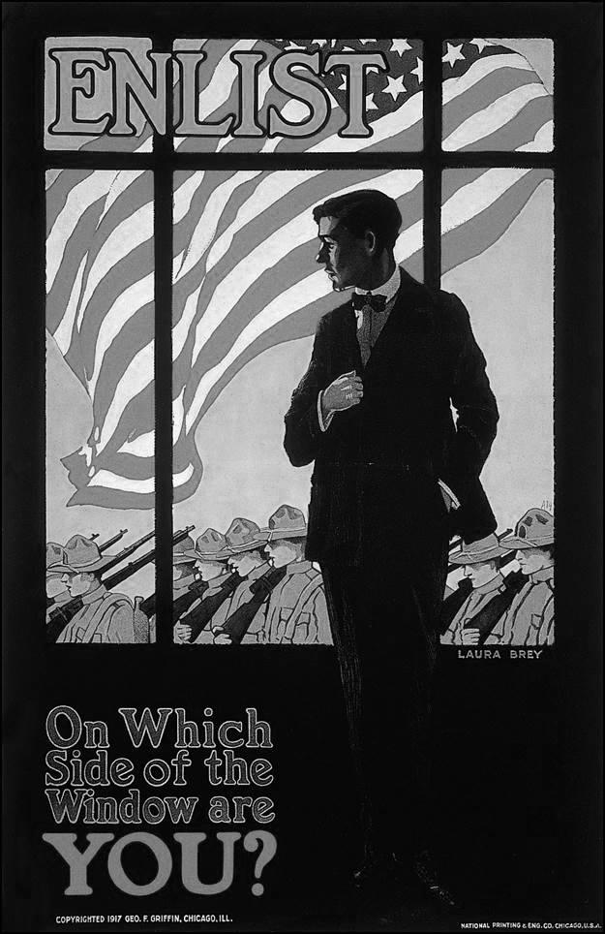
- Before the United States enter the war there were several threats to the nation’s neutrality. (FastTrackCH15)
  - What were the goals of these posters?
  - Besides war-related propaganda, there were several other threats to neutrality. Choose one of the following and discuss whether this was a great or lesser threat to the nation’s neutrality than propaganda. Support your answer with historical evidence.
    - Unrestricted submarine warfare
    - The immigrant population of the United States
    - German threats to America’s safety.

- Answer a, b, and c. (AMSCO23)
  - Briefly explain ONE example of how the media of 1920s contributed to development of a shared national culture.
  - Briefly explain ONE development that caused the disillusionment among writers of the 1920s.
  - Briefly explain ONE important artistic response during the 1920s and 1930s to industrial development or urban experience.

“Strange,
That in this nigger place
I should meet life face to face;
When, for years, I had been seeking
Life in places gentler-speaking,
Until I came to this vile street
And found Life stepping on my feet!”
-Langston Hughes, “Esthete in Harlem,” 1930

- Langston Hughes was a major figure and prolific poet in the Harlem Renaissance. (FastTrackCH16)
  - How does Hughes describes Harlem in this poem?
  - Why were the 1920s the right time for a movement like the Harlem Renaissance? Include at least ONE historical example in your answer.

This question is based on the following 1919 political cartoon.
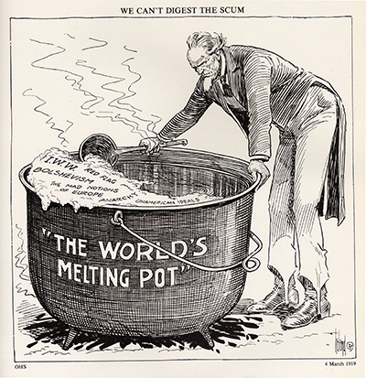
We Can't Digest the Scum
- Use the image above and your knowledge of United States history to answer parts A, B, and C. (SurvivalGuide-SAQ)
  - Explain the point of view reflected in the cartoon above about ONE of the following:
    - The Red Scare
    - Immigration
    - The labor movement
  - Briefly explain how ONE element of the cartoon expresses the point of view explained in Part A.
  - Briefly explain ONE development in the period between 1919 and 1928 that challenged or supported the point of view expressed by the cartoonist.

- Answer a, b, and c. (AMSCO23)
  - Briefly explain ONE example of religion and science were a source of conflict in American society during the 1920s.
  - Briefly explain ONE development during the 1920s that changed attitudes toward Prohibition.
  - Briefly explain ONE important difference in the immigrant legislation of the 1920s in comparison to earlier periods.

"Through his artistic efforts the Negro is smashing this immemorial stereotype faster than he has ever done through any other method he has been able to use....He is impressing upon the national mind the conviction that he is an active and important force in American life; that he is a creator as well as a creature.; that he has given as well as received; that he is the potential giver of larger and richer contributions....
"I do not think it too much to say through artistic achievment the Negro has found a means of getting at the very core of the prejudice against him by challenging the Nordic superiority complex. A great deal has been accomplished in this decade of 'renaissance."
-James Weldon Johnson, poet and secretary of the NAACP, Harper’s, 1928

- Using the excerpt, answer a, b, and c. (AMSCO23)
  - Briefly explain ONE way the Harlem Renaissance supported the point of view in the excerpt.
  - Briefly explain ONE example of an African artist’s achievements from the era that would support this excerpt.
  - Briefly explain what the author most likely meant by “the very core of prejudice” faced by African Americans in the 1920s.

“I couldn't forgive him or like him, but I saw that what he had done was, to him, entirely justified. It was all very careless and confused. They were careless people, Tom and Daisy--they smashed up things and creatures and then retreated back to their money or their vast carelessness, or whatever it was that kept them together, and let other people clean up the mess they had made”
-F. Scott Fitzgerald, novelist, The Great Gatsby, 1925

“Never was a decade snuffed out so quickly as the 1920’s. The stock market crash was taken as a judgment pronounced on the whole era, and, in the grim days of the depression, the 1920’s were condemned as a time of irresponsibility and immaturity.”
-William E. Leuchtenburg, historian, The Perils of Prosperity, 1959

- Using the excerpts, answer a, b, and c. (AMSCO23)
  - Briefly explain ONE social development in the 1920s that supports the Fitzgerald quote.
  - Briefly explain ONE economic development in the 1920s that supports the Leuchtenburg quote.
  - Briefly explain ONE argument that supports that the 1920s made a positive contribution the long-term prosperity of the United States.

"During [the 1920s], the city contested the supremacy of rural, small-town America. The city represented a challenge for economic power: the determination of finance capitalism to regain the political preeminence that had been pared away in the Progressive era. The city threatened to disrupt class stability through the drive by unskilled labor to form industrial unions. . . . The city imperiled the hierarchy of social status through the clamor of new immigrant[s]. Most of all, the older America was alarmed by the mores of the metropolis."
William E. Leuchtenburg, historian, 1958

"The geographic reorganization of urban and rural areas [in the 1920s] drew these regions into a closer and more interdependent relationship with each other. This relationship was most evident in cities and towns which lay in the outlying districts around urban centers. These towns attracted people from both central cities and the surrounding countryside. . . . In addition, farm families that converted to truck farming were tied more closely into the urban market and urban culture. . . . [A] shift from the direct production of goods to the purchase of them in metropolitan markets [also] changed people's habits of consumption. . . . Consumption habits [drew] women out of the household and into the marketplace. . . . A 1930 study of bread consumption, for example, found that most families [in urban and rural areas] had shifted to store-bought goods."
Joseph Interrante, historian, 1980

- Using the excerpts above, answer (a), (b), and (c). (APUSH6-9)
  - Briefly explain ONE major difference between Leuchtenburg's and Interrante's interpretations of cities and rural areas during the 1920s.
  - Briefly explain how ONE specific historical event or development in the period 1919-1930 that is not explicitly mentioned in the excerpts could be used to support Leuchtenburg's interpretation.
  - Briefly explain how ONE specific historical event or development in the period 1919-1930 that is not explicitly mentioned in the excerpts could be used to support Interrante's interpretation.

