Road to the Civil War
- Growth of Slavery
  - 1790
    - Total U.S. population was 3.5 million…
    - 700,000 slaves in the U.S. at this time.
    - Still bought slaves through the slave trade.
  - 1830
    - Total U.S. population was 18 million
    - 2 million slaves in the U.S. at this time.
    - 1808, importation of slaves was illegal
    - Slave trade within the U.S.
    - Increase of slave population was from natural reproduction
  - 1860
    - 33 million U.S. population
    - 4 million slaves in the South
    - U.S. was the largest slave institution in the world by 1860
  - Cotton Production
    - 1791
      - 4,000 bales of cotton are produced
      - 6 cents a pound
    - 1849
      - 2,246, 900 bales of cotton are produced
      - 14 cents a pound
    - Expanded into Arkansas and Texas
    - Crop increase:
      - 2,500,000 bales in 1850 to 5,300,000 in 1860
    - Crop Value
      - In 1800, $8 million: In 1860, $250 million
  - Tobacco by 1860:
    - 200,000,000 lbs. to 430,000,000 lbs.
    - More slaves you had the greater social status
- Slavery History in the United States
  - Transportation to the Americas
    - Middle Passage
      - Conditions on a slave ship were horrible.
  - At the Constitutional Convention
    - 3/5’s Compromise
    - 1807, imported slaves was abolished in the U.S.
      - There was a slave trade within the U.S.
    - Fugitive Slave Law
  - Effects on the Economy
    - 90% of Europe’s cotton came from the South by 1860
    - 1/2 of U.S. exports were from cotton
    - More money invested in slaves than land and tools---$2 billion
    - U.S. produced 7/8’s of world’s cotton supply
  - Effects on Politics
    - 2/3’s of presidents since independence were slaveowners
    - More millionaires in the South than the North
    - 75% of the cotton harvest was done by plantations with10 or more slaves.
    - Cotton is King/King Cotton and the South was not willing to change
    - Always felt isolated and threatened from the rest of the U.S.
- Southern Society
  - Chart (end of notes)
    - Caste system and difficult to move up the social ladder.
    - Based on white supremacy and the slave was inferior.
  - % of Slaveowning Families in the South
    - Total of 1,534,000 Southern white families in 1860……A total population of 7,981,000….
    - About 1,150,000 Southern white families owned no slaves---75%
    - About 384,000 Southern white families owned 1 slave or more---25%
      - Breakdown of the number of slaveowning families.
        - 75% owned 1 to 9 slaves.
        - 22% owned 10 to 49 owned slaves.
        - 3% owned 50 or more slaves.
  - Slavery
    - In 1619, the first recorded introduction of African slaves into what would become the United States was in the settlement of Jamestown……20 slaves were purchased….
    - Existed in every colony, but far fewer in the north, where there wasn’t an economic need
    - Sugar colonies drew the vast majority of slaves, but southern Colonies all bought slaves
  - African Response to Slavery
    - Cooperation the most common response, as it was the easiest, and carried rewards
    - Passive resistance common as well, working slowly, or “accidentally” breaking things
      - theft or sabotage
      - violence and murder
      - running away, intermarry with Native Americans, or hiding as a free man
    - Slaves often married and formed families, and passed on family names, and traditions
  - Slave Revolts
    - Slaves resorted to revolts in the 13 colonies and later in the southern U.S.
    - 250 insurrections have been documented; between 1780 and 1864.
    - Revolts would lead to a series of slave codes which restricted the movement of the slaves.
  - Famous Slave Revolts
    - Gabriel Prosser
      - Rebellion near Richmond, VA.
      - Hundreds of slaves heard about the plan, and 2 of them told the white authorities.
      - Governor James Monroe called out the militia and Prosser and 25 of his followers were executed and their owners received compensation.
    - Denmark Vessey
      - Spent five years devising an elaborate scheme to seize control of Charleston, SC.
      - Betrayed by slaves and hanged with 35 fellow conspirators in the summer of 1822.
    - Nat Turner
      - In 1831, he led about 30 slaves on a rampage through tidewater Virginia, killing about 60 men, woman, and children.
      - As an effect, a slaughter of blacks took place before the uprising was put down.
      - Eluded his pursuers for 2 months before being captured, tried, and then executed.
      - The Southern States as a result enforced laws prohibiting the education of slaves and increased surveillance of free African Americans.
  - Slaves Codes
    - Revolts would lead to a series of slave codes which restricted the movement of the slaves.
    - Examples
      - Slaves were not taught to read or write
      - Restricted to the plantation
      - Slaves could not congregate after dark
      - Slaves could not possess any type of firearm
      - 1662 Virginia law made slave status dependent on who mother was
      - 1669 Virginia law made murder of a slave by owner not punishable by law
      - 1692 interracial sex made illegal (widely ignored by white males)
    - Slave owners wanted to keep their slaves ignorant of the outside world because learning about life beyond the plantation could lead to more slave revolts and wanting to escape.
    - Many of the Caribbean and South American colonies were crueler and disregarded human dignity, because the profits from sugar were so high, and the supply of slaves so close and so cheap, that they worked their slaves to death and bought more
- Philosophies about Slavery
  - Arguments for Slavery
    - Economically profitable
    - Slavery was in the Bible
    - Duty of Southerners to Christianize the slaves, Positive Good
    - Provided a better life for slaves than in Africa, Positive Good
    - 5th Amendment legalized and protected slavery because slaves were considered property.
  - Arguments against Slavery
    - Peculiar institution or it is odd, strange or weird to own another human being.
    - Abolitionists believed slavery was immoral
      - It violated the ideals that this country was founded on.
      - All men are created equal (DOI)
      - If the U.S. was to succeed as a democratic society, slavery had to be abolished
- Abolitionist Movement
  - William Lloyd Garrison
  - Frederick Douglass
    - Escaped slave in 1838
    - Bought his freedom for $600.00
    - Wrote his autobiography, Narrative of the Life of Frederick Douglass
    - Editor of the North Star--Abolitionist paper
    - Organized the 54th Black Regiment of Mass
  - Underground Railroad
    - Existed as early as 1786.
    - Started by the Quakers and spread through most of the North by 1830.
    - One estimate places the number of African Americans who escaped through the Underground Railroad between 1830 and 1860 at 50,000.
    - Provided food, shelter, and hiding places to runaway slaves as they escaped to Canada
    - Violated the Fugitive Slave Law
  - Harriet Tubman,
    - Moses of her people.
    - Led over 300 escaped slaves out of the South during the 1850’s.
    - Conductor of the Underground Railroad
    - Supplied money from abolitionists.
  - Fugitive Slave Law
    - A law at the Constitutional Convention in 1787 as a compromise between the North/South.
    - Any escaped slaves captured in the North or free state had to be returned to their plantation.
    - Unpopular in the North and led to the creation of the Underground Railroad.
    - Southerners became bitter towards the North because they refused to enforce it.
  - Harriet Beech Stowe
    - Authored the book Uncle Tom’s Cabin
    - Book was used as propaganda to show the inhumanity of slavery.
    - Southerners were enraged by this book and called it “lies”.
  - Henry David Thoreau
    - Abolitionist and transcendentalist
    - Refused to pay a tax, did night in jail because the tax supported a war that supported slavery
    - Believer in Civil Disobedience or passive resistance---protest with non-violent actions
    - Spent a night in jail over the Mexican War….
  - Women's Rights Advocates
    - Elizabeth Cady Stanton & Susan B. Anthony
    - Supported the abolition of slavery
  - Gag Rule
    - Gag rule was passed in Congress which nothing concerning slavery could be discussed.
    - Under the gag rule, anti-slavery petitions were not read on the floor of Congress
    - In 1840, the House passed an even stricter rule, which refused to accept all anti-slavery petition. On December 3, 1844, the gag rule was repealed
- Road to the Civil War
  - Missouri Compromise
    - Causes
      - In 1819, Missouri, first part of the Louisiana Purchase to apply for statehood
      - Threatened balance of power in Congress
        - 11 free states and 11 slave states
    - Course
      - The Tallmadge amendment
        - prohibited the further introduction of slaves into Missouri
        - All slaves born in Missouri would be freed at the age of 25.
        - Passed by the House, not in the Senate.
        - North controlled the House, and South had power to block it in the Senate.
      - Henry Clay won majority support for 3 bills that represented a compromise
        - Missouri was to be admitted as a slaveholding state
        - Maine was to be admitted as a free state
        - Rest of Louisiana Territory north of latitude 36”30', slavery was prohibited
    - Consequence
      - Maintains balance of free and slave states
  - Texas War for Independence
    - Americans began moving into Texas in the 1820’s and brought their slaves with them.
    - War fought by Texans against Mexico because they believed their rights had been violated.
    - Won by Texans in 1836 and requests to enter the U.S.
    - President Jackson and Van Buren refused to recognize Texas statehood because of slavery.
    - Texas became its own country with Sam Houston president, 1836 to 1845.
    - Mexico never recognized the independence of Texas.
    - Texas entered as a U.S. state in 1845.
    - Mexico vowed if Texas became part of the U.S., this would be an act of war.
  - President James K. Polk (1845-1849)
    - Responsible for the Manifest Destiny and an expansionist
    - Acquired the Oregon Territory from Great Britain in 1846
      - 54’, 40’ or Fight
      - 49th Parallel as a compromise
    - Mexican War acquired Mexican Cession and completed U.S. control of the continent
  - Oregon
    - Treaty with Great Britain in 1846
    - President Polk campaign slogan was “54”40’ or Fight”…
    - Compromised with British and divided the Oregon Country at the 49th parallel
    - Oregon Trail
- Mexican American War
  - Long Term Causes
    - American belief that U.S. would control the continent from the Atlantic to the Pacific.
    - California
  - Immediate Causes
    - Texas statehood, 1845
    - Border dispute
    - "American Blood Spilt on American Soil"
  - Spot Resolutions
    - After news from president James K. Polk that 16 American service men had been killed or wounded on the Mexican border in American territory, Abraham Lincoln proposed these resolutions to find out exactly on what spot the American soldier's blood had been shed.
    - In Polk's report to Congress the President stated that the American soldiers fell on American soil, but they actually fell on disputed territory that Mexico had historical claims to.
  - Wilmot Proviso
    - Dispute over whether any Mexican territory that America won during the Mexican War should be free or a slave territory.
    - Representative David Wilmot introduced an amendment stating that any territory acquired from Mexico would be free.
    - This amendment passed the House twice, but failed to ever pass in Senate.
  - Treaty of Guadalupe Hidalgo
    - Mexico ceded the Mexican Cession to U.S.
    - Rio Grande River boundary between U.S. and Mexico
    - U.S. paid Mexico $15 million
- Compromise of 1850
  - John C. Calhoun (Southerner)
    - North should honor the Constitution and enforce the Fugitive Slave Law
    - South wanted California
      - Threatened to secede from U.S.
    - U.S. should have two Presidents---one from the North and one for the South
  - Daniel Webster (Northerner)
    - Secession is impractical & impossible
    - Compromise at all cost
    - Preserve the Union
  - Henry Clay (Westerner)
    - The Great Compromiser, with Calhoun, Webster and Douglas, propose this compromise.
  - Senator Stephen Douglas (Illinois)
    - Popular Sovereignty
      - People in each territory decide through voting whether they want slavery or not.
  - Provisions of Compromise of 1850
    - California will become a free state
    - Popular Sovereignty in the Utah and New Mexico Territories
      - Allow the people in a territory to vote on whether they want slavery to exist or not
    - stop slave trade in Washington, D.C.
    - enforce Fugitive Slave Law
  - Fugitive Slave Law
    - paid federal commissioners were appointed and given authority to issue warrants, gather, possess and force citizens to help catch runaway slaves;
    - the slaves could not testify in their own behalf,
    - "Man-Stealing Law" shocked moderates into being antislaveryites
  - Abolitionists Respond
    - Denounced by Abolitionists
    - Harriet Beecher Stowe’s Uncle Tom’s Cabin is published
    - Abolitionists refuse to enforce the law
    - Underground Railroad becomes more active
  - Southerners Respond
    - Southerners threatened secession and war
    - Should be enforced b/c the Constitution protects property and Federal law is over State law.
      - 5th Amendment
      - Supremacy Clause
- Kansas Nebraska Act
  - Goal
    - Build a transcontinental connecting California to the East Coast either in the South or North
  - Stephen Douglas
    - wanted the railroad built in the North but had to convince the South otherwise.
    - Proposed a plan that Kansas and Nebraska territories be opened up to slavery in return for building the railroad in the North.
      - Missouri Compromise currently prevented expansion of slavery into territories
    - Kansas and Nebraska would use popular sovereignty
  - Bleeding Kansas
    - Pro-slavery and antislavery supporters rushed to settle in Kansas.
    - Led to several acts of violence between pro-slavery settlers and anti-slavery settlers.
    - First battles of the Civil War begin in Kansas in 1856.
    - Over 200 killed
    - Led to the formation of the Republican Party.
- Republican Party
  - Goal
    - Formed to stop the expansion of slavery
  - Members
    - Abolitionists
    - Know Nothing Party against immigration
    - National Republicans which become the Whigs.
    - Democrats opposed the expansion of slavery
    - Free Soil Party against the expansion of slavery
- Dred Scott Decision
  - Case
    - Slave from Missouri traveled with his owner to Illinois & Minnesota both free states.
    - His master died, Scott wanted to move to Missouri---Missouri still recognized him as a slave.
    - Sued his master’s widow for freedom since he had lived in a free state for a period of time.
  - Questions
    - Can a slave sue for his freedom?
    - Is a slave property?
    - Is slavery legal?
  - Decision
    - Slaves cannot sue the U.S. for their freedom because they are property.
    - They are not citizens and have no legal right under the Constitution.
    - Supreme Court legalized slavery by saying that
  - Significance
    - Congress could not stop a slaveowner from moving his slaves to a new territory
    - Missouri Compromise and all other compromises were unconstitutional
    - North refused to enforce Fugitive Slave Law
    - Free states pass personal liberty laws.
    - Republicans claim the decision is not binding
    - Southerners call on the North to accept the decision if the South is to remain in the Union.
- John Brown’s Raid on Harper’s Ferry
  - Background
    - Violent abolitionist
    - Involved in the Bleeding Kansas where he murdered 5 pro-slavery men in Kansas
  - Raid at Harper’s Ferry (October 1959)
    - Wanted to lead a slave revolt throughout the South by raising an army of freed slaves..
    - Attacked an ammunition depot in Harper’s Ferry, VA to capture weapons and begin revolt.
    - Unsuccessful and captured by USMC under the leadership of Robert E. Lee
    - He was found guilty of treason and sentenced to death.
    - Northerners thought of John Brown as a martyr to the abolitionist cause.
    - Southerners were terrified that if John Brown almost got away with this, there must be others like him in the North who are willing to die to end slavery.
    - South’s outcome: To leave the U.S. and start their own country.
- Election of 1860
  - Lincoln-Douglas Debates
    - Lincoln and Douglas both running for the U.S. Senate in Illinois.
    - The debates were followed by the country because both candidates were interested in running for the Presidency in 1860.
    - Slavery was the issue
      - Lincoln
        - House Divided against itself cannot stand. Either we become one or the other.
        - Was against the expansion of slavery
      - Douglas
        - Believed that slavery should be decided by the people in a territory.
        - Popular sovereignty
    - Freeport Doctrine
      - Developed by Stephen Douglas that said the exclusion of slavery in a territory could be determined by the refusal of the voters to enact any laws that would protect slave property. It was unpopular with Southerners, and thus cost him the election.
    - Douglas forced to admit that Popular Sovereignty could work against the slavery.
    - Southerners would not support Douglas for the presidency in 1860
  - Election of 1860
    - Country is polarized (divided) over the issue of slavery.
    - Once Lincoln is elected as president, South Carolina will secede from the U.S.
    - South Carolina and other states will form the Confederate States of America---CSA
  - Crittenden Compromise (1860)
    - 1860 - attempt to prevent Civil War by Senator Crittenden
    - Offered a Constitutional amendment recognizing slavery in the territories south of the 36º30'
    - Noninterference by Congress with existing slavery
    - Compensation to the owners of fugitive slaves
    - Defeated by Republicans
Civil War

- Confederacy
  - Constitution
    - When the Confederate States of America was formed, its founders wrote a constitution similar to the United States Constitution.
    - Its differences, however, indicate how the South Wanted to change their structure of government.
      - State’s rights
      - Tariffs are equal throughout the CSA
      - Slavery is legal and is allowed to expand

  - West Virginia secedes from Virginia in 1863 and sides with USA.
- Military Strategies
  - Union Strategy
    - War goal
      - Preserve Union and later abolish slavery
    - Aggressive offensive to crush the rebellion.
    - War of attrition:
      - South has less manpower.
    - Gen Winfield Scott’s Anaconda Plan
      - Control Ohio and Mississippi River systems
      - Blockade and seizure of ports
      - Capture Richmond
      - Don’t allow Confederacy to rest.
  - Lincoln's Necessary Action
    - Suspended “civil liberties” or parts of the Constitution
    - Writ of habeas corpus:
      - Protects from unfair arrest and trial by jury.
    - Occupation of Baltimore:
      - Controlled by military---- “martial law”
    - Arrested over 15,000 civilians
      - Without “probable cause”
      - suspicious “Rebel” sympathizers.
    - Closed “rebel” newspapers
      - Violated 1st Amendment rights of “free speech and press”.
    - First Income Tax
    - Greenbacks or 1st paper money
  - Confederate Strategy
    - Goal:
      - Defend and delay until Union gives up.
    - Strategy
      - Quick victories to demoralize Union
      - Alliance with Great Britain
      - Capture Washington, D.C.
      - Defend Richmond
      - Sought decisive battle that would convince the Union it wasn’t worth it
    - Use better military leadership to your advantage and outsmart Union generals.
- Key Battles in the East
  - Union
    - Strategy was capture Richmond, Virginia
    - Leaders
      - Several different leaders: Winfield Scott, George McClellan, John Pope, Ambrose Burnside, Joe Hooker, George Meade, Ulysses Grant
  - Confederate
    - Strategy was Capture Washington, D.C.
    - Leader was General Robert E. Lee
Date | Battle | Victor | Result
July 1861 | Bull Run or Manasses | South | Union retreats to Wash. D.C.
June 1862 | 7 Days | South | Lee stops McClellan from taking Richmond
August 1862 | Bull Run | South | Lee stops John Pope from taking Richmond
Sept. 1862 | Antietam* | Draw | McCellan stops Lee from taking Washington, D.C. Lincoln issues Emancipation Proclamation
 | *Turning Point battle

  - Battle of Bull Run (1st Battle of Manasses) July 1861
    - Lincoln sent 30,000 inexperienced soldiers to fight at Bull Run.
    - Northern troops were pushed back to D.C.
    - South won this battle but “lost the war”.
      - Why? Failed to capture Washington, D.C.
      - Would never be so close to Washington, D.C.
  - Emancipation Proclamation
    - Did not end slavery in US
    - Background
      - Abolitionists pressured Lincoln to free the slaves.
      - After the Battle of Antietam, he announced that the slaves would be freed.
    - Provisions
      - Became effective on Jan. 1, 1863, in those states still in rebellion.
      - Freed all slaves in states in rebellion against the US
      - Did not apply to slaves in border states fighting for US
      - No effect on southern areas already under US control.
    - Significance
      - Lincoln’s “first” step towards ending slavery.
      - “Final step” 13th Amendment to the Constitution on Dec. 1865 would legally and constitutionally abolish slavery.
      - War was now fought to end slavery.
        - US soldiers were “Freedom Fighters”
      - Kept Great Britain from siding with the South and becoming an ally.
    - War was now a war to
      - abolish slavery
      - destroy the South
      - preserve the Union
    - Response by African Americans
      - Over 200,000 freed slaves fought for the US.
      - 54th Black Regiment of Massachusetts which was organized by Frederick Douglass.
- Key Battles in the West
  - Union
    - Strategy
      - Control river systems and split the Confederacy in half and isolate the 3 sections.
    - Leaders
      - General Ulysses S. Grant
  - Confederate
    - Strategy
      - Fight a defensive war and drive Union out of South
    - Leader was several different generals
Date | Battle | Victor | Result
Feb. 1862 | Fort Donelson | Union | Controlled the Ohio River
March 1862 | Fort Henry | Union | Controlled Cumberland River
April 1862 | Shiloh | Union | Controlled Tennessee River
April 1862 | New Orleans | Union | Controlled mouth of Mississippi
July 1863 | Vicksburg* | Union | Controlled Mississippi River  Split Confederacy in half
 | *Turning Point battle
  - Battle of Vicksburg
    - On July 4, 1863
    - 30,000 Confederate troops defending Vicksburg surrendered their arms.
    - Former slaves celebrated Independence Day for the first time.
    - 4 days later, the Mississippi River was in the hands of the Union army
    - Effectively cutting the Confederacy in two.
- Battles in the East
Date | Battle | Victor | Result
Dec. 1862 | Fredericksburg | South | Lee stops Burnside from taking Richmond
Jan. 1863 | Chancellorsville | South | Lee stops Joe Hooker from taking Richmond
July 1863 | *Gettysburg | North | George Meade stops Lee from moving into
 | *Turning Point battle
  - Battle of Gettysburg
    - General Lee invades the North.
    - The “High Tide of the Confederacy”.
      - South’s last chance to capture Washington, D.C.
    - The defeat of Lee at Gettysburg would be the last time Lee would invade the North and try to take Washington, D.C.
    - Lee’s retreat at Gettysburg on July 3rd and Grant’s defeat of the South at Vicksburg on July 4th would lead to the eventual surrender of the South by 1865.
  - Gettysburg Address
    - On November 19, 1863, some 15,000 people gathered at Gettysburg to honor the Union soldiers who had died there just four months before.
    - President Lincoln delivered a two-minute speech which became known as the Gettysburg Address.
    - He reminded people that the Civil War was being fought to preserve a country that upheld the principles of freedom, equality, and self-government.
    - The Gettysburg Address has become one of the best-loved and most-quoted speeches in the English language.
    - It expresses grief at the terrible cost of war and the importance of preserving the Union.
- Union Change in Leadership
  - General Grant

    - After Union victories at Vicksburg and Gettysburg, President Lincoln appointed General Grant as the Commanding General of all Union troops.
    - Commanded the Army of the Potomac and was instructed to force General Lee to surrender.
    - Appointed 2nd in command General William T. Sherman to head up the Army of the West.
  - William T. Sherman
    - Grant’s right hand general.
    - Most noted for this saying;
      - “War is hell and the worse you make it the sooner it will be over.”
    - Put in charge of the Army of the West after Lincoln appoints Grant as head of Union troops.
    - Responsible for the March to the Sea and using “total war” in destroying the South.
  - Total War
    - Tactic of war where the Union marched through the South and destroyed all resources the civilian population needed to survive.
    - Goal
      - To make war as horrible and destructive as possible to force your enemy to surrender.
    - Brings the civilian population into the war to demoralize the enemy and force surrender.
  - Sherman’s March through Georgia to the Sea, 1864
    - Destructive route from Atlanta to Savannah in Georgia.
    - Sherman practiced Total War in this move, and destroyed anything and everything, hoping to demoralize the South.
  - Surrender at Appomattox Courthouse
    - This was the location of the last battle.
    - While there, Lee was cornered, and forced to surrender.
    - Grant offered generous terms, and the confederates became countrymen again
  - Lincoln Assassinated by John Wilkes Booth
- Military Significance of Civil War
  - Military Preparedness
    - Professional development of officers.
      - 1802 West Point is formed
      - 55 of 60 largest battles, both sides were commanded by West Pointers.
      - Artillery and Infantry schools opened.
    - Greater independence for military leaders.
    - Politicians focus on strategy and are less involved in operational and tactical decisions.
    - Mexican War
      - Many leaders on both sides gain valuable experience.
    - First great post-Industrial Revolution war.
  - Inventions/Innovation
    - Telegraph
      - Davis uses to gather forces for Shiloh.
      - Fredericksburg sees first extensive use on the battlefield.
    - Railway
      - Greatly changes logistics and strategic maneuver.
      - North had good system;
      - South had acceptable quantity, but no standardized track width.
    - Weapons
      - Outdated muskets replaced with rifle
        - greatly changes tactics.
        - more accurate, faster loading, fire more rounds than muskets
      - Minié ball (more destructive bullet)
        - Cold Harbor: 2k dead in 20 minutes, another 5k wounded.
      - Calvary used for reconnaissance
        - Scouting and skirmishes
      - Artillery
        - invention of shells, devices that exploded in the air.
        - fired canisters, special shells filled with bullets.
      - Grenades
      - Ironclads
        - Monitor v. Merrimack is the first Ironclad ship battle
        - replaces wooden ships
      - Trench warfare replaces Napoleonic tactics
- Supporting the Cause
  - Army
    - North
      - volunteers- 1861
      - conscription - 1863
        - 20-45 years
        - buy exemption
        - caused riots
      - bounty system - government paid a bounty of $1000 to volunteer
      - Total service: 4 million and 186,00 Blacks
    - South
      - volunteers 1861
      - conscription 1862
        - 18-35 years
        - hire a substitute
        - 1864 16-50 years
        - highly unpopular
      - recruited slaves
      - total service 1.5 million
  - New York City Draft Riots (July 1863)
    - Mobs of Irish working-class men and women roamed the streets for four days until federal troops suppressed them.
    - They loathed the idea of being drafted to fight a war on behalf of slaves who, once freed, would compete with them for jobs.
    - Lynched several blacks and burned down black homes, businesses, and an orphanage.
    - It was the bloodiest riot in U.S. history. Only the arrival of the federal troops halted the violence
  - Financing the War
    - North
      - Tariffs
      - War bonds
      - Income taxes
      - Paper money called “greenbacks”
    - South
      - Wealthy lent over $100 million
      - Foreign aid $15 million
      - Income taxes
      - Paper money

Reconstruction
- Reconstruction
  - Overview
    - Between 1865 and 1877, the federal government carried out a program to repair the damage to the South and restore the southern states to the Union.
    - Freed slaves were starting out their new lives in a poor region with slow economic activity.
    - Plantation owners lost slave labor worth $3 billion.
    - Poor white Southerners could not find work because of new job competition from Freedmen.
    - War destroyed two thirds of the South’s shipping industry and about 9,000 miles of railroad.
  - Lincoln's 2nd Inaugural Speech
    - “With malice toward none; with charity for all; with firmness in the right, as God gives us to see the right, let us strive on to finish the work we are in; to bind up the nation’s wounds….to do all which may achieve and cherish a just and a lasting peace, among ourselves, and with all nations.”
  - President Andrew Johnson
    - Remained loyal to the Union during the Civil War.
    - Lincoln chose him as his VP to help with the South’s Reconstruction.
    - Supported Lincoln’s Plan
    - Power struggle with Congress over who would lead the country during Reconstruction.
    - Would be impeached but not removed from office.
  - Radical Republicans
    - Leaders were Representative Thaddeus Stevens and Senator Charles Sumner
    - Wanted to the see the South punished.
    - Advocated political, social and economic equality for the Freedmen.
    - Go after President Johnson with impeachment after he vetoes Civil Rights Act of 1866.
- Reconstruction Plans
  - Presidential Plan (10% Plan)
    - Lincoln and Andrew Johnson’s plan to readmit the South was considered too gentle.
      - State could be reintegrated into the Union when 10 percent of the 1860 vote count from that state had taken an oath of allegiance to the U.S.
      - Pledged to abide by emancipation
      - Citizens of former Confederate states would be given the opportunity to swear allegiance to the government in Washington (high-ranking Confederate military and civilian authorities would not be offered this opportunity),
      - State was afforded the chance to form its own state government,
      - State legislature could write a new constitution but it also had to abolish slavery
      - Reject secession and state’s rights
    - No mention of citizenship, voting rights, or education for Freedmen
  - Congressional Reconstruction
    - Reconstruction Act of 1867--76 (Harsh)
    - Divided the Confederate states except Tennessee into five military districts.
      - Military commanders in the districts were appointed to oversee constitutional conventions in the districts and the creation of state constitutions.
      - Occupation would last until the states created new constitutions that included:
        - Oath of allegiance of 50% of the state population in 1860
        - Ratification of the 14th Amendment which allowed for black citizenship.
        - Black suffrage (15th Amendment)
        - Permanent disfranchisement of Confederate leaders
    - Help for Freedmen
      - Freedmen’s Bureau for education
      - 40 acres and a mule
  - Southern Reconstruction
    - As southern states were restored to the Union under President Johnson’s plan, they began to enact black codes, laws that restricted freedmen’s rights.
    - Black Codes
      - Similar to Slave Codes.
      - Restricted the freedom of movement.
      - Limited their rights as free people.
    - The black codes established virtual slavery with provisions such as these:
      - Curfews: Generally, black people could not gather after sunset.
      - Vagrancy laws: Freedmen convicted of vagrancy– that is, not working– could be fined, whipped, or sold for a year’s labor.
      - Labor contracts: Freedmen had to sign agreements in January for a year of work. Those who quit in the middle of a contract often lost all the wages they had earned.
      - Land restrictions: Freed people could rent land or homes only in rural areas. This restriction forced them to live on plantations.
- Johnson's Impeachment
  - Causes
    - President Johnson vetoed the Civil Rights Act of 1866
      - Gave $$$$ to Freedmen’s Bureau for schools and granted citizenship to the Freedmen
    - Congress believed Johnson was working against Reconstruction and overrode his veto.
      - Led to the 14th Amendment
  - Impeachment
    - Bringing charges against the President
    - 1st Step:
      - U. S. House of Representatives hold hearings to decide if there are crimes committed.
      - Vote on charges and if there is a majority, then, charges are brought against President.
    - 2nd Step:
      - U.S. Senate becomes a courtroom.
      - The President is tried for the charges brought against him.
      - The Chief Justice of the Supreme Court is the judge.
      - Once trial is completed, Senators must vote to remove President with a 2/3’s vote.
  - Impeachment Trial
    - Tenure in Office Act
      - President can’t fire any of his cabinet members without consulting Congress.
      - Johnson thought it was unconstitutional and fired Edwin Stanton
    - Johnson was Brought up on 11 charges of high crimes and misdemeanors.
    - Missed being removed from office by 1 vote
  - Significance
    - Presidency would suffer as a result of this failed impeachment.
    - President would be more of a figure-head.
    - Saved the separation of powers of 3 branches govt.
    - Once Johnson is impeached, Congress passes Reconstruction Act of 1867.
    - The South would be reconstructed under the Radical Republicans plan.
    - Ulysses Grant elected as President and he would carry out the Radical Reconstruction.
- Reconstruction Effects on Freedman
  - Constitutional Amendments
    - 13th Amendment
      - Abolished slavery (1865)
    - 14th Amendment
      - Provided citizenship & equal protection under the law. (1868)
    - 15th Amendment
      - Provided the right to vote for all men which included white and black men. (1870)
      - Some Women rights supporters refused to support the 14th and 15th Amendment giving African American Men citizenship unless women were added to it.
  - Southern State Constitutions
    - In 1867 and 1868, voters in southern states chose delegates to draft new state constitutions.
    - One quarter of the delegates elected were black.
    - The new state constitutions guaranteed civil rights, allowed poor people to hold political office, and set up a system of public schools and orphanages.
    - In 1870, southern black men voted in legislative elections for the first time.
    - More than 600 African Americans were elected to state legislatures, Louisiana gained a black governor, and Hiram Revels of Mississippi became the first black elected to the Senate.
  - Slaughterhouse Cases
    - Supreme Court argued that the "privileges and immunities" clause only forbids the states from withholding privileges & immunities belonging to US citizenship, not state citizenship.
    - Furthermore, the privileges and immunities of American citizenship extended only to those specified in the U.S. Constitution, which bans any state from discriminating against out-of-state citizens residing within its boundaries.
    - Constitution does not, however, require a state to grant special privileges, like a right to start a slaughterhouse, to every one of its own citizens.
  - Taste of Freedom
    - Freedom of movement
      - Slaves often walked away from plantations upon hearing that Union army was near.
      - Exodusters: moved to Kansas and Texas
    - Freedom to own land
      - Proposals to give white-owned land to freed people got little support from gov’t.
      - Unofficial land redistribution did take place, however.
    - Freedom to worship
      - African Americans formed their own churches and started mutual aid societies, debating clubs, drama societies, and trade associations.
    - Freedom to learn
      - Between 1865 and 1870, black educators founded 30 African American colleges.
  - Freedom's Bureau
    - Overview
      - 1865, Congress created the Freedman’s Bureau to help former slaves get a new start in life. This was the first major relief agency in United States history.
    - Bureau’s Accomplishments
      - Built thousands of schools to educate Blacks.
      - Former slaves rushed to get an education for themselves and their children.
      - Education was difficult and dangerous to gain.
      - Southerners hated the idea that Freedmen would go to school.
  - New South

    - Becomes industrialized
    - Cities rebuilt
    - Railroads
    - Schools, over a thousand
    - Hospitals, 45 in 14 states
    - Diversify economy.

  - Funding Reconstruction
    - Rebuilding the South’s infrastructure, the public property and services that a society uses, was one giant business opportunity.
    - Roads, bridges, canals, railroads, and telegraph lines had to be rebuilt.
    - Funds were also needed to expand services to southern citizens. Following the North’s example, all southern states created public school systems by 1872.
    - Congress, private investors, and heavy taxes paid for Reconstruction. Spending by Reconstruction legislatures added another $130 million to southern debt.
- Efforts to Resist Reconstruction
  - KKK
    - Overview
      - Ku Klux Klan refers to a secret society or an inner circle (Circle of Friends)
      - Organized in 1867, in Polaski, Tennessee by Nathan Bedford Forrest.
    - Goals
      - Disrupted Reconstruction as much as they could.
      - Eliminate the Republican Party in the South by intimidating voters.
      - Keep African Americans as submissive laborers.
      - Plant burning crosses on lawns of victims & tortured, kidnapped, or murdered them.
      - Prosperous African Americans, carpetbaggers, and scalawags became their victims.
    - Victims
      - During Radical Reconstruction, the Republican Party was a mixture of people who had little in common except a desire to prosper in the postwar South.
      - Carpetbaggers
        - Northerners/Republicans sent to help reconstruct the South.
        - Southerners gave them this insulting nickname, which referred to a type of cheap suitcase made from carpet scraps.
        - Depicted as greedy men seeking to grab power or make a fast buck.
      - Scalawags
        - Southerners who helped Carpetbaggers
        - White southern Republicans were seen as traitors and called scalawags.
        - Refers to one who is a “scoundrel”, reprobate or unprincipled person.
        - Some scalawags were former Whigs who had opposed secession.
        - Small farmers who resented the planter class. Many scalawags were poor.
      - Freedmen
        - Blacks who tried to vote or were involved in the reconstruction of their states’ governments.
  - The Federal Response
    - President Grant’s War On Terrorism.
      - Enforcement Act of 1870 banned the use of terror, force, or bribery to prevent voting.
      - Other laws banned the KKK and used the military to protect voters and voting places.
      - As federal troops withdrew from the South, black suffrage all but ended.
  - The Republican South
    - This bloc of voters included freedmen and two other groups: carpetbaggers and scalawags.
  - Sharecropping
    - Overview
      - Sharecroppers were Freedmen and poor Whites who stayed in the South and continued to farm.
      - Freedmen signed a work contract with their former masters.
      - Freedmen did not receive “40 acres and a mule”
      - Landowner provided land, tools, animals, house and charge account at the local store to purchase necessities
      - Freedmen provided the labor.
    - Advantages
      - Part of a business venture
      - Raised their social status
      - Received 1/3 to 1/2 of crop when harvested
      - Raised their self esteem
    - Disadvantages
      - Blacks stay in South
      - Some landowners refused to honor the contract
      - Blacks poor and in debt
      - Economic slavery
    - A Vicious Cycle of Debt
      - Poor whites and freedmen have no jobs, no homes, and no money to buy land.
      - Landowners need laborers and have no money to pay laborers.
      - Hire poor whites and freedmen as laborers
      - Sign contracts to work landlord’s land in exchange for a part of the crop.
      - Landlord keeps track of the money that sharecroppers owe him.
      - At harvest time, the sharecropper is paid and pays off debts.
      - If sharecropper owes more to the landlord or store than his share of the crop is worth;
      - Sharecropper cannot leave the farm as long as he is in debt to the landlord.
  - Segregation
    - Jim Crow Laws
      - Laws at the local and state level which segregated whites from blacks and kept African Americans as 2nd class citizens and from voting.
      - Derogatory name for a Black person, from the title of a 19th-century minstrel song.
      - Goal: Take away political and constitutional rights guaranteed by Constitution: Voting and equality of all citizens under the law.
      - Used at the local, state levels and eventually the national to separate the races in schools, parks, transportation, restaurants, etc….
    - Poll Taxes
      - Before you could vote, you had to pay taxes to vote.
    - Literacy Test
      - You had to prove you could read and write before you could vote.
    - Grandfather clause
      - If your grandfather voted in the 1864 election than you could vote.
  - Plessy v. Ferguson (1896)
    - Supreme Court decision which legalized segregation throughout the nation.
    - “Separate but Equal” as long as public facilities were equal
    - Problem: Black facilities would never be equal to White facilities
    - Our nation would be segregated until the 1960’s.
- End of Reconstruction
  - 1876 Election
    - Democratic Presidential candidate Samuel J. Tilden did not receive enough electoral votes.
    - 3 states submitted multiple results to Congress on who won the election.
    - Republican-majority Congress sets up a commission that has more Reps. than Democrats
    - Special Commission gives votes to the Republican Presidential candidate Rutherford Hayes.
    - Hayes wins the election
    - Democrats refuse to recognize Hayes as President
  - Compromise of 1877
    - The Democrats and Republicans work out a deal to recognize Hayes as President
    - President Hayes must end Reconstruction and pull the Union troops out of the South.
    - Once this happens, there is no protection for the Freedmen and the South will regain their states and go back to the way it was.
  - Redeemers
    - Southerners who take over their state governments
  - Causes of the End of Reconstruction
    - Corruption
      - Reconstruction legislatures & Grant’s administration symbolized corruption.
    - The economy:
      - Southern legislatures taxed & spent heavily, putting southern states deeper into debt.
    - Violence:
      - As federal troops withdrew from the South, some white Democrats used violence and intimidation to prevent freedmen from voting.
      - This tactic allowed white Southerners to regain control of the state governments.
    - The Democrats’ return to power:
      - The pardoned ex-Confederates combined with other white Southerners to form a new bloc of Democratic voters known as the Solid South.
      - Political term that describes how the South would vote in future elections.
      - Always voted for the Democrats because they hated the Republicans.
    - Weariness
      - Many Americans wanted to return to what the country was doing before the war.
    - Leaders Move On
      - Radical Republicans Charles Sumner and Thaddeus Stevens pass away
  - Successes
    - Union is restored.
    - South’s economy grows and new wealth is created in the North.
    - 14th & 15th Amendment guarantee citizenship, equal protection under the law, and suffrage.
    - Freedmen’s Bureau helped many black families obtain housing, jobs, and schooling.
    - Southern states adopt a system of mandatory education.
  - Failures
    - Many white southerners bitter towards US govt & Republicans.
    - The South is slow to industrialize.
    - After US troops are withdrawn, southern state governments and terrorist organizations effectively deny Blacks the right to vote.
    - Many black and white southerners remain caught in a cycle of poverty.
    - Racist attitudes toward African Americans continue, in both the South and the North.
Southern Society at 1860
*Based on The American Journey: A History of the United States by Goldfield, et al.
Group | Size | Notes
Large planters  (1000 or more acres) | Less than 1% of the total number of white families | The wealthiest class in all of America, the large planters exercised social and political power far beyond their percentage of the population. Most owned 50 slaves or more.
Planters  (100-1000 acres) | Perhaps 3% of white families | Usually owned 20-49 slaves. Provided many political leaders and controlled much of the wealth of the South
Small slaveholders | About 20% of white families | Owning fewer than 20 slaves, the small  slaveholders were primarily farmers, though  some were merchants in Southern towns.
Nonslaveholding whites | About 75% of white families | Yeoman farmers. They owned their small pieces of land and produced enough food for the family. 20% did not own either slaves or land and squatted on poor lands where they often grazed livestock or raised corn. Some were day laborers in towns.
Free blacks | 3% of all free families | Usually in upper South, such as Virginia, Maryland, and Kentucky. Many were either tenant-farmers or day laborers. Legally and socially restricted in terms of mobility and economic advancement.
Slaves | 4 million in 1860. In some Southern states, slaves outnumbered whites | Almost all native born, 75% worked on plantations and medium-sized farms. Another 10% were laborers at hard physical labor considered “below” whites.

Key Events and Battles of the Civil War
Event | Date | Location | Significance
Lincoln elected president | November 1860 | U.S. | Though winning in the electoral college, Lincoln's lack of a popular majority (1.9 million out of 4.7 million votes cast) is an indication of the problems he would face with a divided nation
South Carolina secedes | December 1860 | South Carolina | On news of Lincoln's election, South Carolina (site of nullification fight in 1830s) secedes
Confederacy formed | February 1861 | Montgomery, Alabama | Seven states form Confederacy, write their own constitution, and plan for an independent nation
Lincoln inaugurated | March 1861 | Washington, D.C. | Lincoln enters Washington D.C. in disguise because of unrest. Southerners begin seizing federal posts.
Ft. Sumter attacked | April 1861 | Charleston, South Carolina | Lincoln decides to supply Ft. Sumter, but wants the South to fire the first shot.
Bull Run (Manassas), 1st battle | July 21, 1861 | Northern Virginia | Gen. McDowell leads 30,000 men against Gen. Johnston's 22,000 Southern troops in an attempt to crush the rebels and go "On to Richmond." South scores victory as Union troops flee back to Washington in disarray. McDowell replaced by Gen. McClellan
Ft. Henry & Ft. Donelson | February 1862 | Tennessee rivers | Gen. Grant captures two forts on the Tennessee and Cumberland Rivers. Confederates forced out of Kentucky and yield much of Tennessee
Monitor vs. Merrimac | March 1862 | Off Hampton Roads, Virginia | First ironclad battle in history ends in a draw as the Merrimac withdraws after daylong exchange of fire. Union blockade of South is maintained
Shiloh (Pittsburgh Landing) | April 1862 | Tennessee | Grant overcomes Southern forces with heavy losses for each side: 13,000 Union casualties, 11,000 for South
New Orleans | April 1862 | Louisiana | Farragut seizes New Orleans for Union after boldly attacking Southern position. 11 Southern ships sunk
Peninsular Campaign (Yorktown, Seven Days' Battle, Fair Oaks) | March-July 1862 | Southern Virginia | After continual prodding by Lincoln, McClellan decides to attack Richmond via the South. He moves his large army down the Potomac, marches on Richmond, and then assumes a defensive position rather than pushing for victory. Gen. Lee takes command of Southern troops
Bull Run (Manassas) 2nd battle | August 1862 | Northern Virginia | McClellan replaced by Gen. Pope. Lee and Gen. Stonewall Jackson defeat Union troops again at Manassas and Pope is replaced by McClellan
Antietam | September 1862 | Maryland | Heavily outnumbered, Lee's troops face McClellan in bloody fighting. Over 23,000 casualties (more than all previous American wars combined). Lee retreats to Virginia.
Event | Date | Location | Significance
Emancipation Proclamation | September 23, 1862 | Washington, D.C. | With victory at Antietam, Lincoln announces that on 1/1/63, all slaves in the rebelling states would be free. Does not affect border states. Forces European nations to recognize that choosing sides in the Civil War is to take a stand on slavery
Fredericksburg | December 1862 | Central Virginia | Gen. Burnside attacks Lee's fortified position and suffers 10,000 casualties (to Lee's 5000).
Chancellorsville | May 1863 | Northern Virginia | Gen. Hooker defeated by Lee, but Jackson is mistakenly shot by his own men and killed.
Vicksburg | July 1863 | Mississippi | After a long siege, Vicksburg surrenders to Grant. All of Mississippi River is now in Union control
Gettysburg | July 1863 | Pennsylvania | Over 165,000 soldiers participate in the largest battle in the Western Hemisphere. After three days of fighting, Lee retreats, leaving 4,000 dead Confederates. Total casualties: 23,000 Union, 28,000 Confederates
Chattanooga | November 1863 | Tennessee | Reinforced with troops from the East, Grant is able to push Southern troops back and prepare for assault on Atlanta and the heart of the Confederacy
Grant promoted to Lt. General and given command of all Union troops | March 1864 | Washington, D.C. | Grant prepares for assault on Richmond. When Lincoln's Cabinet complains that Grant is a drunk and seeks to interfere with his command, Lincoln gives him unconditional support and asks not to be notified of his plans.
Wilderness & Spotsylvania | May 1864 | Central Virginia | Lee stops Union troops at the Wilderness, but Grant resumes march to Richmond. Though suffering huge losses (55,000 men to South's 31,000), Grant states "I propose to fight on this line if it takes all summer"
Petersburg | June 1864--April 1865 | South of Richmond, Virginia | Grant focuses on important railroad junction and communication outside Richmond. Long siege of Petersburg begins with troops living in trenches which stretched for 50 miles
Atlanta to Savannah | September-December 1864 | Georgia | Gen. Sherman destroys Atlanta and then sends troops on 300 mile destructive march to the sea. Railroads torn up, buildings destroyed, crops burned in an attempt to break the will of the South
Lee surrenders | April 9, 1865 | Appomattox Court House, Virginia | Lee, refusing to see his troops suffer any further, surrenders to Grant. Southern troops given generous terms of surrender

Source: Thaddeus Stevens, speech before the United States House of Representatives, December 18, 1865.

We have turned, or are about to turn, loose four million slaves without a hut to shelter them, or a cent in their pockets. The infernal laws of slavery have prevented them from acquiring an education, understanding the commonest laws of contract, or of managing the ordinary business of life. This Congress is bound to provide for them until they can take care of themselves. If we do not furnish them with homesteads, and hedge them around with protective laws; if we leave them to the legislation of their late masters, we had better have left them in bondage. Their condition would be worse than that of our prisoners at Andersonville. If we fail in this great duty now, when we have the power, we shall deserve and receive the [denunciation] of history and of all future ages.

Historical Context
- Causation: Can you bring into the open connections between the Document and Historical Facts?
- Chronology: Can you place the Primary Source within its appropriate place in the Historical Narrative or Timeline?
- PRIOR KNOWLEDGE: What do you know that would help you further understand the Primary Source?

Intended Audience
- For whom was the source created, and how might this affect the reliability or accuracy of the source?

Purpose
- WHY or FOR WHAT REASON was the source produced at the time it was produced? What was the author’s GOAL?

Point of View
- Can you identify an important aspect of WHO the author is, and explain HOW this might have impacted what they wrote?
- Can you identify an influence that shaped the author or source, and EXPLAIN HOW THAT INFLUENCE specifically affected the document’s content?
- THE MAIN IDEA: What point is the Author trying to convey?

Summary of key points explaining content of source or argument made by the author:
- Stevens was asking for new legislation to provide homesteads and protective legislation to former slaves.
- Stevens feared a continuity in the lives of African Americans if Congress does not act.

Examples of historical context:
- Less than one year after the end of the Civil War, still in the phase of Reconstruction dominated by President Andrew Johnson

Example of author’s purpose:
- To call for economic and social support for African Americans who had previously been enslaved

Examples of author’s point of view:
- Stevens was a member of the Radical wing of the Republican Party and a strong advocate for African American rights

Examples of audience:
- United States House of Representatives, but also the public more generally.

Document 1
Source: Senator Henry Clay, speech to the Senate, February 12, 1833

I merely throw out these sentiments for the purpose of showing you that South Carolina, having declared her purpose to be this, to make an experiment whether, by a course of legislation, in a conventional form, or legislative form of enactment, she can defeat the execution of certain laws of the United States, I for one, will express my opinion that I believe it is utterly impracticable, whatever course of legislation she may choose to adopt, for her to succeed. . . . I say it is impossible that South Carolina ever desired for a moment to become a separate and independent state.

Document 2
Source: "Declaration of the National Anti-Slavery Convention," first annual report of the American Anti-Slavery Society, 1834

[W]e believe and affirm:
That every American citizen who retains a human being in involuntary bondage as his property is (according to Scripture) a MAN STEALER.
That the slaves ought instantly to be set free. . . .
That all those laws which are now in force, admitting the right of slavery, are . . . , before God, utterly null and void, being an audacious usurpation of the Divine prerogative. . . .
[T]hat no compensation should be given to the planters emancipating their slaves. . . . [That], if compensation is to be given at all, it should be given to the outraged and guiltless slaves and not to those who have plundered and abused them.
[That] we concede the Congress under the present national compact, has no right to interfere with any of the slave states, in relation to this momentous subject [slavery]. But we maintain that Congress has a right . . . to suppress the domestic slave trade between the several states, and to abolish slavery in those portions of our territory which the Constitution has placed under its [Congress's] exclusive jurisdiction.

Document 3
Source: Resolution of the Pinckney Committee, House of Representatives, May 18, 1836
And whereas it is extremely important and desirable, that the agitation of this subject should be finally arrested, for the purpose of restoring tranquillity to the public mind, your committee respectfully recommend the adoption of the following additional resolution:

All petitions, memorials, resolutions, propositions, or papers relating in any way or to any extent whatsoever, to the subject of slavery or the abolition of slavery, shall without being either printed or referred, be laid on the table and that no further action whatever shall be had thereon.
Document 4
Source: Senator Daniel Webster, speech to the Senate, March 7, 1850

Mr. President, I wish to speak today, not as a Northern man, but as an American. . . .

I will state . . . one complaint of the South . . . that there has been found at the North, among individuals and among the legislatures of the North, a disinclination to perform fully their constitutional duties in regard to the return of persons bound to service who have escaped into the free states. In that respect, it is my judgement that the South is right and the North is wrong. . . .

I hear with pain and anguish the word "secession," especially when it falls from the lips of those who are emminnently [sic] patriotic, and known to the country, and known all over the world for their political services. Secession! Peaceable secession! Sir, your eyes and mine are never destined to see that miracle. . . . I hold the idea of a separation of these states—those that are free to form one government and those that are slaveholding to form another—as a moral impossibility. We could not separate the states by any such line if we were to draw it. We could not sit down here today and draw a line of separation that would satisfy any five men in the country.

Document 5
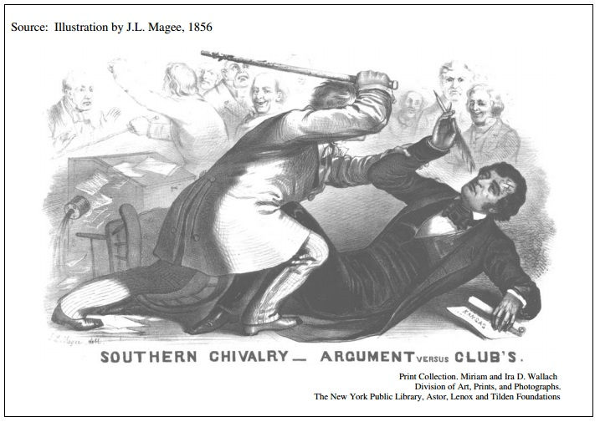

Document 6
Source: Muscogee, Georgia, Herald, quoted in the New York Tribune, September 10, 1856

Free society! We sicken at the name. What is it but a conglomeration of greasy mechanics, filthy operatives, small-fisted farmers, and moon-struck theorists? All northern, and especially the New England, states are devoid of society fitted for well-bred southern gentlemen. The prevailing class one meets with is that of mechanics struggling to be genteel, and small farmers who do their own drudgery, and yet are hardly fit for association with a southern gentleman's body servant.

Document 7
Source: Abraham Lincoln, speech at Alton, Illinois, October 15, 1858

You may say . . . that all of this difficulty in regard to the institution of slavery is the mere agitation of office seekers and ambitious Northern politicians. . . . But is it true that all of the difficulty and agitation we have in regard to this institution of slavery springs from office seeking—from the mere ambition of politicians? . . . How many times have we had danger from this question? . . . [D]oes not this question make a disturbance outside of political circles? Does it not enter into the churches and rend them asunder?

. . . Is it not this same mighty, deep- seated power that somehow operates on the minds of men, exciting and stirring them up in every avenue of society—in politics, in religion, in literature, in morals, in all manifold relations in life? Is this the work of politicians?

Unit 5: Road the Civil War, the Civil War, and Reconstruction
DBQs
- (2013) #1: Evaluate the causes and consequences of the growing opposition to slavery in the United States from 1776 to 1856.

- (2009) #1: Evaluate the extent to which the expansion of slavery contributed to maintaining continuity as well as fostered change in the lives of African-Americans prior to the Civil War.

- (2009B) #1: Evaluate the changing role of African-Americans within American society from 1861 to 1870.

- (2005B) #1: Evaluate the extent to which sectional conflict from 1820 to 1860 contributed to maintaining continuity as well as fostering change in political ideals and attempts to compromise.

Long Essays
- (2016) #2: Evaluate the extent to which the ratification of the Fourteenth and Fifteenth Amendments to the Constitution marked a turning point in the history of United States politics and society. In the development of your argument, explain what changed and what stayed the same from the period immediately before the amendments to the period immediately following them. (Historical thinking skill: Periodization)

- (2015) #3: Evaluate the extent to which the Mexican-American War (1846–1848) marked a turning point in the debate over slavery in the United States, analyzing what changed and what stayed the same from the period before the war to the period after it.

- (2014) #3: Compare and contrast views of the role of the federal government and westward expansion between different regional political leaders from 1800 to 1848.

- (2014) #4: Evaluate the extent to which the goals of Reconstruction (1865 – 1877) regarding African Americans were achieved by 1900. Be sure to address both continuities as well as changes during this time period.

- (2012) #3: Evaluate the extent to which western expansion contributed to maintaining continuity as well as fostered change with regard to growing sectional tensions between the North and South in United States from 1800 to 1850.

- (2010) #3: Explain the ways in which the growth of slavery contributed to the coming of the Civil War from 1800 to 1860.

- (2006) #3: Explain the causes which led to a shift in political power as a result of the impact of the Civil War on the federal government from 1861 to 1877.

- (2004) #3: Evaluate the extent to which political compromise contributed to maintaining continuity as well as fostering change on sectional tensions in the period 1820 to 1861.

- (2003) #4: Evaluate the impact of the Civil War, politically and economically, in different regions of the United States.

- (2002B) #2: Evaluate the main causes that lead to nationalism and sectionalism prior to the Civil War.
Unit 5: Road the Civil War, the Civil War, and Reconstruction
Short Answer Questions

This question is based on the following two passages.

“President James K. Polk manufactured the war with Mexico. Some North Americans opposed the war—not on the ground that it violated Mexico’s territorial integrity, but because of the probability of the extension of slavery. Many North American military leaders admitted that the war was unjust, and that the United States had committed an act of aggression. However, patriotism and support for the war overwhelmed reason in the march ‘To the Hall of the Montezumas [sic].’ North Americans, buoyant in their prosperity, wanted to prove that the United States was a world-class power.”
Rodolfo Acuna, Occupied America, A History of Chicanos,1988

“Polk and his advisors developed their Mexican polices on the dual assumption that Mexico was weak and that the acquisition of certain Mexican territories would satisfy admirably the long-range interests of the United States. Within that context, Polk’s policies were direct, timely, and successful.…Polk’s persistence led him and the country to war. Like all escalation in the exertions of force, his decision responded less to unwanted and unanticipated resistance than to the requirements of the clearly perceived and inflexible purposes which guided the administration. What perpetuated the president’s escalation to the point of war was his determination to pursue goals to the end whose achievement lay outside the possibilities of successful negotiations. Senator Thomas Hart Benton of Missouri saw this situation when he wrote: ‘It is impossible to conceive of an administration less warlike, or more intriguing, than that of Mr. Polk. They were men of peace, with objects to be accomplished by means of war; so that war was a necessity and indispensability to their purpose.’…What the Mexican War revealed in equal measure is the simple fact that only those countries which have achieved their destiny, whatever that may be, can afford to extol the virtues of peaceful change.”
Norman A. Graebner, “The Mexican War: A Study in Causation,” 1980

- Based on the two interpretations above of the origins of the Mexican-American War, complete the following three tasks: (SurvivalGuide-SAQ)
  - Briefly explain ONE major difference between Acuna’s and Graebner’s historical interpretations of the debates over origins of the Mexican-American War in the 1840s.
  - Briefly explain how ONE development in the 1840s or 1850s not directly mentioned in the passages supports Acuna’s argument.
  - Briefly explain how ONE development in the 1840s or 1850s not directly mentioned in the passages supports Graebner’s argument.

- Answer parts A, B, and C. (SurvivalGuide-SAQ)
  - Briefly explain why ONE of the following developments was the most significant factor contributing to the outbreak of the Civil War.
    - The Compromise of 1850
    - The Dred Scott Decision
    - The Presidential Election of 1860
  - Provide ONE piece of evidence to support your choice in Part A.
  - Contrast your choice in Part A against one of the other options, demonstrating why that option is not as good as your choice.

This question is based on the 1856 political cartoon below.
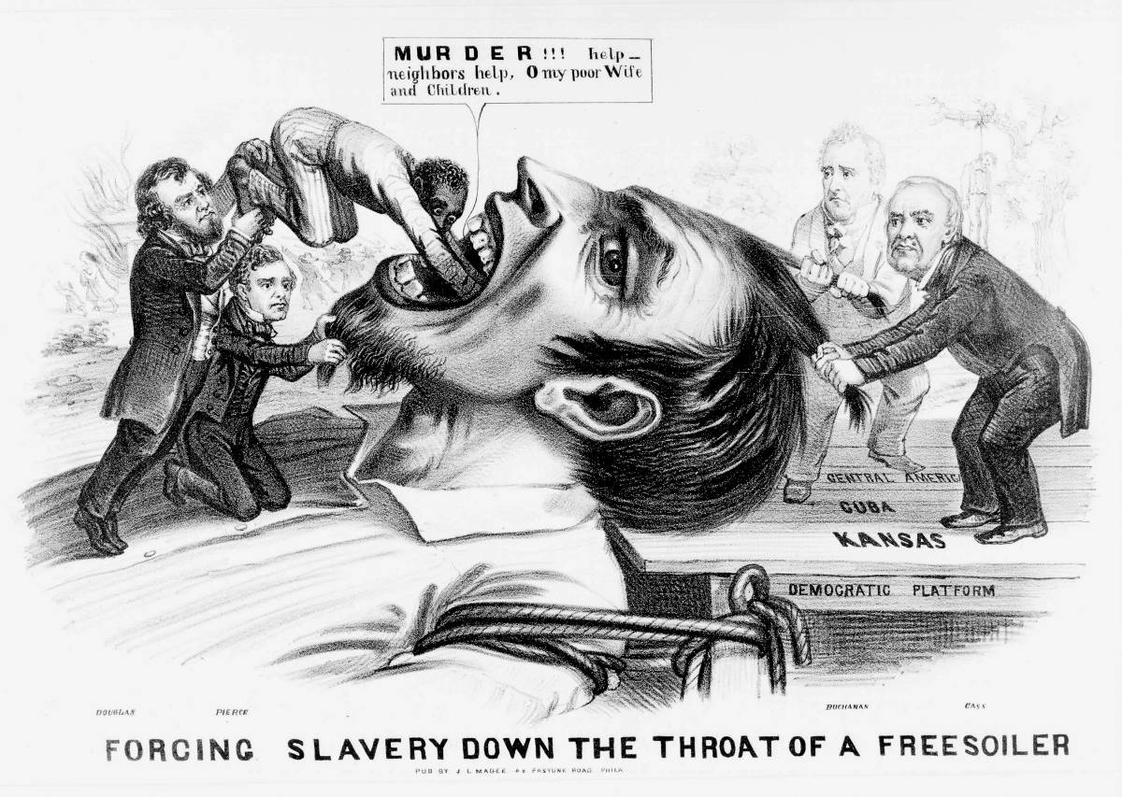
- Use the image above and your knowledge of United States history to answer parts A, B, and C. (SurvivalGuide-SAQ)
  - Briefly explain the point of view expressed by the cartoonist about ONE of the following:
    - Territorial Expansion
    - States’ Rights
    - Attempts at Political Compromise
  - Briefly explain ONE development from the period 1844 to 1856 that led to the point of view expressed by the cartoonist.
  - Briefly explain ONE way in which developments in the period following 1844 challenged or supported the view expressed by the cartoonist.

- Answer a, b, and c. (ExamDescription)
  - Briefly explain why ONE of the following options most clearly marks the beginning of the sectional crisis that led to the outbreak of the Civil War.
    - Northwest Ordinance (1787)
    - Missouri Compromise (1820)
    - Acquisition of Mexican territory (1848)
  - Provide an example of an event or development to support your explanation.
  - Briefly explain why one of the other options is not as useful to mark the beginning of the sectional crisis.

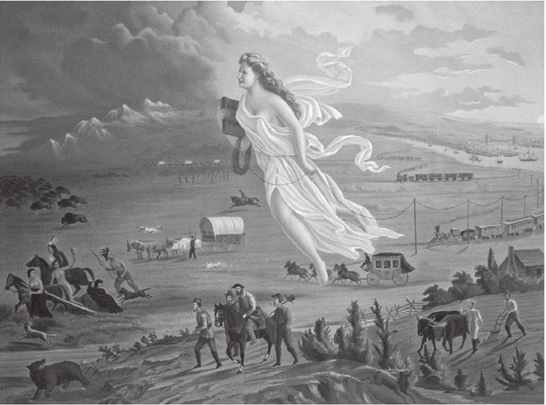
- Use the image above and your knowledge of United States history to answer parts A, B, and C. (APUSHSample)
  - Explain the point of view reflected in the image regarding ONE of the following:

    - Migration
    - Technology
    - American Indians

  - Explain how ONE element of the image expresses the point of view you identified in Part A.
  - Explain how the point of view you identified in Part A helped to shape ONE specific United States government action between 1845 and 1900.

- Answer a, b, and c. (AMSCO11)
  - Briefly explain why ONE of the following best supports the view that by the mid-19th century, the antislavery movement had gradually become more radical

    - American Colonization
    - The Liberator
    - Nat Turner

  - Contrast your choice against ONE of the other options demonstrating why that option is not as good as your choice.
  - Briefly explain ONE critical response to the changes during this period.

- Answer a, b, and c. (AMSCO12)
  - Briefly explain why ONE of the following best supports the view that a belief in a manifest destiny played a decisive role in U.S. politics and policies during the 1840s.

    - Annexation of Texas
    - “Fifty-four Forty or Fight!”
    - Mexican Cession

  - Contrast your choice against ONE of the other options demonstrating why that option is not as good as your choice.
  - Briefly explain ONE criticism of this belief in manifest destiny during the 1840s.
- Answer a, b, and c. (AMSCO13)
  - Briefly explain why ONE of the following best supports the view that the enforcement of a new Fugitive Slave Law in the 1850s resulted in strong and varied reactions in the North.
    - Formation of the Republican Party
    - Publication of Uncle Tom’s Cabin
    - Creation of the Underground Railroad
  - Contrast your choice against ONE of the other options demonstrating why that option is not as good as your choice.
  - Briefly explain ONE critical response to the changes during this period.

- Answer parts A, B, and C. (SurvivalGuide-SAQ)
  - Briefly explain ONE important way in which the Emancipation Proclamation changed social relations in the United States.
  - Briefly explain ONE important way in which the Emancipation Proclamation impacted the outcome of the Civil War.
  - Briefly explain ONE important way in which the Emancipation Proclamation had little to no impact upon EITHER social relations in the United States OR the outcome of the Civil War.

"The statistics of crime demonstrate that the moral superiority of the slave over the free laborer is still greater than his superiority in animal well-being. There never can be among slaves a class so degraded as is found about the wharves and suburbs of cities. The master requires and enforces ordinary morality and industry...
"The free laborer rarely has a house and home of his own; he is insecure of employment; sickness may overtake him at any time and deprive him of the means of support; old age is certain to overtake him, if he lives, and generally finds him without the means of subsistence; his family is probably increasing in numbers, and is helpless and burdensome to him."
-George Fitzhugh, lawyer, Sociology of the South, 1854

"You relied on the constitution. It has not the word slave in it; and very good argument has shown that it would not warrant the crimes that are done under it...
"For one would have said that a Christian would not keep slaves;—but the Christians keep slaves. Of course they will not dare to read the Bible? Won’t they? They quote the Bible, quote Paul, quote Christ, to justify slavery. If slavery is good, then is lying, theft, arson, homicide, each and all good, and to be maintained by Union societies?"
"These things show that no forms, neither constitutions, nor laws, nor covenants, nor churches, nor bibles, are of any use in themselves. The Devil nestles comfortably into them all. There is no help but in the head and heart and hamstrings of a man."
-Ralph Waldo Emerson, lecturer and author, speech on the Fugitive Slave Law, 1854
- Using the excerpts, answer a, b, and c. (AMSCO13)
  - Briefly explain the main point of the excerpt by Fitzhugh
  - Briefly explain the main point of the excerpt by Emerson
  - Provide ONE piece of evidence from the period of 1830 to 1860 that is not included in the excerpts and explain how it supports the interpretation in either excerpt.
- Answer a, b, and c. (AMSCO15)
  - Briefly explain the significance of ONE of the following during Reconstruction in the South during this period.

    - Scalawags
    - Carpetbaggers
    - African American legislators

  - Briefly explain the effects of ONE of the following on African Americans in the South during Reconstruction.

    - Black Codes
    - Sharecropping
    - Ku Klux Klan

  - Briefly explain the impact of the impeachment of Andrew Johnson on Reconstruction

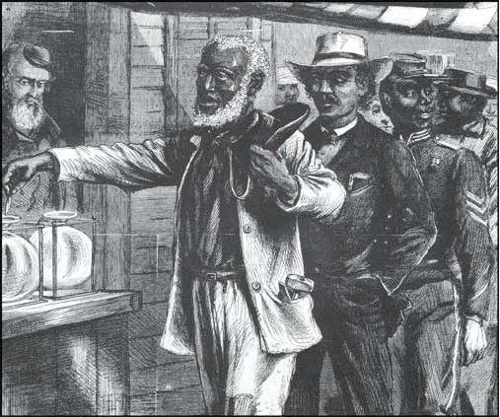
- Use the image above to answer parts a, b, and c. (APUSH2014)
  - Briefly explain the point of view expressed through the image about ONE of the following.
    - Emancipation
    - Citizenship
    - Political participation
  - Briefly explain ONE outcome of the Civil War that led to the historical change depicted in the image.
  - Briefly explain ONE way in which the historical change you explained in part b was challenged in the period between 1866 and 1896.

"It is apparent to my mind that the President thoroughly believed the tenure-of-office act to be unconstitutional and void. He was so advised by every member of his cabinet...
"This was a punitive statute. It was directed against the President alone. It interfered with the prerogatives of his department as recognized from the foundation of the Government.... This Government can only be preserved and the liberty of the people maintained by preserving intact the co-ordinate branches of it-legislative, executive, judicial—alike. I am no convert to any doctrine of the omnipotence of Congress.
"I cannot agree to destroy the...Constitution for the sake of getting rid of an Unacceptable President."
-Senator James W. Grimes, Iowa, statement on the trial of Andrew Johnson, 1868.

"This is one of the last great battles with slavery... this monstrous power has found a refuge in the Executive Mansion... Andrew Johnson is the impersonation of the tyrannical slave power...
"The veto power conferred by the Constitution ...was turned by him into a weapon of offence against Congress....Laws enacted by Congress for the benefit of the colored race, including... the Freedmen's Bureau, and....Civil Rights, were first attacked by his veto... he boldly attempted to prevent the adoption of a constitutional amendment, by which the right of citizens and the national debt were placed under the guarantee of irrepealable law. "
-Senator Charles Sumner, Massachusetts, statement on the trial of Andrew Johnson, Congressional Globe, 1868
- Using the excerpt, answer a, b, and c. (AMSCO15)
  - Briefly explain the main point of Excerpt 1.
  - Briefly explain the main point of Excerpt 2.
  - Provide ONE piece of evidence from the period 1865 to 1868 that is not included in the excerpts and explain how it supports the interpretation in either excerpt.
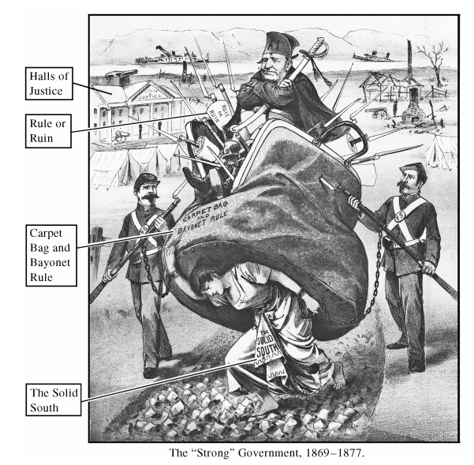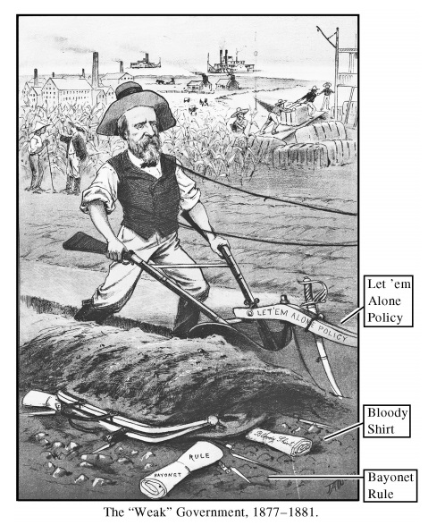

- Using the two images, both by artist James Wales, answer (a), (b), and (c). (APUSH2017)
  - Briefly explain ONE historical perspective expressed by the artist about the changes from the period 1869–1877 to the period 1877–1881.
  - Briefly explain how ONE specific event or development led to a historical change suggested by the images.
  - Briefly explain ONE specific result in the period 1877–1900 of a historical change suggested by the images.

