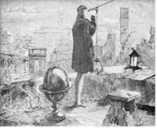 | THE HISTORY HERALD  August 25th, 2025  9th World History  MrDuncansHistoryClass.com | 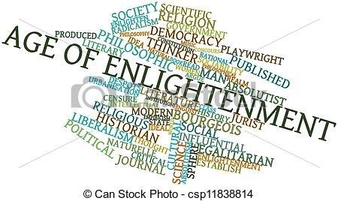

THIS WEEK  FUTURE ASSIGNMENT IS BELOW!!  DO NOT MISS IT  Mon 25th Peter the Great Lecture Pg 22-23  Tues 26th Scientific Revolution Chapter 17 Online  Wed 27th EXAM Chapter One Absolutism  Thurs 28th Scientific Revolution Chapter 17 Online  Fri 29th Scientific Revolution Chapter 17 Online  NEXT WEEK  Mon 1st NO SCHOOL  Tues 2nd Enlightenment Chap 2 Sec 1 pg 29-36  Wed 3rd Enlightenment Chap 2 Sec 1  Thurs 4th Enlightenment Chap 2 Sec 2 Enlightened Absolutism pg 48-54  Fri 5th Enlightenment Chap 2 Sec 2 Enlightened Absolutism pg 48-54  ASSIGNMENT: DUE on SEPT 10th  You must turn in on a 3 x 5 Note Card for all the vocabulary in the Right Hand Column Chapter 17 and 2 ( both sides of the History Herald). On one side of the 3 x 5 notecard you must write the word and on the back side a complete definition. Some of the words are an author/composer and their work, these may be combined. This will count as an extra exam grade and NO LATE CARDS will be accepted. I would do a few EVERY DAY  Chapter Summary  Finally, in the seventeenth century man attempted to bring order to the universe through scientific inquiry and the use of reason.  The eighteenth century stands as the turning point in world history, as the power of the old order diminished and revolution ushered in a new age. The century began with power in the hands of nobles, monarchs and clerics. Large-scale war demanded increasingly large armies with the subsequent need for higher taxes to fund them. In addition, growing populations and fundamental changes in economics began to reduce the power and importance of the old order. New world wars allowed Great Britain to create a world wide empire backed by the greatest navy. Increasing economic pressures helped to spawn a revolutionary movement that surged to the surface in the Western Hemisphere and in France. The movement demanded political liberty and equality –key concepts of the Enlightenment. While limited in reality, opportunities for most people were increased, and government became more responsive to the desires of its citizens.  Chapter Outline  The Scientific Revolution  Toward a New Heaven: A Revolution in Astronomy  Women in the Origins of Modern Science  Toward New Earth: Descartes and Rationalism  The Spread of Scientific Knowledge  Europe, China, and Scientific Revolutions  Enlightenment  Paths to Enlightenment  Newton and Locke  Philosophes and Their Ideas  Montesquieu  Voltaire  Diderot  Toward a New "Science of Man"  Later Enlightenment  The "Woman Question" in the Enlightenment  Culture in an Enlightenment Age  Music  High Culture  Popular Culture  Economic Changes and the Social Order  New Economic Patterns  European Society in the Eighteenth Century  Changing Patterns of War: Global Confrontation  The Seven Years’ War: A Global War  Colonial Empires and Revolution in the Western Hemisphere  The Society of Latin America  The Economic Foundations  The State and the Church in Colonial Latin America  British North America  The American Revolution  Birth of a New Nation  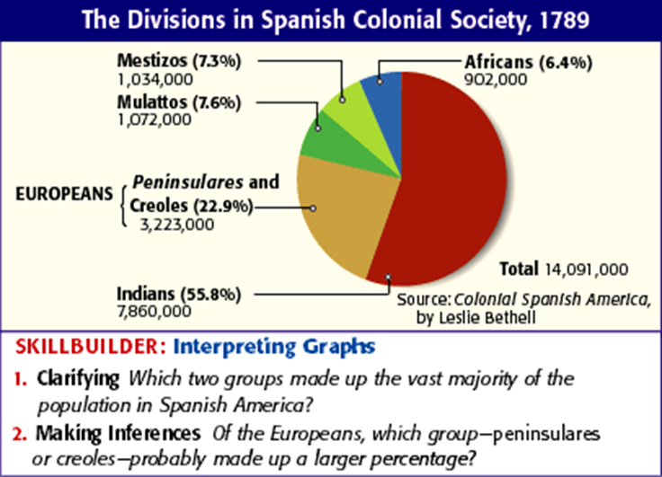 | Science (chap 17 online) and Chap 2 New Book  You MAY combine Cards of Similar Material  Scientific Revolution  new instruments  mathematics  Ptolemaic conception of the universe  Nicolaus Copernicus  On the Revolutions of the Heavenly Spheres  heliocentric conception of the universe  Johannes Kepler  humanist education for women  female scientists  Margaret Cavendish  Maria Winkelmann  René Descartes  Discourse on Method  Isaac Newton  Principia  three laws of motion  universal law of gravitation  Newtonian mechanistic concept  Galileo Galilei  The Starry Messenger  Blaise Pascal  Francis Bacon  The Enlightenment  Immanuel Kant  reason  Bernard de Fontenelle  skepticism  travel literature  John Locke  Essay Concerning Human Understanding  tabula rasa  philosophes  Baron de Montesquieu  The Spirit of the Laws  Voltaire  Treatise on Toleration  deism  Diderot  Encyclopedia  "science of man"  Physiocrats  laissez-faire  Adam Smith  The Wealth of Nations  Jean-Jacques Rousseau  Discourse on the Origins of the Inequality of Mankind  The Social Contract  Emile  "natural" inferiority  Mary Astell  A Serious Proposal to the Ladies  Mary Wollstonecraft  Vindication of the Rights of Woman  salons  Marie-Thérèse de Geoffrin  learned and secret societies  Rococo art  Antoine Watteau  Baroque-Rococo architectural style  Balthasar Neumann  Baroque musical style  Johann Sebastian Bach  George Frederick Handel  Classical musical style  Franz Joseph Haydn  Fireworks Music  oratorios  Wolfgang Amadeus Mozart  operas  English novel  Samuel Richardson  Henry Fielding  The History of Tom Jones, a Foundling  high culture  publishing  popular culture  Carnival  population growth  food  cottage industry  Richard Arkwright  global economy  NOTE CARDS STOP  MORE of Chapter 2  Seven Years' War  Great War for Empire  Treaty of Paris  French and British rivalry in North America  mercantilist theory  Gulf of St. Lawrence  Ohio River valley  William Pitt the Elder  General James Wolfe  Louis-Joseph Montcalm  Treaty of Paris  armies  navies  Portuguese colonial empire  Spanish colonial empire  Latin America  repartimento  mestizos  haciendas and fazendas  asiento  viceroy  viceroyalties  cabildo  Spanish Bourbon kings  missions  Catholicism in Latin America  Sor Juana Inés de la Cruz  British North America  Parliament  Hanoverians  Stamp Act  voters  representation  national identity  First Continental Congress  Lexington and Concord  Second Continental Congress  Declaration of Independence  Thomas Jefferson  Continental Army  George Washington  French, Spanish, Dutch, and Russian support of colonies  Cornwallis  Treaty of Paris  Articles of Confederation  Constitution  "checks and balances"  three branches of federal government  Federalists  Bill of Rights  natural laws  natural rights

