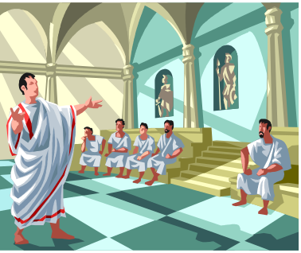 | THE GOVERNMENT GAZETTE  January 9th, 2024  Darrell.Duncan@Sumnerschools.org  www.MrDuncansHistoryClass.com | 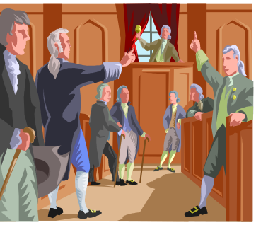

GOOGLE CLASSROOM CODE 2ecbpmu  The First Week  Monday 9th NO School  Tuesday 10th Syllabus and Intro/ Sign in Google Class  Wednesday 11th Intro to Democaracy  Thursday 12th Intro and Chap 1 pg 2-9  Friday 13th Packet Due Writings and Articles  Locke/Montesquieu/Rousseau – Come Prepared  DUE: http://www.politicalcompass.org/test  Take this quiz and see where you rate – print your  results and bring them to class with you  DUE on FRIDAY: http://www.politicalcompass.org/test  Take this quiz and see where you rate – print your  results and bring them to class with you  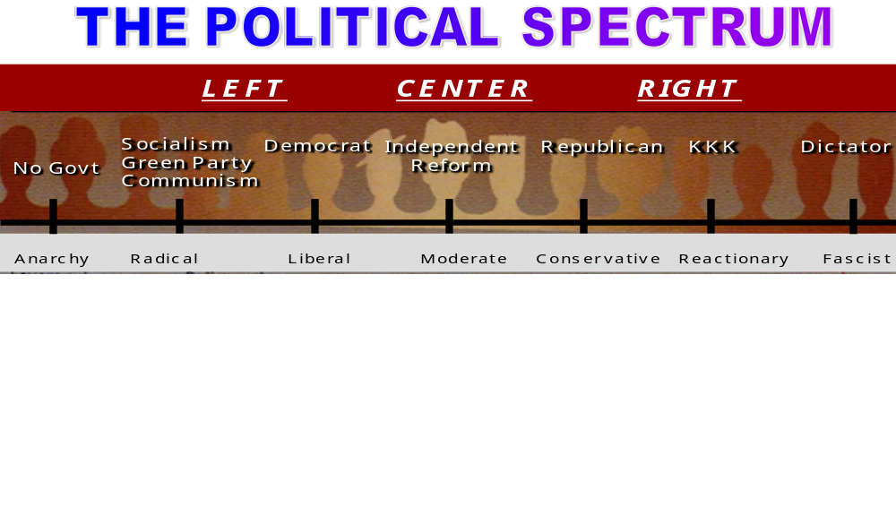  Lecture Objectives:  - Briefly describe several forms of government (totalitarianism, authoritarian regime, aristocracy, democracy).  - Understand the difference between direct democracy on the one hand and a democratic republic (or a representative democracy) on the other.  - Describe competing theories of how the U.S. democracy works (majoritarianism, elite theories, and pluralism).  - Describe the trade-off between order or security and liberty, and between equality and liberty (in the form of property).  - Define the concept of ideology and explain the dominant ideologies in the U.S. (liberalism and conservatism).  - Distinguish between economic liberalism and conservatism and cultural liberalism and conservatism.  - Provide some distinguishing characteristics of selected totalitarian ideologies, specifically communism fascism, and radical Islamism. | Lecture words  Totalitarian Regime  Authoritarianism  Aristocracy  Democracy  Direct Democracy  Legislature  Republic  Democratic Republic  Representative Democracy  Political Socialization  Conservatism  Liberalism  Socialism  Libertarianism  Communism  Fascism  Popular Sovereignty  Chapter 1  Government 7  Collective goods 7  Politics 8  Political participation 8  Single-issue groups 9  Policymaking system 9  Linkage institutions 10  Policy agenda 10  Political issue 11  Policymaking institutions 11  Public policy 11  Policy impacts 12  Democracy 12  Majority rule 13  Minority rights 13  Representation 13  Pluralism 13  Elitism 14  Hyperpluralism 14  Policy gridlock 16  Political culture 16  Gross domestic product 20
Chapter 1 Overview
A. Learning Objectives
􀂾1.1 Describe the key functions of government and explain why they matter
􀂾1.2 Define the various aspects of politics
􀂾1.3 Assess how citizens can have an impact on public policy and how policies can impact people
􀂾1.4 List the key principles of democracy, theories regarding how it works in practice, and challenges it faces today
􀂾1.5 Explain the debate in America over the proper scope of government

What is the definition and difference between a Liberal and a Conservative?

What is the definition of a Moderate?

What is the difference between a Radical and a Reactionary?

Can you give an example of Anarchy? Historical or Present Day

Can you give several examples of Fascist or a Dictator? Historical and Present Day

 | THE GOVERNMENT GAZETTE  January 16th, 2023  Darrell.Duncan@Sumnerschools.org  www.MrDuncansHistoryClass.com |  | 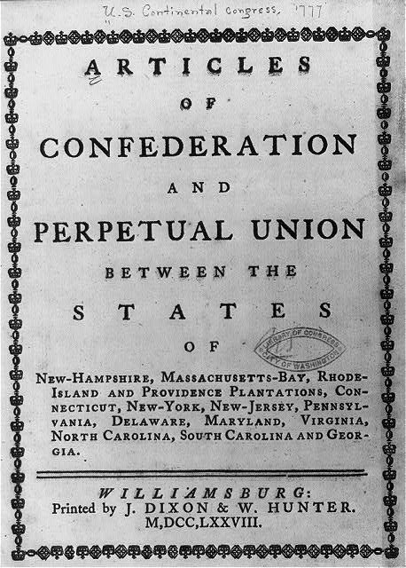
NEXT WEEK -  Monday 16th NO SCHOOL  Tuesday 17th Chap 1pg 9-15 Reading Quiz (pg 2-15)  Wednesday 18th Chap 1 pg 15- 23 Political Spectrum  Thursday 19th Chap 2 pg 24 – 30  Outside Reading ( Declaration of Independence)  Friday 20th Chap 2 30 - 37  Catch up and Current Events DUE  Chapter 1 Test will be online – open Friday Jan 20th at 4pm to Sunday night Jan 21st at 12 ( Midnight) For this first test you will be given TWO opportunities to take it and it will record the BEST SCORE. It will contain vocabulary, multiple choice, and short answer.  Monday 22nd Chap 2 pg 38 - 44  Outside Reading ( Federalist Papers #10)  Tues 18th Chap 2 pg 44 – 57  Wed 19^{h} Chap 2 Finish Lecture and Discussion  Outside Reading ( Brutus 1)  CHAPTER TWO EXAM IS Monday JAN 29th  Weaknesses of the AOC Strengths of the CON  THE GREAT COMPRIMISE  Virginia Plan New Jersey Plan  CONNECICUT COMPROMISE  Who:  What:  Chapter 2: LEARNING OBJECTIVES  A. Learning Objectives  2.1 Explain the ideas behind the American Revolution and how these ideas shaped the Constitution  2.2 Identify the causes of the failure of the Articles of Confederation  􀂾2.3 2.3 Describe the delegates to the Constitutional Convention and the core  ideas they shared  􀂾2.4 2.4 Identify three types of issues the delegates to the Constitutional  Convention confronted and how the Constitution resolved these issues  2.5 Explain the Madisonian system and how it addressed the dilemma of reconciling majority rule with the protection of minority interests  2.6 Contrast the Federalists and Anti-Federalists in terms of their background and their positions regarding government  2.7 Explain the various routes to formal amendment of the Constitution and how the Constitution changes informally  2.8 Explain whether the Constitution establishes a majoritarian democracy  and how it limits the scope of government |  | Chapter 2  THEMES in Chap 2  Origins in American Government  Our political beginnings  Coming Independence  Critical Period  Creating the Constitution  Ratifying the Constitution  WORD LIST  Lecture and Chapter  Representative Assembly  Mayflower Compact  Fundamental Orders of Connecticut  First Continental Congress  Second Continental Congress  Thomas Paine and Common Sense  Declaration of Independence 27  Natural Rights 28  Social Contract  Consent of the Governed 28  Unicameral Legislature  Confederation  State  Articles of Confederation  (AOC) 30  Accomplishments under the AOC  Weaknesses of the AOC  Shays Rebellion 33  Factions Among the Delegates  Constitution 26  Virginia Plan 35  New Jersey Plan 35  Bicameral Legislature  Connecticut Compromise 37  The “Great” Compromise  Supremacy Doctrine  The 3/5 Compromise  Limited Government 28  Writ of Habeas Corpus 39  Separation of Powers 41  Madisonian model  Checks and Balances 42  Republic 43  Electoral College  Federal System  Ratification  US Constitution 34  Factions 34  Federalist 44  Federalist Papers 44  Anti Federalist 44  Beard’s Theory  Bill of Rights 45  Amending the Constitution  Equal Rights Amendment  (ERA) 48  Executive Agreement  Judicial Review 50  Marbury v Madison 50
  WHO:  WHAT: | WHO:  WHAT:

Name: __________________________________

1. Define the word: Government
(Think about your word choice and put some effort into this!
You are at an academic High School you know?!)

2. Get with a partner and synthesize your definitions (two heads are better than one)

3. Get with a group ( 4 to 5ish ) and chose the best definition from the group by
voting on it. You may not reword it. You must chose the best AS WRITTEN.

4. Elect a Representative from your group (it does not have to be the one whose definition you voted on) to go to the Center Chairs and they will now from those definitions write a definition of the word: Government

5. While they are doing this, go check out your text book from the library and start
reading and working on your word list for Chapter 1.

