Table of Contents for AP European History DBQs

DBQ Topics | Pages Numbers
The Poor of the 16th and 17th Centuries | 2-4
The Reformation | 5-7
The Thirty Years’ War | 8-12
Scientific Revolution | 13-15
The Glorious Revolution | 16-19
The Renaissance and the Enlightenment | 20-24
Enlightened Despots | 25-28
French Revolution | 29-34
Bismarck and German Nationalism | 35-40
The Industrial Revolution | 41-43
The New Imperialism | 44-47
Women | 48-53
The Arts | 54-58
Causes of World War I | 59-62

Question 1: The Poor of the 16th and 17th Centuries

Directions: It is suggested that you spend 10 minutes reading the documents and 35 minutes writing your response.

Note: You may begin writing your response before the reading period is over.

Question 1 is based on the accompanying documents. The documents have been edited for the purpose of this exercise.

In your response you should do the following.

- Respond to the prompt with a historically defensible thesis or claim that establishes a line of reasoning.
- Describe a broader historical context relevant to the prompt.
- Support an argument in response to the prompt using at least two and/or four documents.
- Uses the content of at least two documents to address the topic of the prompt.
- Use at least one and/or two additional pieces of specific historical evidence (beyond that found in the documents) relevant to an argument about the prompt.
- For at least one and/or two documents, explain how or why the document’s point of view, purpose, historical situation, and/or audience is relevant to an argument.
- Use evidence to corroborate, qualify, or modify an argument that addresses the prompt.

Evaluate the extent to which the attitudes toward the poor in Europe changed between 1450 and 1700.

Document 1
Source: Juan Luis Vives, Spanish humanist, On Assistance to the Poor, Bruges, Spanish Netherlands, 1526
When the general funds have been expended, those without means of subsistence are driven to robbery in the cities and on the highways; others commit theft stealthily. Women of eligible age put modesty aside, and, no longer holding to chastity, put it on sale. Old women run brothels and take up sorcery. Children of the needy receive a deplorable upbringing. Together with their offspring, the poor are shut out of churches and wander over the land. We do not know by what law the poor live, nor what their practices or beliefs are.
Some know that they have a duty of charity to the poor, yet they do not perform what has been commanded. Others are repelled by the unworthiness of the applicants. Still others withdraw because their good intention is embarrassed by the great number, and they are uncertain where first or most effectively top bestow their money.

Document 2

Source: Town council, meeting minutes, Rouen, France 1542
-Those unwilling to work should indeed be expelled from the city, but those who are unable to find work should not be treated thus. Instead they should be put to work on sites in the city in exchange for food until such time they succeed in finding work in their trades.
-Idleness is harmful to the public good and should not be tolerated. Idlers should not be considered poor.
-Before expelling the poor from the city we must consider whether our defensive capacity would not suffer from such a measure. After all, it is the people, and not the judges and councilors, who will fight when the need arises.

Document 3

Source: Poorhouse regulations, Suffolk county, England, 1588
Every strong rogue, at his or her first entrance into the house, shall have 12 stripes with the whip on bare skin and every young rogue or idle loiterer shall have 6 stripes in the same manner. All unruly or stubborn persons shall be corrected oftener and given heavier shackles, a thinner diet, and harder labor until they are brought to reasonable obedience and submission to the master of the poorhouse.
Document 4

Source: Cardinal Richelieu, royal councilor, unofficial statement on poverty, France, 1625
Instead of working as they should to earn a living, vagabonds and good-for-nothings have turned to begging, taking the bread from the sick and deserving poor to whom it is due. We desire that in every town in our kingdom rules and regulations for the poor should be established, so that not only those of the said town but of the neighboring areas should be confined and fed, and those who are able to do so should be employed on public works.

Document 5

Source: Rembrandt van Rijn, Beggars Receiving Alms at the Door of a House, 1648
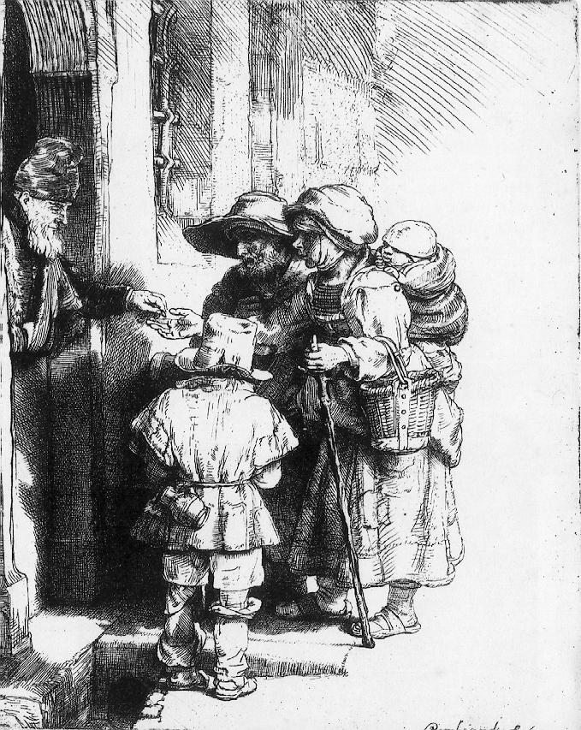

Question 2: The Reformation

Directions: It is suggested that you spend 10 minutes reading the documents and 35 minutes writing your response.

Note: You may begin writing your response before the reading period is over.

Question 2 is based on the accompanying documents. The documents have been edited for the purpose of this exercise.

In your response you should do the following.

- Respond to the prompt with a historically defensible thesis or claim that establishes a line of reasoning.
- Describe a broader historical context relevant to the prompt.
- Support an argument in response to the prompt using at least two and/or four documents.
- Uses the content of at least two documents to address the topic of the prompt.
- Use at least one and/or two additional pieces of specific historical evidence (beyond that found in the documents) relevant to an argument about the prompt.
- For at least one and/or two documents, explain how or why the document’s point of view, purpose, historical situation, and/or audience is relevant to an argument.
- Use evidence to corroborate, qualify, or modify an argument that addresses the prompt.

Evaluate the extent to which the Reformation affected traditional authority during the 16th century.

Document 1

Source: Martin Luther's reply when summoned to appear before the Emperor at the Diet of Worms 1521
"I cannot submit my faith either to the Pope or to the Councils, because it is clear as day they have frequently erred and contradicted each other. Unless therefore, I am convinced by the testimony of Scripture...I cannot and will not retract...Here I stand, I can do no other. So help my God, Amen."

Document 2

Source: An Abomination of Peace (1525), Martin Luther
We have no one on earth to thank for this mischievous rebellion, except you lords and princes, especially you blind bishops and mad priests and monks....In your government you do nothing but flay and rob your subjects in order that you may lead a life of splendor and pride, until the poor common folk can bear it no longer.

Document 3

Source: The Act in Restraint of Appeals Made by English Parliament (1533)
“England is an empire governed by one supreme King who has the power of an imperial crown. Through his government the King has the following of people who owe him humble obedience second only to their obedience to God. Just as importantly, the King is given his power, importance, authority, and the right to render justice within his realm by Almighty God himself. From now on when any cause of the divine law happens to come in question or of spiritual learning, it will be interpreted by the English Church, without the intermeddling of any exterior person or persons, such as the Pope.”

Document 4

Source: Henry VIII's Act of Supremacy (1534)
“The King's Majesty justly and rightfully is and ought to be the supreme head of the Church of England, and so is recognized by the clergy of this realm. By the authority of this Parliament, the king, his heirs and successors, shall be taken, accepted, and reputed the only supreme head in earth of the Church of England, called Anglicans Ecclesia. “

Document 5

Source: Depicts the use of the printing press, invented by Johannes Gutenberg. Allowing the spread of Reformation literature.
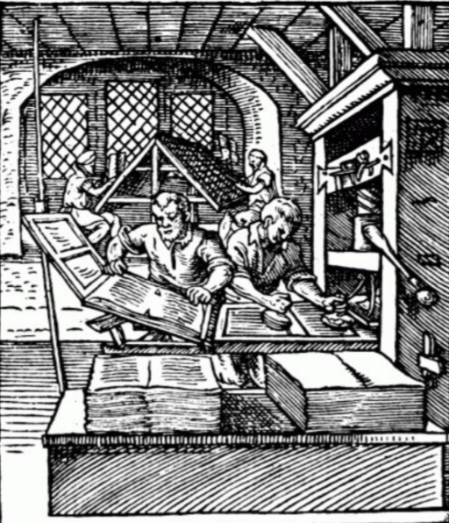

Question 3: The Thirty Years’ War

Directions: It is suggested that you spend 10 minutes reading the documents and 35 minutes writing your response.

Note: You may begin writing your response before the reading period is over.

Question 3 is based on the accompanying documents. The documents have been edited for the purpose of this exercise.

In your response you should do the following.

- Respond to the prompt with a historically defensible thesis or claim that establishes a line of reasoning.
- Describe a broader historical context relevant to the prompt.
- Support an argument in response to the prompt using at least two and/or four documents.
- Uses the content of at least two documents to address the topic of the prompt.
- Use at least one and/or two additional pieces of specific historical evidence (beyond that found in the documents) relevant to an argument about the prompt.
- For at least one and/or two documents, explain how or why the document’s point of view, purpose, historical situation, and/or audience is relevant to an argument.
- Use evidence to corroborate, qualify, or modify an argument that addresses the prompt.

Evaluate whether the Thirty Years’ War was fought primarily for religious or primarily for political reasons.

Document 1
Source: Holy Roman Emperor Matthias, open letter to his Protestant subjects in Bohemia, 1618

It has been alleged that the free exercise of religion will be abolished. We want to make it clear to you through this open letter that we have no intention of rescinding the agreement between the religions, still less want anyone else to do this, despite what others in Bohemia may have said. Moreover, we have always intended, and still intend, to preserve all the Bohemian privileges, liberties, and treaties. Anyone who claims otherwise slanders us before God and the world. Rest assured, dear obedient, loyal, and true Bohemian subjects, and do not give credence to such falsehoods. We would like nothing more than to return in person to our royal throne and residence amongst our loyal and obedient subjects and inhabitants and clear up these misunderstandings with God’s help. However, we cannot come to our Bohemian territories at the moment, partly through poor health, but also pressure of other important affairs. Capable and prominent individuals will be appointed to clear up this misunderstanding. Since no enemy threatens us as ruler of Bohemia, there are no constitutional grounds to raise soldiers to defend the country, and thus no grounds for anyone, whoever, they might be, to use the territorial privileges, letters of majesty, ordinances, freedoms, or laws to justify arming.

Document 2

Source: Selections from the constitution of the Bohemian Federation, a coalition of nobles and city governments, 1619
Since the Almighty has also given his grace and blessing as this Confederation is solely in defense of religion, the territories have agreed that each and every one of their coreligionists should follow a Christian life according to the Calvinist teaching and faith, avoid and prevent sin, vice, public trouble, hypocrisy, in whatever form, and follow strictly the admonishments from the pulpit and the authorities. . . .
All churches in these united territories currently in Calvinist hands are to remain so in perpetuity. . . .
The free exercise of Calvinist religion is extended to every man and woman in all united territories and towns regardless as to whether they belong to the king or queen, permitting the construction of churches, schools, and cemeteries, and the appointment of Calvinist pastors and schoolteachers. Everyone shall be allowed to follow the old ceremonies of their Christian conscience in their own church. However, to ensure better unity and to prevent all kinds of difficulties and bitterness, there are to be no insults or personal attacks from the pulpit upon pain of removal from office. . . .
Should, contrary to hope, a king attempt anything contravening the religious concessions, unions, and this constitution, and thereby force the territories to take defensive measures, then all of these united kingdoms and provinces are released from their duty and cannot be subsequently held to account for any insults to the royal sovereignty and majesty.

Document 3
Source: Confidential account of a meeting between Axel Oxenstierna, Swedish high chancellor, and Sweden’s ally Brandenburg after the death of Gustavus Adolphus, 1633
Concerning the late Gustavus Adolphus’ intentions:
They were, in general, to disrupt the plans of the enemy, whose intentions with regards to the Baltic Sea are sufficiently well-known. His Majesty therefore intended to ensure the safety of his kingdom and the Baltic region, and liberate the oppressed lands [of Germany]; and thereafter to proceed according as events might develop: it was no part of his original intention to march as far into Germany as he did. He saw and clearly understood where that would lead, but the enemy and the circumstances compelled this. His majesty was there in person wherever the greatest danger was.

Document 4

Source: Jean Gagniere, “The elimination of heresy, and of rebellion, through the care of Cardinal Richelieu,” France, 1640. Richelieu, the chief minister of France, removes caterpillars representing Protestant Huguenots from the fleur-de-lis, the symbol of France, while the lion and eagle, representing Catholic Spain and Austria, are kept restrained by chains.
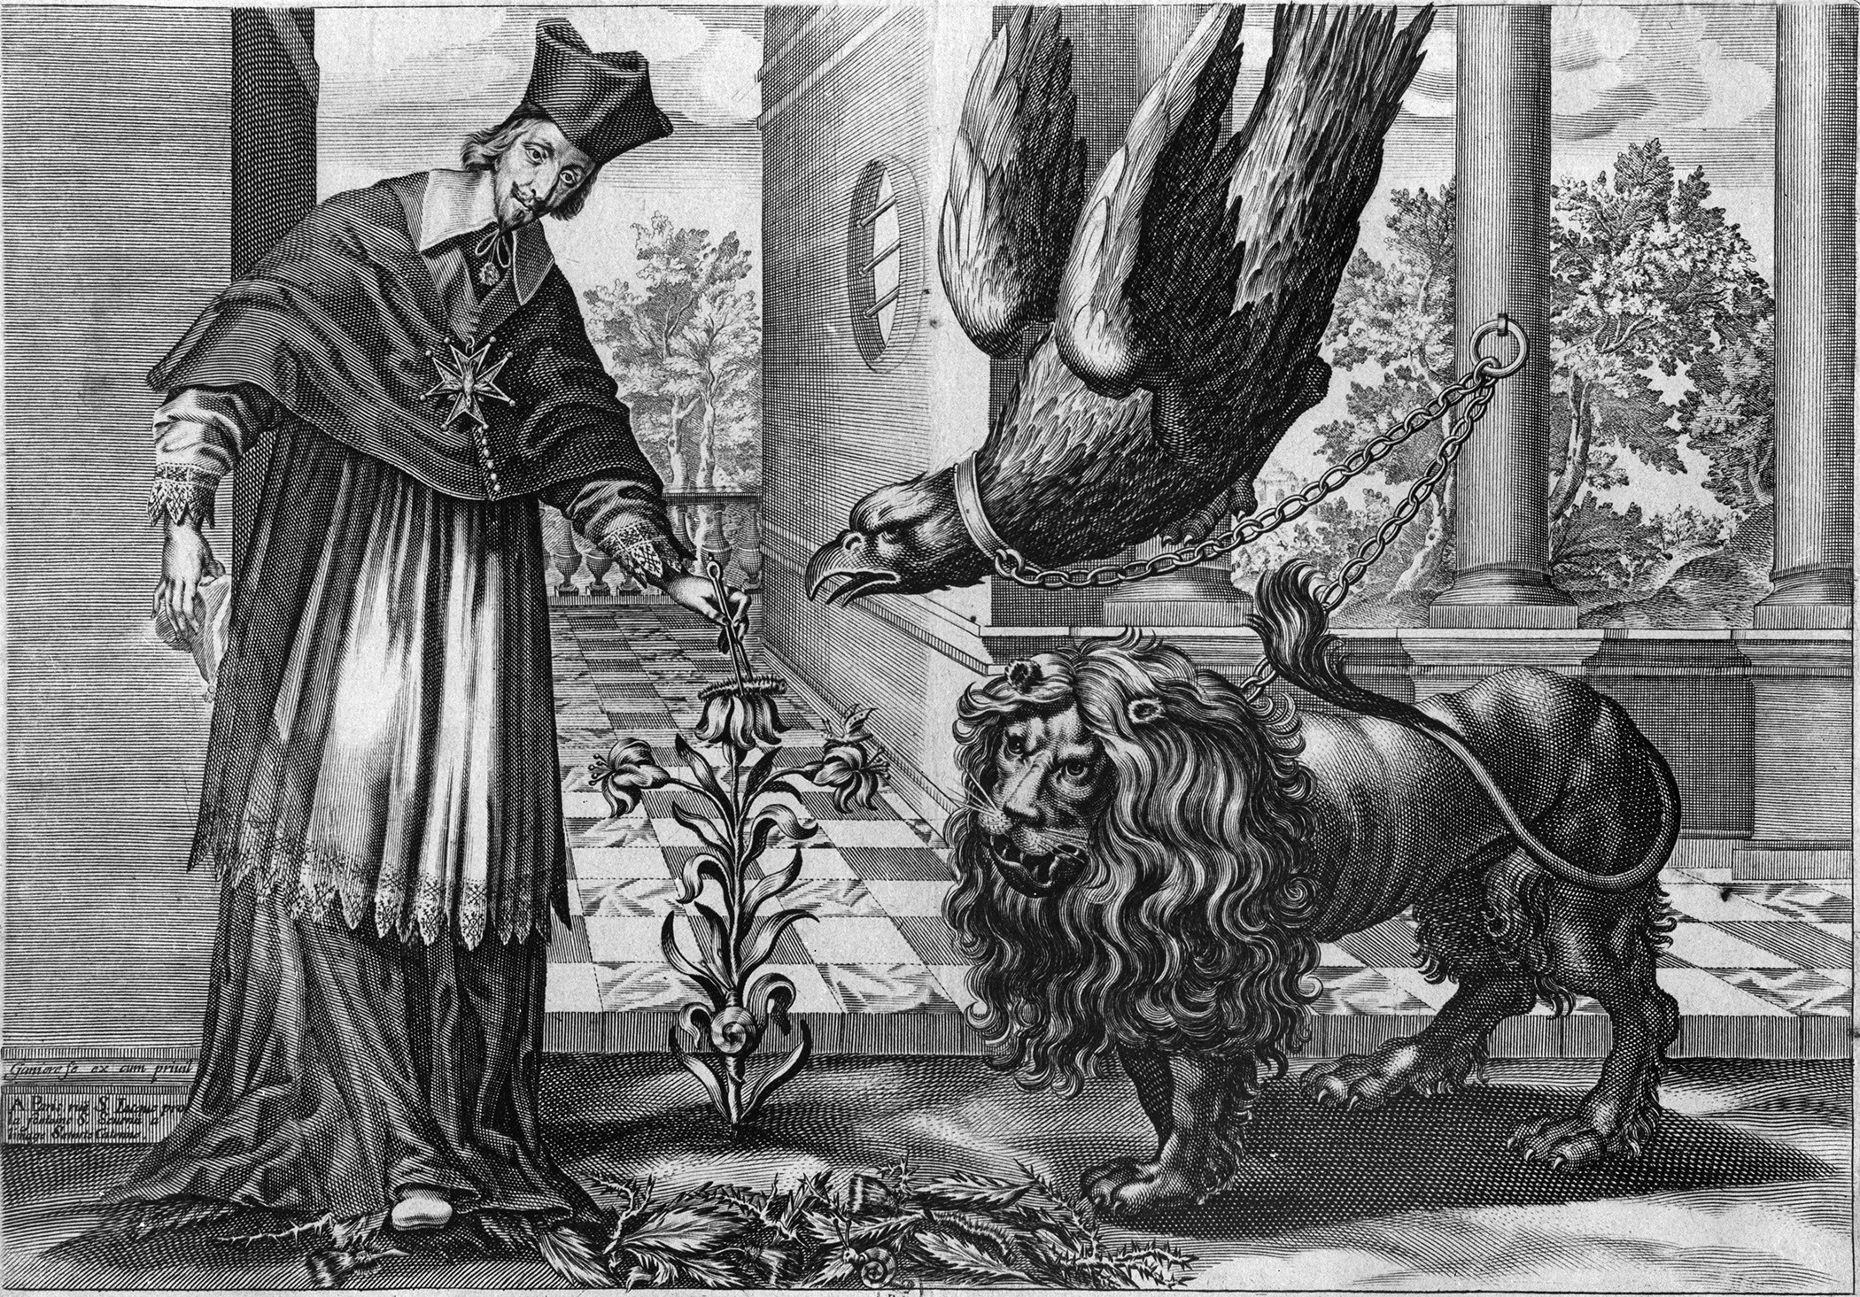

Bibliotheque Nationale, Paris, France/Bridgeman Images

Document 5
Source: Pope Innocent X, papal declaration in response to the treaty of Westphalia, 1648
Consumed by zeal for the house of the Lord, we endeavor everywhere to maintain the integrity and the authority of the Catholic Church, so that the ecclesiastical rights of which we have been appointed guardian by our Savior shall not in any way be impaired by those who seek their own interest rather than God’s, and that we may not be accused of negligence when we shall render account to God. Accordingly it is not without deep pain that we have learned that by several articles in the peace concluded at [Westphalia], between our very dear son in Christ, Ferdinand, king of the Romans and emperor elect, on the one hand, and the Swedes, as well as our very dear son in Jesus Christ, Louis, the very Christian king of the French, on the other, great prejudice has been done to the Catholic religion, the divine service, the Roman apostolic see, the ecclesiastical order, their jurisdictions, authority, immunities, liberties, exemptions, privileges, possessions, and rights . . .
Accordingly we assert and declare that all the articles in the treaty which in any way impair . . . the Catholic religion, divine worship, or the salvation of souls. . . . have been, and are of right, and shall perpetually be, null and void . . . even when they be ratified by oath.

Question 4: Scientific Revolution

Directions: It is suggested that you spend 10 minutes reading the documents and 35 minutes writing your response.

Note: You may begin writing your response before the reading period is over.

Question 4 is based on the accompanying documents. The documents have been edited for the purpose of this exercise.

In your response you should do the following.

- Respond to the prompt with a historically defensible thesis or claim that establishes a line of reasoning.
- Describe a broader historical context relevant to the prompt.
- Support an argument in response to the prompt using at least two and/or four documents.
- Uses the content of at least two documents to address the topic of the prompt.
- Use at least one and/or two additional pieces of specific historical evidence (beyond that found in the documents) relevant to an argument about the prompt.
- For at least one and/or two documents, explain how or why the document’s point of view, purpose, historical situation, and/or audience is relevant to an argument.
- Use evidence to corroborate, qualify, or modify an argument that addresses the prompt.

Analyze how political, social and religious factors affected the work of scientists in the sixteenth and seventeenth centuries.
Document 1
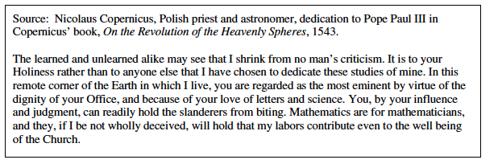

Document 2
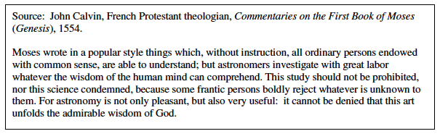
Document 3
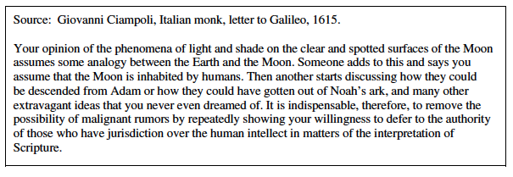

Document 4
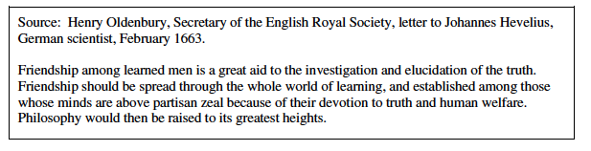

Document 5
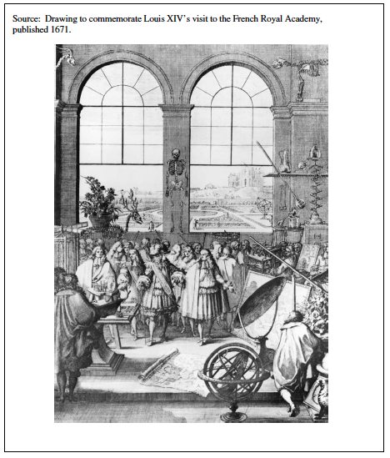

Question 5: The Glorious Revolution

Directions: It is suggested that you spend 10 minutes reading the documents and 35 minutes writing your response.

Note: You may begin writing your response before the reading period is over.

Question 5 is based on the accompanying documents. The documents have been edited for the purpose of this exercise.

In your response you should do the following.

- Respond to the prompt with a historically defensible thesis or claim that establishes a line of reasoning.
- Describe a broader historical context relevant to the prompt.
- Support an argument in response to the prompt using at least two and/or four documents.
- Uses the content of at least two documents to address the topic of the prompt.
- Use at least one and/or two additional pieces of specific historical evidence (beyond that found in the documents) relevant to an argument about the prompt.
- For at least one and/or two documents, explain how or why the document’s point of view, purpose, historical situation, and/or audience is relevant to an argument.
- Use evidence to corroborate, qualify, or modify an argument that addresses the prompt.

Evaluate whether or not the Glorious Revolution of 1688 can be considered part of the Enlightenment.

Document 1
Source: John Evelyn, writer and founding member of the Royal Society of London for Improving Natural Knowledge, diary entry, 1688
7th October—Dr. Tenison [an Anglican minister] preached at St. Martin’s church, showing the Scriptures to be our only rule of faith, and its perfection above all traditions. After which, near 1,000 devout persons partook of the Communion. The sermon was chiefly a response to a sermon by a Jesuit, who the Sunday before had disparaged the Scripture and railed at our translation. Some who were present [on that Sunday] pulled the Jesuit out of the pulpit, and treated him very coarsely. Hourly expectation of William, the Prince of Orange’s invasion heightened to that degree, that his Majesty [James II] thought fit to dispense with all laws and in the meantime, he called over 5,000 Irish and 4,000 Scots soldiers, and continued to remove Protestants and put in Papists at Portsmouth harbor and other places of trust, and retained the Jesuits about him, increasing the universal discontent. It brought people to so desperate a pass, that they seemed passionately to long for and desire the landing of the Prince of Orange, whom they looked on to be their deliverer from Popish tyranny, praying incessantly for an east wind, which was said to be the only hindrance of his expedition [from the Netherlands] with a numerous army ready to make a descent.
Document 2
Source: King William III, declaration, October 10, 1688
The Declaration of His Highness William, by the Grace of God, Prince of Orange, etc., of the reasons inducing him to appear in arms in the Kingdom of England, and for preserving the Protestant religion, and for restoring the laws and liberties of England, Scotland, and Ireland:
We for our part will concur in everything that may procure the peace and happiness of that nation, which a free and lawful Parliament shall determine, since we have nothing before our eyes in this our undertaking but the preservation of the Protestant religion, the covering of all men from persecution for their conscience, and the securing to the whole nation the free enjoyment of all their laws, rights, and liberties, under a just and legal government.

Document 3
Source: John Locke, English writer, Two Treatises of Government, 1689
The reason why men enter into society, is the preservation of their property; and the end why they choose and authorize a legislative power, is, that there may be laws made, and rules set, as guards and fences to the properties of all the members of the society, to limit the power, and moderate the dominion, of every part and member of the society: for since it can never be supposed to be the will of the society, that the legislative should have a power to destroy that which every one designs to secure, by entering into society, and for which the people submitted themselves to legislators of their own making; whenever the legislators endeavour to take away, and destroy the property of the people, or to reduce them to slavery under arbitrary power, they put themselves into a state of war with the people, who are thereupon absolved from any farther obedience, and are left to the common refuge, which God hath provided for all men, against force and violence. . . . the supreme executor, who having a double trust put in him, both to have a part in the legislative, and the supreme execution of the law, acts against both, when he goes about to set up his own arbitrary will as the law of the society.

Document 4
Source: Voltaire, French writer, Letters on the English, 1726–1729
The English are the only people upon earth who have been able to prescribe limits to the power of kings by resisting them; and who, by a series of struggles, have at last established that wise Government where the Prince is all powerful to do good, and, at the same time, is restrained from committing evil; where the nobles are great without insolence, though there are no vassals; and where the people share in the Government without confusion. . . . The English have doubtless purchased their liberties at a very high price, and waded through seas of blood to drown the idol of arbitrary power. Other nations have been involved in as great calamities, and have shed as much blood; but then the blood these other nations split in defense of their liberties only enslaved them the more.

Document 5
Source: “William and Mary,” woodcut from a mid-eighteenth-century English children’s book, showing William III and his wife and coruler Queen Mary II.
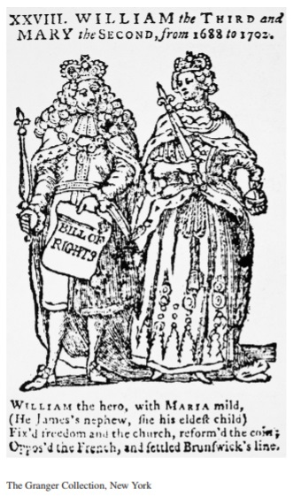
The scroll in William’s hand is labeled “Bill of Rights.” The rhyming verse below the image reads: “William the hero, with Maria mild, /(He James’s nephew, she his eldest child)/Fix’d freedom and the church, reform’d the coin;/Oppos’d the French and settled Brunswick’s line*.”
* a reference to the principle that only a Protestant would be allowed to become ruler of Great Britain, offıcially adopted in 1701

Question 6: The Renaissance and the Enlightenment

Directions: It is suggested that you spend 10 minutes reading the documents and 35 minutes writing your response.

Note: You may begin writing your response before the reading period is over.

Question 6 is based on the accompanying documents. The documents have been edited for the purpose of this exercise.

In your response you should do the following.

- Respond to the prompt with a historically defensible thesis or claim that establishes a line of reasoning.
- Describe a broader historical context relevant to the prompt.
- Support an argument in response to the prompt using at least two and/or four documents.
- Uses the content of at least two documents to address the topic of the prompt.
- Use at least one and/or two additional pieces of specific historical evidence (beyond that found in the documents) relevant to an argument about the prompt.
- For at least one and/or two documents, explain how or why the document’s point of view, purpose, historical situation, and/or audience is relevant to an argument.
- Use evidence to corroborate, qualify, or modify an argument that addresses the prompt.

Evaluate the extent to which the cultural values of the fourteenth and fifteenth-century Renaissance were similar to the cultural values of the eighteenth-century Enlightenment.

Document 1

Source: Francesco Petrarch, Italian scholar, historian, and poet, letter to Giovanni Boccaccio, a fellow poet, c. 1372
0 inglorious age! that scorns antiquity, its mother, to whom it owes every noble art- that dares to declare itself not only equal but superior to the glorious past. . . . .You see that I cannot speak of these matters without the greatest irritation and indignation. There has arisen of late a set of dialecticians [experts in logical argument], who are not only ignorant but demented. Like a black army of ants from some old rotten oak, they swarm forth from their hiding places and devastate the fields of sound learning. They condemn Plato and Aristotle, and laugh at Socrates and Pythagoras. [Greek philosophers]. . . . What shall we say of men who scorn Marcus Tullius Cicero, [Roman statesman and rhetorician] the bright sun of eloquence?. . . .
Such are the times, my friend, upon which we have fallen; such is the period in which we live and are growing old. Such are the critics of today, as I so often have occasion to lament and complain – men who are innocent of knowledge and virtue, and yet harbor the most exalted opinion of themselves. Not content with losing the words of the ancients, they must attack their genius and their ashes. They rejoice in their ignorance, as if what they did not know were not worth knowing.

Document 2

Source: Jan van Eyck’s Virgin and Child with Canon Joris van der Paele (completed 1436). The painting depicts Van der Paele, a wealthy canon of the Church of Saint Donatian in Bruges, kneeling before the enthroned Virgin and Child, flanked by Saint George and Saint Donatian.

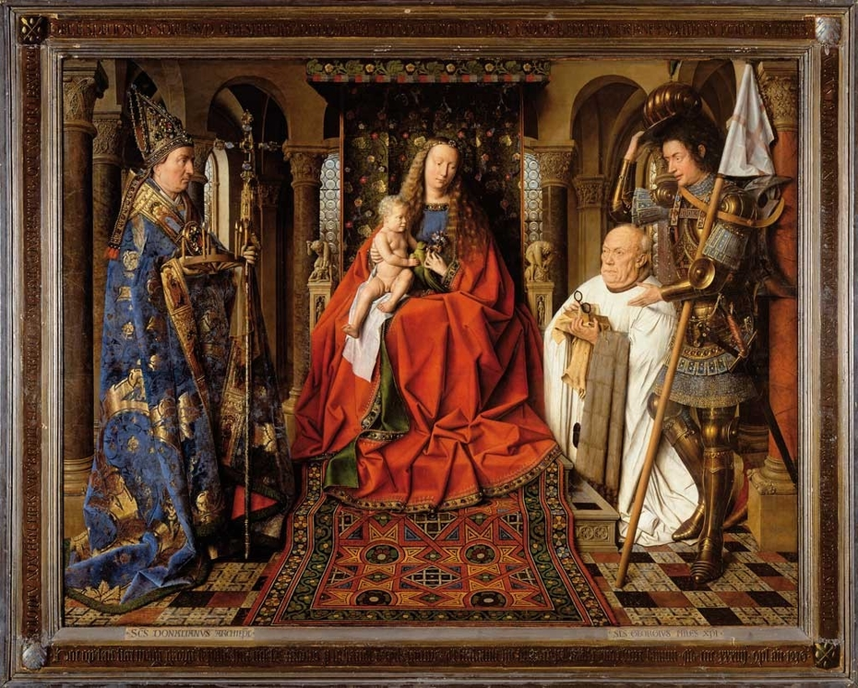

Document 3

Source: Giovanni Pico Della Mirandola, Italian scholar and philosopher, Oration on the Dignity of Man, composed in 1486 and published posthumously in 1496

Finally, the Great Artisan [God] mandated that this creature who would receive nothing proper to himself shall have joint possession of whatever nature had been given to any other creature. He made man a creature of indeterminate and indifferent nature, and, placing him in the middle of the world, said to him “Adam, we give you no fixed place to live, no form that is peculiar to you, nor any function that is yours alone. According to your desires and judgment, you will have and possess whatever place to live, whatever form, and whatever functions you yourself choose. All other things have a limited and fixed nature prescribed and bounded by our laws. You, with no limit or no bound, may choose for yourself the limits and bounds of your nature. We have placed you at the world’s center so that you may survey everything else in the world. We have made you neither of heavenly nor of earthly stuff, neither mortal nor immortal, so that with free choice and dignity, you may fashion yourself into whatever form you choose. To you is granted the power of degrading yourself into the lower forms of life, the beasts, and to you is granted the power, contained in your intellect and judgment, to be reborn into the higher forms, the divine.”

Document 4
Source: Claude-Adrien Helvetius, French intellectual and philosopher, Essays on the Mind, 1758
The inequality observable among men, therefore, depends on the government under which they lie; on the greater or less happiness of the age in which they are born; on the education; on their desire of improvement, and on the importance of the ideas that are the subject of their contemplations. The man of genius is then only produced by the circumstances in which he is placed. Thus all the art of education consists in placing young men in such a concurrence of circumstances as are proper to unfold the buds of genius and virtue. . . .I am convinced that a good education would diffuse light, virtue and consequently happiness in society; and that the opinion, that geniuses and virtue are merely gifts of nature, is a great obstacle to the making of any further progress in the science of education, and in this respect is the great favourer of idleness and negligence.

Document 5

Source: Paul-Henri Thiry, Baron d’Holbach, a prominent contributor to the Encyclopedia, Good Sense, 1772

How could the human mind make any considerable progress, while tormented with frightful phantoms and guided by men, interested in perpetuating its ignorance and fears? Man has been forced to vegetate in his primitive stupidity: he has been taught nothing but stories about invisible powers upon whom his happiness was supposed to depend. Occupied solely by his fears, . . .he has always been at the mercy of his priests, who have reserved to themselves the right of thinking for him, and directing his actions. Thus man has remained a child without experience, a slave without courage, fearing to reason, and unable to extricate himself from the labyrinth, in which he has so long been wandering. . . . Oppressed by the double yoke of spiritual and temporal power, it has been impossible for the people to know and pursue their happiness.

Question 7: Enlightened Despots

Directions: It is suggested that you spend 10 minutes reading the documents and 35 minutes writing your response.

Note: You may begin writing your response before the reading period is over.

Question 7 is based on the accompanying documents. The documents have been edited for the purpose of this exercise.

In your response you should do the following.

- Respond to the prompt with a historically defensible thesis or claim that establishes a line of reasoning.
- Describe a broader historical context relevant to the prompt.
- Support an argument in response to the prompt using at least two and/or four documents.
- Uses the content of at least two documents to address the topic of the prompt.
- Use at least one and/or two additional pieces of specific historical evidence (beyond that found in the documents) relevant to an argument about the prompt.
- For at least one and/or two documents, explain how or why the document’s point of view, purpose, historical situation, and/or audience is relevant to an argument.
- Use evidence to corroborate, qualify, or modify an argument that addresses the prompt.

Evaluate to what extent did the ideas of the Enlightenment ushered in a new political age in 18th century Europe.
Document 1
Source: Jean-Jacques Rousseau, French Social Contract, 1762
To renounce liberty is to renounce being a man, to surrender the rights of humanity and even its duties. For him how renounces everything no indemnity is possible… Such a renunciation is incompatible with man’s nature; to remove all liberty from his will is to remove all morality from his acts. Finally, it is an empty and contradictory convention that sets up, on the one side, absolute authority, and, on the other, unlimited obedience. Is it not clear that we can be under no obligation to a person from whom we have the right to exact everything?

Document 2
Source: Catherine II's Decree on Serfs, 1767.
The Governing Senate…has deemed it necessary to make known that the landlords’ serfs and peasants…owe their landlords proper submission and absolute obedience in all matters according to the laws that have been enacted from time immemorial by the autocratic forefathers of Her Imperial Majesty and which have not been repealed, and which provide that all persons who dare to incite serfs and peasants to disobey their landlords shall be arrested and taken the nearest government office, there to be punished forthwith as disturbers of the public tranquility, according to the laws and without leniency. And should it so happen that even after the publication of the present decree of Her Imperial Majesty any serfs and peasants should cease to give the proper obedience to their landlords . . . and should make bold to submit unlawful petitions complaining of their landlords, and especially to petition Her Imperial Majesty personally, then both those who make the complaints and those who write up the petitions shall be punished by the knot and forthwith deported to Nerchinsk to penal servitude for life.
Document 3

Source: Frederick II, King of Prussia, Essay on Forms of Government and Testament Politque, 1770.
Rulers should always remind themselves that they are men like the least of their subjects. The sovereign is the foremost judge, general, financier, and minister of this country, not merely for the sake of his prestige. Therefore, he should perform with care the duties connected with these offices. He is merely the principal servant of the State. Hence, he must act with honesty, wisdom, and complete disinterestedness in such as way that he can render an account of his stewardship to the citizens at any moment…However, we have too many Jews in the towns. They are needed on the Polish border because in these areas Hebrews alone perform trade. As soon as you get away from the frontier, the Jews become a disadvantage, they form cliques, they deal in contraband and get up to all manner of rascally tricks which detrimental to Christian burghers and merchants.

Document 4
Source: Joseph II, Holy Roman Emperor, The Serfdom Patent, 1781.
Patent of November 1, 1781, in re Manorial Lords and Subjects.

- Any subject is entitled to marry, subject to previous notification and acquisition of a certificate, to be delivered free of charge.
- He may, provided he observes the regulations governing conscription for military service, leave his present manor and settle or take service on another within the Province; but if he wishes to establish himself as a peasant cultivator or cottager on another manor, he must ask for a leaving certificate, which must also be issued him free of charge, to be shown to the new manorial authority.
- A subject is free to learn any handicraft, trade, etc., and seek his livelihood where he will. For this no leaving permit is necessary.
- Subjects are no longer required to perform domestic service for their lords, except orphans, who may be required to do such service for a period not exceeding three years.
- No services shall be imposed on or required of subjects beyond the robot* and payments in kind and cash attaching to their holdings. Subjects are bound to render obedience to their lords in virtue of the existing laws.

*The robot was three days of unpaid labor for a week, although many serfs worked every day except Sunday.

Document 5
Source: Caricature of Thomas Paine, published in London, 1792.
The scroll reads “Rights of Man”/“Common Nonsense”/ “Equality of Property.” Paine stands on the discarded scraps of the established British order—“Protection [of] Property, Religion, National Prosperity, Magna Charta [sic], Loyalty, Obedience to the Laws, Morality, Happiness, Industry, Personal Security, Inheritance, Justice."
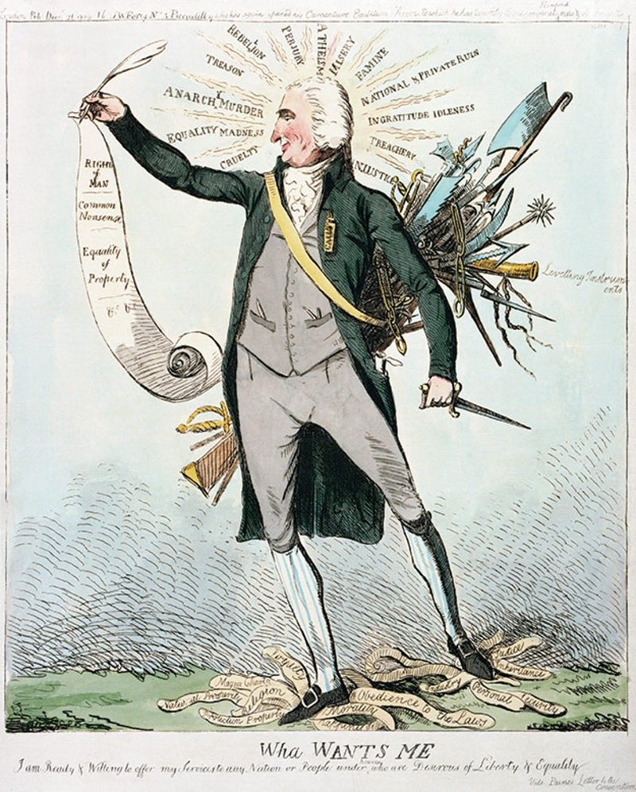
Question 8: French Revolution

Directions: It is suggested that you spend 10 minutes reading the documents and 35 minutes writing your response.

Note: You may begin writing your response before the reading period is over.

Question 8 is based on the accompanying documents. The documents have been edited for the purpose of this exercise.

In your response you should do the following.

- Respond to the prompt with a historically defensible thesis or claim that establishes a line of reasoning.
- Describe a broader historical context relevant to the prompt.
- Support an argument in response to the prompt using at least two and/or four documents.
- Uses the content of at least two documents to address the topic of the prompt.
- Use at least one and/or two additional pieces of specific historical evidence (beyond that found in the documents) relevant to an argument about the prompt.
- For at least one and/or two documents, explain how or why the document’s point of view, purpose, historical situation, and/or audience is relevant to an argument.
- Use evidence to corroborate, qualify, or modify an argument that addresses the prompt.

- Evaluate the extent to which the Enlightenment affected the French Revolution.

Document 1

Source: Second Treatise of Government, John Locke, 1690
The state of nature has a law of nature to govern it, which obliges every one: and reason, which is that law, teaches all mankind, who will but consult it, that being all equal and independent, no one ought to harm another in his life, health, liberty, or possessions… (and) when his own preservation comes not in competition, ought he, as much as he can, to preserve the rest of mankind, and may not, unless it be to do justice on an offender, take away, or impair the life, or what tends to the preservation of the life, the liberty, health, limb, or goods of another.

The reason why men enter into society, is the preservation of their property; and the end why they choose and authorize a legislative, is, that there may be laws made, and rules set, as guards and fences to the properties of all the members of the society, to limit the power, and moderate the dominion, of every part and member of the society… whenever the legislators endeavour to take away, and destroy the property of the people, or to reduce them to slavery under arbitrary power, they put themselves into a state of war with the people, who are thereupon absolved from any farther obedience, and are left to the common refuge, which God hath provided for all men, against force and violence. Whensoever therefore the legislative shall transgress this fundamental rule of society; and either by ambition, fear, folly or corruption, endeavour to grasp themselves, or put into the hands of any other, an absolute power over the lives, liberties, and estates of the people; by this breach of trust they forfeit the power the people had put into their hands… and it devolves to the people, who have a right to resume their original liberty, and, by the establishment of a new legislative, provide for their own safety and security.

Document 2

Source: The Social Contract, Jean-Jacques Rousseau, 1762
Man was born free, but everywhere he is in chains. I suppose men to have reached the point at which the obstacles in the way of their preservation in the state of nature show their power of resistance to be greater than the resources at the disposal of each individual for his maintenance in that state. That primitive condition can then subsist no longer; and the human race would perish unless it changed its manner of existence.
But, as men cannot engender new forces, they have no other means of preserving themselves than the formation of a sum of forces great enough to overcome the resistance. These they have to bring into play by means of a single motive power, and cause to act in concert.
"The problem is to find a form of association which will defend and protect with the whole common force the person and goods of each associate, and in which each, while uniting himself with all, may still obey himself alone, and remain as free as before." This is the fundamental problem of which the Social Contract provides the solution.
These clauses, properly understood, may be reduced to one -- the total alienation of each associate, together with all his rights, to the whole community; for, in the first place, as each gives himself absolutely, the conditions are the same for all; and, this being so, no one has any interest in making them burdensome to others.
Moreover, the alienation being without reserve, the union is as perfect as it can be, and no associate has anything more to demand: for, if the individuals retained certain rights, as there would be no common superior to decide between them and the public, each, being on one point his own judge, would ask to be so on all; the state of nature would thus continue, and the association would necessarily become inoperative or tyrannical.
If then we discard from the social compact what is not of its essence, we shall find that it reduces itself to the following terms --
"Each of us puts his person and all his power in common under the supreme direction of the general will, and, in our corporate capacity, we receive each member as an indivisible part of the whole."
At once, in place of the individual personality of each contracting party, this act of association creates a moral and collective body, composed of as many members as the assemble contains votes, and receiving from this act its unity, its common identity, its life and its will.

Document 3
Source: Declaration of the Rights of Man and Citizen, the National Assembly of France, August 26, 1789

The representatives of the French people, organized as a National Assembly, believing that the ignorance, neglect, or contempt of the rights of man are the sole cause of public calamities and of the corruption of governments, have determined to set forth in a solemn declaration the natural, unalienable, and sacred rights of man, in order that this declaration, being constantly before all the members of the Social body, shall remind them continually of their rights and duties; in order that the acts of the legislative power, as well as those of the executive power, may be compared at any moment with the objects and purposes of all political institutions and may thus be more respected, and, lastly, in order that the grievances of the citizens, based hereafter upon simple and incontestable principles, shall tend to the maintenance of the constitution and redound to the happiness of all. Therefore the National Assembly recognizes and proclaims, in the presence and under the auspices of the Supreme Being, the following rights of man and of the citizen:

Articles:

1. Men are born and remain free and equal in rights. Social distinctions may be founded only upon the general good.
2. The aim of all political association is the preservation of the natural and imprescriptible rights of man. These rights are liberty, property, security, and resistance to oppression.
3. The principle of all sovereignty resides essentially in the nation. No body nor individual may exercise any authority which does not proceed directly from the nation.

Articles:
1. Men are born and remain free and equal in rights. Social distinctions may be founded only upon the general good.
2. The aim of all political association is the preservation of the natural and imprescriptible rights of man. These rights are liberty, property, security, and resistance to oppression.
3. The principle of all sovereignty resides essentially in the nation. No body nor individual may exercise any authority which does not proceed directly from the nation.

Document 4

Source: Louis-Simon Boizot, Liberty Armed with the Scepter of Reason Striking down Ignorance and Fanaticism, France, 1793

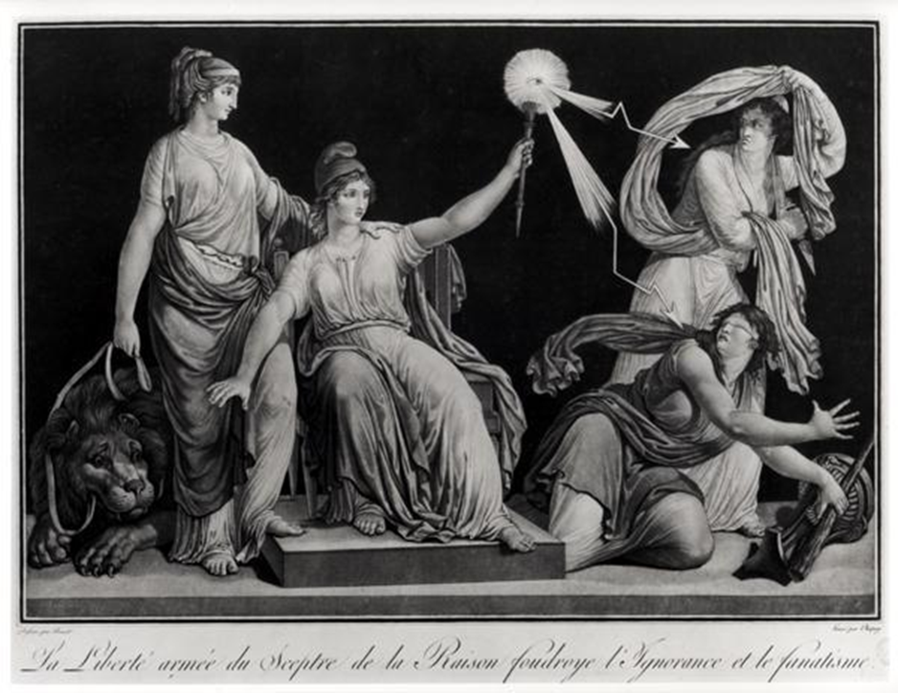

Document 5

Source: The Last “Political Testament” of a Feminist During the French Revolution, Olympe de Gouges, 1793

My son, the wealth of the whole world, the universe in servitude at my feet, the daggers of assassins raised at me, nothing can extinguish the love of country that burns in my soul; nothing could make me betray my conscience. Men deranged by passions, what have you done and what incalculable evils are you perpetrating on Paris and on the whole of France? You are risking everything; you flatter yourselves into thinking that it is only a question of a great purge to save the public; let the departments, infused with terror, blindly adopt your horrible measures.

If, by a last effort, I can save the public welfare, I want even my persecutors, as they destroy me by their furor, to be jealous of my kind of death. And if one day French women are pointed out to future generations perhaps my memory will equal that of the Romans. I have predicted it all; I know that my death is inevitable; but it is glorious for a well-intentioned soul, when an ignominious death threatens all good citizens, to die for a dying country!

I will my heart to the nation, my integrity to men (they have need of it). To women, I will my soul; my creative spirit to dramatic artists; my disinterestedness to the ambitious; my philosophy to those who are persecuted; my intelligence to all fanatics; my religion to atheists; my gaiety to women on the decline; and all the poor remains of an honest fortune to my son, if he survives me.

Frenchmen, those are my last words, listen to what I am saying and reach down into the bottom of your hearts: do you recognize the austere virtues and the unselfishness of a republican? Answer me: who has loved and served the nation more–you or I? People, your reign is over if you fail to stop yourselves at the edge of this abyss. You have never been grander or more sublime than in the majestic calm you have kept during this bloody storm. If you can preserve this calm and this august kind of supervision, you will save Paris, the whole of France, and republican government.

Question 9: Bismarck and German Nationalism

Directions: It is suggested that you spend 10 minutes reading the documents and 35 minutes writing your response.

Note: You may begin writing your response before the reading period is over.

Question 8 is based on the accompanying documents. The documents have been edited for the purpose of this exercise.

In your response you should do the following.

- Respond to the prompt with a historically defensible thesis or claim that establishes a line of reasoning.
- Describe a broader historical context relevant to the prompt.
- Support an argument in response to the prompt using at least two and/or four documents.
- Uses the content of at least two documents to address the topic of the prompt.
- Use at least one and/or two additional pieces of specific historical evidence (beyond that found in the documents) relevant to an argument about the prompt.
- For at least one and/or two documents, explain how or why the document’s point of view, purpose, historical situation, and/or audience is relevant to an argument.
- Use evidence to corroborate, qualify, or modify an argument that addresses the prompt.

Evaluate whether the policies of Otto von Bismarck’s government represented traditional conservatism or a new kind of conservatism in nineteenth-century Europe.

Document 1
Source: Eugen Richter, liberal journalist and politician, newspaper article, 1890

The dismissal of Reich Chancellor Prince Bismarck is an accomplished fact. Thank God he’s gone! A continuation of the domestic policy pursued up to now would actually have brought Germany to ruin, had it been followed by another such period. The fact that in the last elections one-fifth of the German people declared their support for the Social Democratic Party is mainly the fault of the Bismarckian system of government; it boosted socialism artificially by offering the carrot one moment and applying the stick the next.
Existing religious differences were exacerbated through the battle over church policy, carried out by way of the police and criminal regulations. The incitement of the parties against each other, the suspicions cast upon people’s patriotism, and the denial of patriotism to any political dissident resulted from a press corrupted by bribery and fear. Before the eyes of the world, what he did to unify the Fatherland was shown to the fullest advantage; but later generations, those destined to suffer the consequences of his flawed domestic policies, will become fully aware of how these measures have sinned against national life. We must once again draw inspiration from the idea that the people themselves are called upon to participate in their own destiny. In the long term, people get only the kind of government they deserve.

Document 2
Source: Chancellor Otto von Bismarck, speech in support of the new accident insurance bill, Berlin, March 5, 1884
Government according to Frederick the Great is to serve the people; the opposite is to dominate the people. We want to serve the people. It is not correct that we made the proposal to win more support for the Anti-Socialist law. At the time of the proposal of the law, His Majesty the Emperor and the majority of the Reichstag promised that as a corollary to this law there would also be a serious effort to better conditions for the workers.
The whole problem is rooted in the question: does the state have the responsibility to care for its helpless fellow citizens, or does it not? I maintain that it does have this duty and not simply the Christian state but indeed every state. There are objectives that only the state can fulfill including national defense and the general system of transportation. But the state must help persons in distress and prevent the workers’ complaints that can be exploited by the Social Democrats.
If one argues against my position that this is socialism, then I do not fear that at all. The question is what are the limits of state socialism? Each law for poor relief is socialism. There are states that distance themselves so far from socialism that poor laws do not exist at all. These states take the French view that every French citizen has the right to starve and that the state has no responsibility to hinder him in the exercise of his right.

Document 3
Source: “At the helm,” political cartoon portraying Bismarck, published in a satirical German magazine, 1879
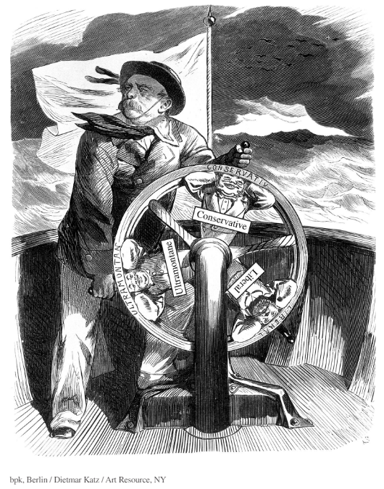

Caption: “The Liberal says to the other two: “Don’t worry, when the wind shifts, I’ll be on top again.””
Note: Ulramontane refers to Papal power and authority.

Document 4
Source: Legislation passed by Bismarck’s government, 1869–1878

Law Concerning the Equality of all Religions with Respect to Civil Rights and Citizenship of July 3, 1869: All restrictions on citizenship or civil rights based on differences in religious confession are abolished. The right to hold public office shall be independent of religious confession.

School Inspection Law of March 11, 1872: The supervision of all public and private school and educational institutions is solely under the control of the state and not of any clergy.

Law Concerning the Order of the Society of Jesus [The Jesuits] of July 4, 1872: The Order of the Society of Jesus and similar order-like Congregations, are banned hereby from the territory of the German Reich. The members of the Order of the Society of Jesus or similar order-like Congregations can be banished, if they are foreigners; if they are natives, their residence in certain districts or places can be denied, or they can be banished.

Law Against the Publicly Dangerous Endeavors of Social Democracy from October 21, 1878: Societies which aim at the overthrow of the existing political or social order through social-democratic, socialist, or communist endeavors are to be prohibited. Public festivities and processions shall be treated the same as meetings. Publications in which social-democratic, socialist, or communist endeavors aimed at the overthrow of the existing political or social order are manifested in a manner calculated to endanger the harmony among all classes of the population are to be prohibited.

Document 5
Source: Hermann Wagener, high public official and conservative politician, memorandum written for Otto von Bismarck, “Why the Government Cannot Ignore the Social Question: A Conservative View,” 1872

It is extremely dangerous to take up the battle against the ultramontane [extremely Catholic] and socialist parties simultaneously. It is important to keep those pursuing anti-national aims away from the social movement but it would be a political mistake to subject socialist leaders to emergency laws on account of their social advocacy, particularly without also doing something substantial to satisfy the just efforts of their followers. It would be hopeless to fight a powerful idea merely with material means, and, with respect to the extremely powerful Catholic-clerical idea, there is currently only one idea that can be used as a political counterweight with any prospect of success—and that is the social idea. The “social Kaiser” has a stronger position than even the “social Pope.” At the moment, the mass of the population is wavering, unsure of the direction in which to turn. So far, the international agitation has not gained a broader basis; where the masses turn, however, will be of crucial significance not just for politics but also for the character of the army. The army will only be completely reliable if the workers, who make up its main contingent, are won over and bound to the idea of the Reich through its very benefits and performance.

Question 10: The Industrial Revolution

Directions: It is suggested that you spend 10 minutes reading the documents and 35 minutes writing your response.

Note: You may begin writing your response before the reading period is over.

Question 10 is based on the accompanying documents. The documents have been edited for the purpose of this exercise.

In your response you should do the following.

- Respond to the prompt with a historically defensible thesis or claim that establishes a line of reasoning.
- Describe a broader historical context relevant to the prompt.
- Support an argument in response to the prompt using at least two and/or four documents.
- Uses the content of at least two documents to address the topic of the prompt.
- Use at least one and/or two additional pieces of specific historical evidence (beyond that found in the documents) relevant to an argument about the prompt.
- For at least one and/or two documents, explain how or why the document’s point of view, purpose, historical situation, and/or audience is relevant to an argument.
- Use evidence to corroborate, qualify, or modify an argument that addresses the prompt.

Identify and analyze the issues raised by and reactions to the problems created by the Industrial Revolution.

Document 1

Source: Robert Southey, English Romantic poet, after visiting Manchester, England in 1807, Colloquies on the Progress and Prospects of Society, 1829
A place more destitute than Manchester is not easy to conceive. In size and population it is the second city of the kingdom. Imagine this multitude crowded together in narrow streets, the houses all brick and blackened with smoke: frequent buildings among them as large as convents, without their antiquity, without their beauty, without their holiness, where you hear from within, the everlasting din of machinery; and where, when the bell rings, it is to call the wretches to their work instead of their prayers.

Document 2
Source: Thomas B. Macaulay, liberal Member of Parliament and historian, essay, "Southey's Colloquies," 1830s

People live lon ger because they are better fed, better lodged, better clothed, and better attended in sickness, and these improvements are owing to the increase in national wealth which the manufacturing system has produced. Mr. [Robert] Southey has found a way, he tells us, in which the effects of manufacturers and agriculture may be compared. And what is this way? To stand on a hill, to look at a cottage and a factory, and to see which is prettier. Does Mr. Southey think that the English peasantry live, or ever lived, in substantial and ornamented cottages, with box-hedges, flower-gardens, beehives, and orchards?

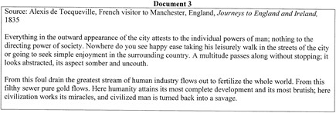
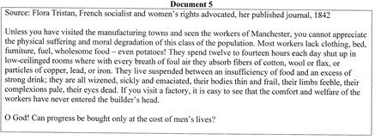
Document 4
Document 5

Source: View from Blacksfriar Bridge over the River Irwell in Manchester, Engraving in The Graphic, weekly magazine dealing with social issues, 1870s.

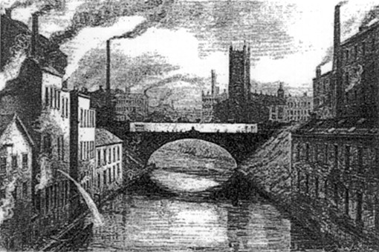

Question 11: The New Imperialism

Directions: It is suggested that you spend 10 minutes reading the documents and 35 minutes writing your response.

Note: You may begin writing your response before the reading period is over.

Question 11 is based on the accompanying documents. The documents have been edited for the purpose of this exercise.

In your response you should do the following.

- Respond to the prompt with a historically defensible thesis or claim that establishes a line of reasoning.
- Describe a broader historical context relevant to the prompt.
- Support an argument in response to the prompt using at least two and/or four documents.
- Uses the content of at least two documents to address the topic of the prompt.
- Use at least one and/or two additional pieces of specific historical evidence (beyond that found in the documents) relevant to an argument about the prompt.
- For at least one and/or two documents, explain how or why the document’s point of view, purpose, historical situation, and/or audience is relevant to an argument.
- Use evidence to corroborate, qualify, or modify an argument that addresses the prompt.

Analyze attitudes toward and evaluate the motivations behind the European acquisition of African colonies in the period 1880 to 1914.

Document 1
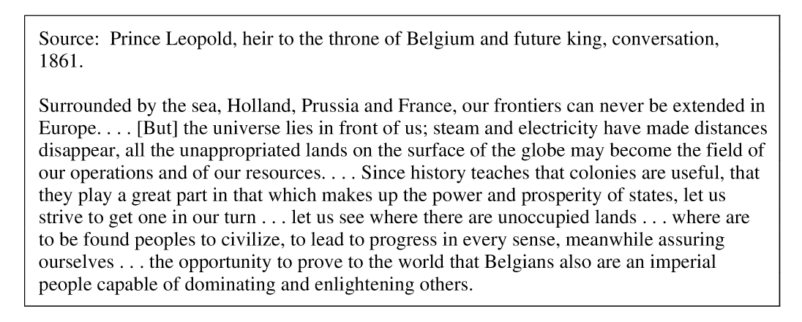

Document 2
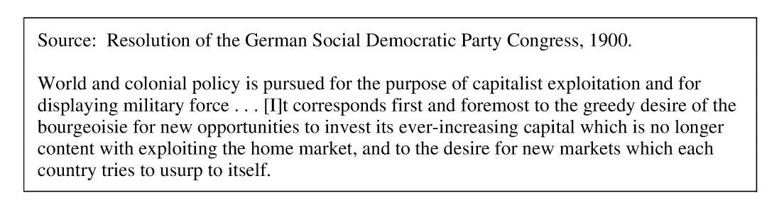

Document 3
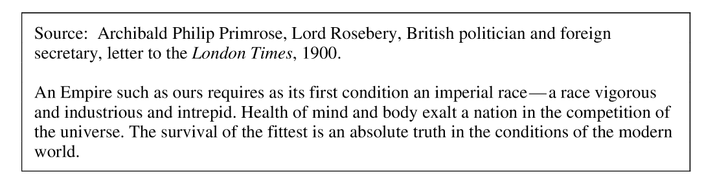

Document 4
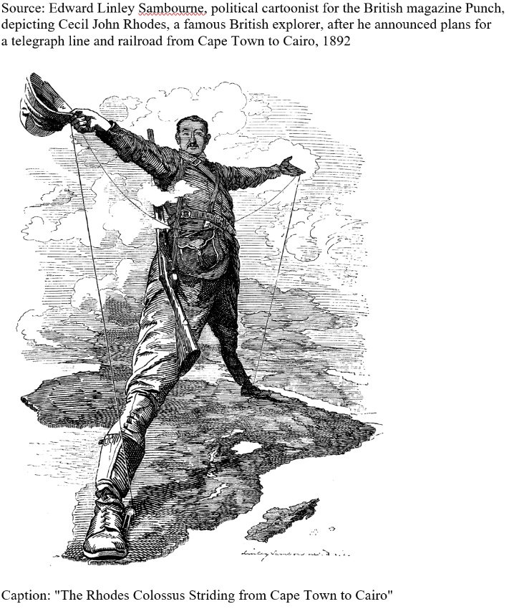

Document 5

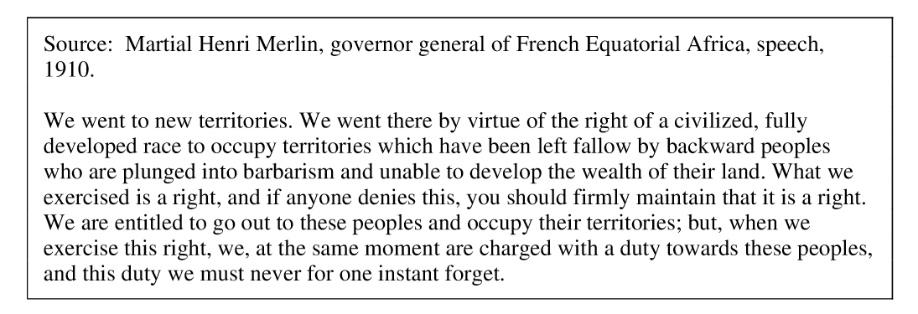

Question 12: Women

Directions: It is suggested that you spend 10 minutes reading the documents and 35 minutes writing your response.

Note: You may begin writing your response before the reading period is over.

Question 12 is based on the accompanying documents. The documents have been edited for the purpose of this exercise.

In your response you should do the following.

- Respond to the prompt with a historically defensible thesis or claim that establishes a line of reasoning.
- Describe a broader historical context relevant to the prompt.
- Support an argument in response to the prompt using at least two and/or four documents.
- Uses the content of at least two documents to address the topic of the prompt.
- Use at least one and/or two additional pieces of specific historical evidence (beyond that found in the documents) relevant to an argument about the prompt.
- For at least one and/or two documents, explain how or why the document’s point of view, purpose, historical situation, and/or audience is relevant to an argument.
- Use evidence to corroborate, qualify, or modify an argument that addresses the prompt.

Evaluate the extent to which social, political and economic opportunities existed for women between 1500 and 1914 in Europe.

Document 1
Source: Queen Elizabeth I Against the Spanish Armada, 1588
My loving people, we have been persuaded by some, that are careful of our safety, to take heed how we commit ourselves to armed multitudes, for fear of treachery; but I assure you, I do not desire to live to distrust my faithful and loving people. Let tyrants fear; I have always so behaved myself that, under God, I have placed my chiefest strength and safeguard in the loyal hearts and good will of my subjects. And therefore I am come amongst you at this time, not as for my recreation or sport, but being resolved, in the midst and heat of the battle, to live or die amongst you all; to lay down, for my God, and for my kingdom, and for my people, my honor and my blood, even the dust. I know I have but the body of a weak and feeble woman; but I have the heart of a king, and of a king of England, too; and think foul scorn that Parma or Spain, or any prince of Europe, should dare to invade the borders of my realms: to which, rather than any dishonor should grow by me, I myself will take up arms; I myself will be your general, judge, and rewarder of every one of your virtues in the field. I know already, by your forwardness, that you have deserved rewards and crowns; and we do assure you, on the word of a prince, they shall be duly paid you. In the mean my lieutenant general shall be in my stead, than whom never prince commanded a more noble and worthy subject; not doubting by your obedience to my general, by your concord in the camp, and by your valor in the field, we shall shortly have a famous victory over the enemies of my God, of my kingdom, and of my people.

Document 2
Source: From Lady Mary Wortley Montagu, Letters of the Right Honourable Lady M--y W--y M--e: Written During her Travels in Europe, Asia and Africa, 1771

A propos of distempers, I am going to tell you a thing, that will make you wish yourself here. The small-pox, so fatal, and so general amongst us, is here entirely harmless, by the invention of engrafting, which is the term they give it. There is a set of old women, who make it their business to perform the operation, every autumn, in the month of September, when the great heat is abated. People send to one another to know if any of their family has a mind to have the small-pox; they make parties for this purpose, and when they are met (commonly fifteen or sixteen together) the old woman comes with a nut-shell full of the matter of the best sort of small-pox, and asks what vein you please to have opened. She immediately rips open that you offer to her, with a large needle (which gives you no more pain than a common scratch) and puts into the vein as much matter as can lie upon the head of her needle , and after that, binds up the little wound with a hollow bit of shell, and in this manner opens four or five veins. The Grecians have commonly the superstition of opening one in the middle of the forehead, one in each arm, and one on the breast, to mark the sign of the Cross; but this has a very ill effect, all these wounds leaving little scars, and is not done by those that are not superstitious, who chuse to have them in the legs, or that part of the arm that is concealed. The children or young patients play together all the rest of the day, and are in perfect health to the eighth. Then the fever begins to seize them, and they keep their beds two days, very seldom three. They have very rarely above twenty or thirty in their faces, which never mark, and in eight days time they are as well as before their illness. Where they are wounded, there remains running sores during the distemper, which I don't doubt is a great relief to it. Every year, thousands undergo this operation, and the French Ambassador says pleasantly, that they take the small-pox here by way of diversion, as they take the waters in other countries. There is no example of any one that has died in it, and you may believe I am well satisfied of the safety of this experiment, since I intend to try it on my dear little son. I am patriot enough to take the pains to bring this useful invention into fashion in England, and I should not fail to write to some of our doctors very particularly about it, if I knew any one of them that I thought had virtue enough to destroy such a considerable branch of their revenue, for the good of mankind. But that distemper is too beneficial to them, not to expose to all their resentment, the hardy wight that should undertake to put an end to it. Perhaps if I live to return, I may, however, have courage to war with them. Upon this occasion, admire the heroism in the heart of
Your friend, etc. etc.

Document 3
Source: Two Women Miners, From Great Britain, Parliamentary Papers, 1842
Betty Harris, age 37: I was married at 23, and went into a colliery when I was married. I used to weave when about 12 years old; can neither read nor write. I work for Andrew Knowles, of Little Bolton (Lancs), and make sometimes 7s a week, sometimes not so much. I am a drawer, and work from 6 in the morning to 6 at night. Stop about an hour at noon to eat my dinner; have bread and butter for dinner; I get no drink. I have two children, but they are too young to work. I worked at drawing when I was in the family way. I know a woman who has gone home and washed herself, taken to her bed, delivered of a child, and gone to work again under the week.
I have a belt round my waist, and a chain passing between my legs, and I go on my hands and feet. The road is very steep, and we have to hold by a rope; and when there is no rope, by anything we can catch hold of. There are six women and about six boys and girls in the pit I work in; it is very hard work for a woman. The pit is very wet where I work, and the water comes over our clog-tops always, and I have seen it up to my thighs; it rains in at the roof terribly. My clothes are wet through almost all day long. I never was ill in my life, but when I was lying in.
My cousin looks after my children in the day time. I am very tired when I get home at night; I fall asleep sometimes before I get washed. I am not so strong as I was, and cannot stand my work so well as I used to. I have drawn till I have bathe skin off me; the belt and chain is worse when we are in the family way. My feller (husband) has beaten me many a times for not being ready. I were not used to it at first, and he had little patience.
I have known many a man beat his drawer. I have known men take liberties with the drawers, and some of the women have bastards.
Patience Kershaw, age 17, Halifax: I go to pit at 5 o'clock in the morning and come out at 5 in the evening; I get my breakfast, porridge and milk, first; I take my dinner with me, a cake, and eat it as I go; I do not stop or rest at any time for the purpose, I get nothing else until I get home, and then have potatoes and meat, not every day meat.

Document 4
Source: Mary Antin, A Little Jewish Girl in the Russian Pale, 1890
THE Gentiles used to wonder at us because we cared so much about religious things about food and Sabbath and teaching the children Hebrew. They were angry with us for our obstinacy, as they called it, and mocked us and ridiculed the most sacred things. There were wise Gentiles who understood. These were educated people, like Fedora Pavlovna, who made friends with their Jewish neighbors. They were always respectful and openly admired some of our ways. But most of the Gentiles were ignorant. There was one thing, however, the Gentiles always understood, and that was money. They would take any kind of bribe, at any time. They expected it. Peace cost so much a year, in Polotzk….
The cheapest way to live in Polotzk was to pay as you went along. Even a little girl understood that. In your father's parlor hung a large colored portrait of Alexander III. The czar was a cruel tyrant---oh, it was whispered when doors were locked and shutters tightly barred, at night---he was a Titus, a Haman, a sworn foe of all Jews---and yet his portrait was seen in a place of honor in your father's house. You knew why. It looked well when police or government officers came on business……
Perhaps I should not have had so many foolish fancies if I had not been so idle. If they had let me go to school---but of course they didn't. There was one public school for boys, and one for girls, but Jewish children were admitted in limited numbers---only ten to a hundred; and even the lucky ones had their troubles. First, you had to have a tutor at home, who prepared you and talked all the time about the examination you would have to pass, till you were scared. You heard on all sides that the brightest Jewish children were turned down if the examining officers did not like the turn of their noses. You went up to be examined with the other Jewish children, your heart heavy about that matter of your nose. There was a special examination for the Jewish candidates, of course: a nine-year-old Jewish child had to answer questions that a thirteen-year-old Gentile was hardly expected to answer. But that did not matter so much; you had been prepared for the thirteen-year-old test. You found the questions quite easy. You wrote your answers triumphantly---and you received a low rating, and there was no appeal.
I used to stand in the doorway of my father's store munching an apple that did not taste good any more, and watch the pupils going home from school in twos and threes; the girls in neat brown dresses and black aprons and little stiff hats, the boys in trim uniforms with many buttons. They had ever so many books in the satchels on their backs. They would take them out at home, and read and write, and learn all sorts of interesting things. They looked to me like beings from another world than mine. But those whom I envied had their troubles, as I often heard. Their school life was one struggle against injustice from instructors, spiteful treatment from fellow students, and insults from everybody. They were rejected at the universities, where they were admitted in the ratio of three Jews to a hundred Gentiles, under the same debarring entrance conditions as at the high school: especially rigorous examinations, dishonest marking, or arbitrary rulings without disguise. No, the czar did not want us in the schools.

Document 5
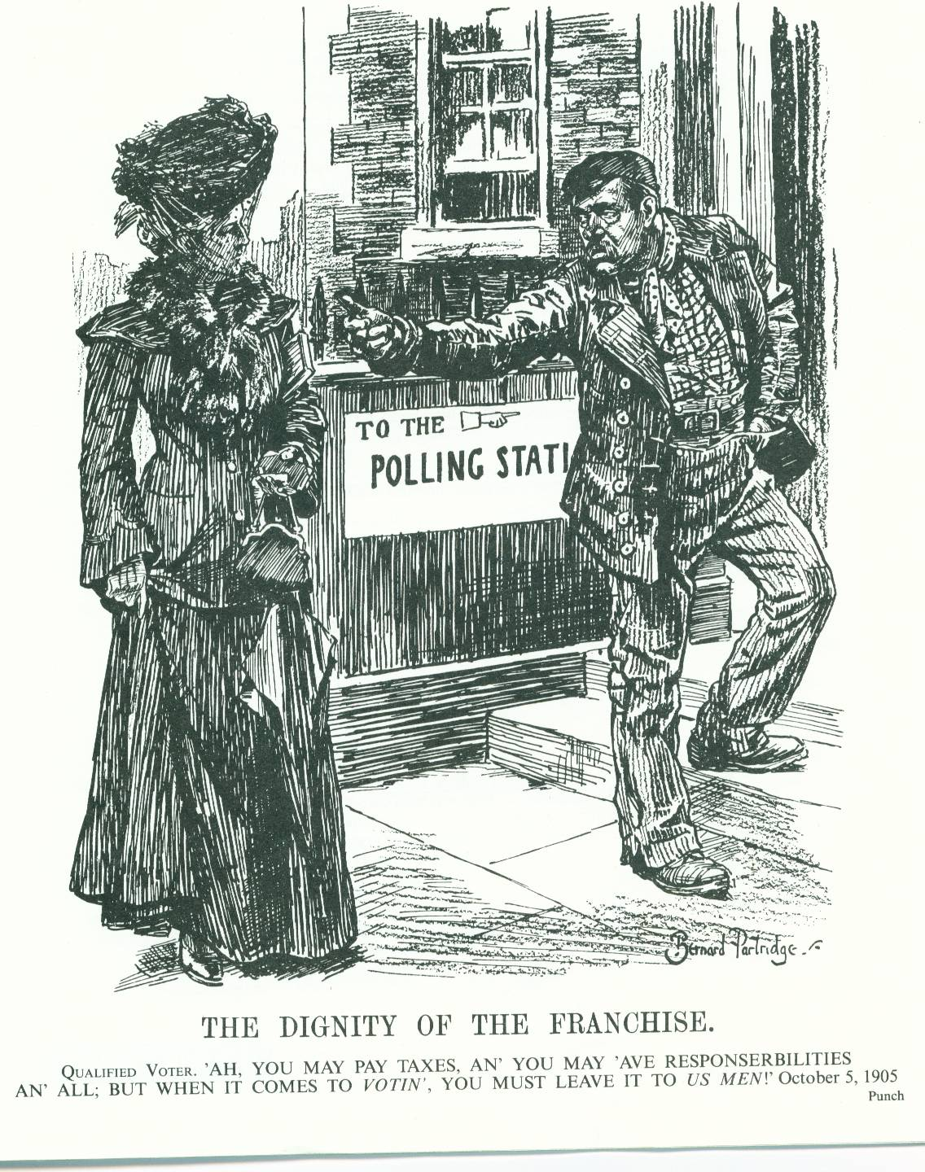
Question 13: The Arts

Directions: It is suggested that you spend 10 minutes reading the documents and 35 minutes writing your response.

Note: You may begin writing your response before the reading period is over.

Question 13 is based on the accompanying documents. The documents have been edited for the purpose of this exercise.

In your response you should do the following.

- Respond to the prompt with a historically defensible thesis or claim that establishes a line of reasoning.
- Describe a broader historical context relevant to the prompt.
- Support an argument in response to the prompt using at least two and/or four documents.
- Uses the content of at least two documents to address the topic of the prompt.
- Use at least one and/or two additional pieces of specific historical evidence (beyond that found in the documents) relevant to an argument about the prompt.
- For at least one and/or two documents, explain how or why the document’s point of view, purpose, historical situation, and/or audience is relevant to an argument.
- Use evidence to corroborate, qualify, or modify an argument that addresses the prompt.

Evaluate the extent to which art challenges the dominant cultural values of society.

Document 1

Source: Georgio Vasari, “Raphael” entry in The Lives of the Most Eminent Painters, Sculptors and Architects, 1568.

When Raffaello resolved to set himself to change and improve his manner. . . He devoted himself to studying the nude . . . and . . . he became excellent in all the points that are looked for in a painter of eminence. Knowing, however, that in this respect he could never attain to the perfection of Michelangelo, he reflected, like a man of supreme judgment, that painting does not consist only in representing the nude human form, but has a wider field; that one can enumerate among the perfect painters those who express historical inventions . . . and . . . a variety of perspectives, buildings, and landscapes, the method of clothing figures gracefully, the making them fade away sometimes in the shadows, and sometimes come forward into the light, the imparting of life and beauty to the heads of women, children, young men and old, and the giving them movement and boldness, according to necessity. He considered, also, how important is the furious flight of horses in battles, fierceness in soldiers, the knowledge how to depict all the sorts of animals, and above all the power to give such resemblance to portraits that they seem to be alive, and that it is known whom they represent. . .

Document 2

Source: Rembrandt, The Syndics of the Drapers’ Guild, 1662. Rijksmuseum, Amsterdam

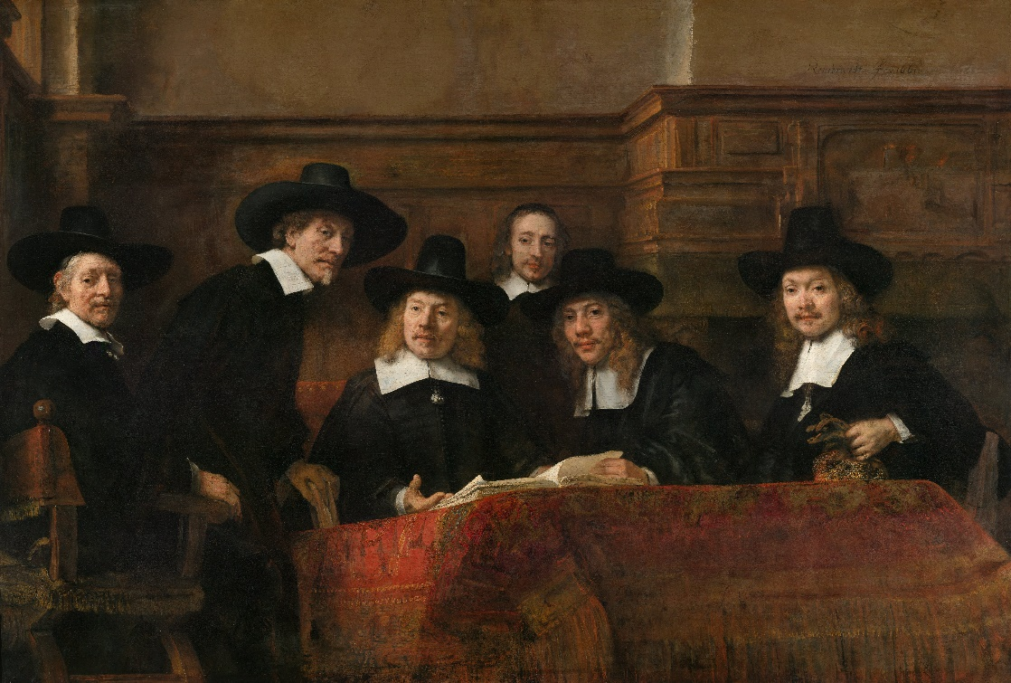

Document 3

Source: Hall of Mirrors at the Palace of Versailles, restored to its appearance in 1684 during the reign of King Louis XIV

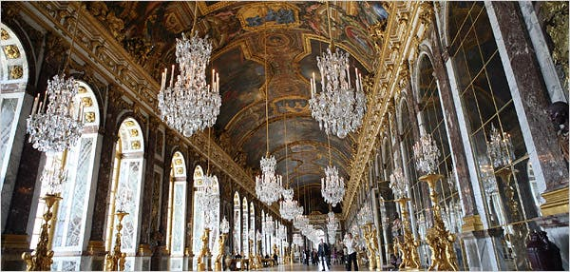

Document 4

Source: William Wordsworth, The Tables Turned, 1789

Up! up! my Friend, and quit your books;
Or surely you'll grow double:
Up! up! my Friend, and clear your looks;
Why all this toil and trouble?

The sun above the mountain's head,
A freshening lustre mellow
Through all the long green fields has spread,
His first sweet evening yellow.

Books! 'tis a dull and endless strife:
Come, hear the woodland linnet,
How sweet his music! on my life,
There's more of wisdom in it.

And hark! how blithe the throstle sings!
He, too, is no mean preacher:
Come forth into the light of things,
Let Nature be your teacher.

She has a world of ready wealth,
Our minds and hearts to bless—
Spontaneous wisdom breathed by health,
Truth breathed by cheerfulness.

One impulse from a vernal wood
May teach you more of man,
Of moral evil and of good,
Than all the sages can.

Sweet is the lore which Nature brings;
Our meddling intellect
Mis-shapes the beauteous forms of things:—
We murder to dissect.

Enough of Science and of Art;
Close up those barren leaves;
Come forth, and bring with you a heart
That watches and receives.

Document 5

Source: Pablo Picasso, The Old Guitarist, 1903. The Art Institute of Chicago

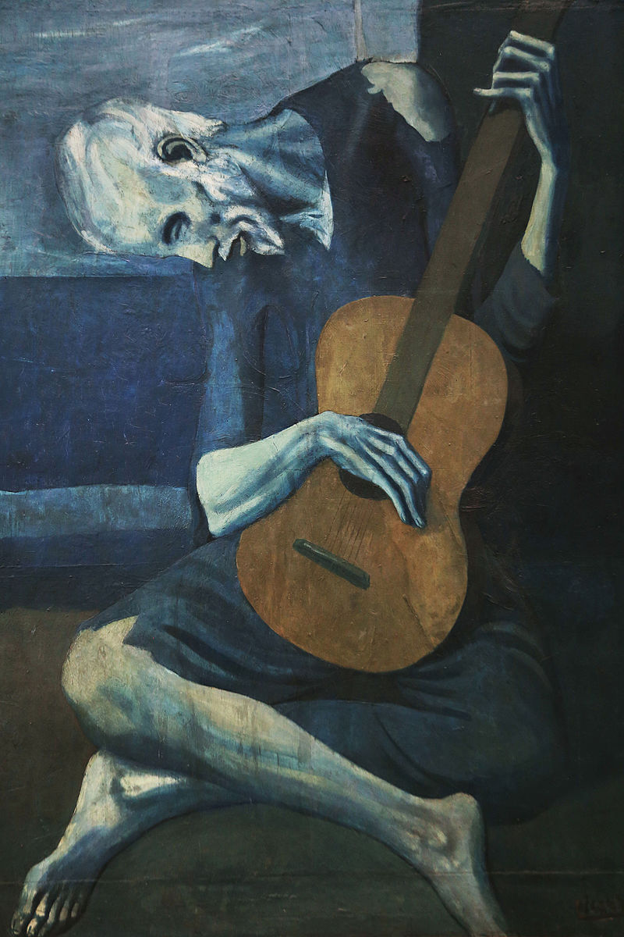

Question 14: Causes of World War I

Directions: It is suggested that you spend 10 minutes reading the documents and 35 minutes writing your response.

Note: You may begin writing your response before the reading period is over.

Question 14 is based on the accompanying documents. The documents have been edited for the purpose of this exercise.

In your response you should do the following.

- Respond to the prompt with a historically defensible thesis or claim that establishes a line of reasoning.
- Describe a broader historical context relevant to the prompt.
- Support an argument in response to the prompt using at least two and/or four documents.
- Uses the content of at least two documents to address the topic of the prompt.
- Use at least one and/or two additional pieces of specific historical evidence (beyond that found in the documents) relevant to an argument about the prompt.
- For at least one and/or two documents, explain how or why the document’s point of view, purpose, historical situation, and/or audience is relevant to an argument.
- Use evidence to corroborate, qualify, or modify an argument that addresses the prompt.
Evaluate the extent to which nationalism was to blame for the outbreak of World War I.
Document 1

This is an excerpt from the Austro-Hungarian Red Book No. 7. It is the ultimatum that Austria-Hungary sent to Serbia on July 23 1914.
...the Royal Serbian Government has done nothing to repress these movements. It has permitted the criminal machinations of various societies and associations directed against the Monarchy, and has tolerated unrestrained language on the part of the press, the glorification of the perpetrators of outrages and the participation of officers and functionaries in subversive agitation…
…[The] Royal Government sees themselves compelled to demand from the Royal Serbian Government a formal assurance that they condemn this dangerous propaganda against the Monarchy…
...To accept the collaboration of Serbia of representatives of the Austro-Hungarian Government for the suppression of the subversive movement...

Document 2

Per Capita Expenditures of the Great Powers on Armaments between 1870-1914

 | 1870 | 1880 | 1890 | 1900 | 1914
Great Britain | $3.54 | $3.46 | $3.84 | $12.60* | 8.23
France | 2.92 | 4.02 | 4.66 | 5.21 | 7.07
Russia | 1.28 | 1.50 | 1.26 | 1.44 | 3.44
Germany | 1.28 | 2.16 | 2.80 | 4.06 | 8.19
Austria-Hungary | 1.08 | 1.70 | 1.50 | 1.46 | 3.10
Italy | 1.38 | 1.74 | 2.52 | 2.34 | 3.16
Source: From Europe, 1815-1914, by Gordon A. Craig, 1966 *Boer War (South Africa) Costs

Document 3

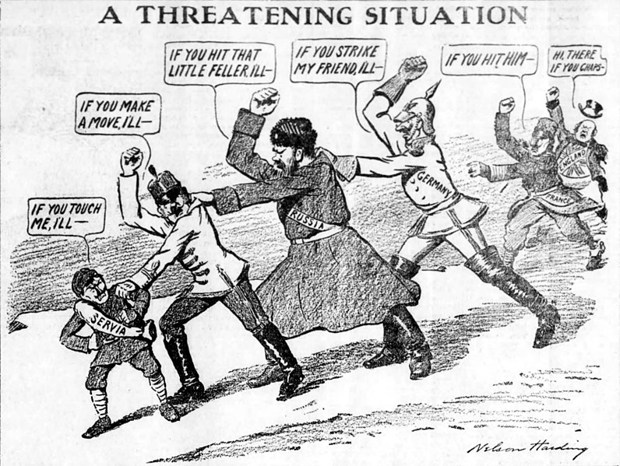
Originally published as “The Chain of Friendship,” Brooklyn Daily Eagle, 1912

Document 4

In this excerpt from May 7, 1919, Count Brockdorff-Rantzau, leader of the German delegation to Versailles Peace Conference, protested.
It is demanded of us that we shall confess ourselves to be the only ones guilty of the war. Such a confession in my mouth would be a lie. We are far from declining any responsibility for the fact that this great World War took place or that it was fought in the way that it was... but we energetically deny that Germany and its people, who were convinced that they were making a war of defense, were alone guilty. Nobody will want to contend that the disaster began only in the disastrous moment when the heir to the throne of Austria-Hungary fell the victim of murderous hands. In the last fifty years the Imperialism of all the European States has chronically poisoned the international situation. The policy of retaliation and the policy of expansion and the disregard of the rights of peoples to determine their own destiny have contributed to the illness of Europe, which reached its crisis in the World War. The mobilization of Russia deprived statesmen of the opportunity of curing the disease, and gave the decision into the hands of the military powers.

Document 5

Now known as the Willy-Nicky Telegrams, Kaiser Wilhelm of Germany and Czar Nicholas of Russia exchanged a series of telegrams in the days between the assassination of Franz Ferdinand and the German declaration of War on Russia. Here are excerpts of several of the telegrams.

Czar to Kaiser, July 29, 1:00 A.M.
“In this serious moment, I appeal to you to help me,” Czar Nicholas wrote to the kaiser in a telegram sent at one o’clock on the morning of July 29. “An ignoble war has been declared to a weak country. The indignation in Russia shared fully by me is enormous. I foresee that very soon I shall be overwhelmed by the pressure forced upon me and be forced to take extreme measures which will lead to war.”

Kaiser to Czar, July 29, 6:30 P.M.
“I…share your wish that peace should be maintained. But…I cannot consider Austria’s action against Serbia an ‘ignoble’ war. Austria knows by experience that Serbian promises on paper are wholly unreliable. I understand its action must be judged as trending to get full guarantee that the Serbian promises shall become real facts…I therefore suggest that it would be quite possible for Russia to remain a spectator of the Austro-Serbian conflict without involving Europe in the most horrible war she ever witnessed.”

Kaiser to Czar, July 31
“...Responsibility for the safety of my empire forces preventive measures of defence upon me. In my endeavours to maintain the peace of the world I have gone to the utmost limit possible. The responsibility for the disaster which is now threatening the whole civilized world will not be laid at my door. In this moment it still lies in your power to avert it. Nobody is threatening the honour or power of Russia who can well afford to await the result of my mediation…”

Czar to Kaiser, July 31. This and the previous telegram crossed.
“...It is technically impossible to stop our military preparations which were obligatory owing to Austria's mobilisation. We are far from wishing war. As long as the negotiations with Austria on Serbia's account are taking place my troops shall not make any provocative action. I give you my solemn word for this...”

