AP European History Name _____________________________________

AP EURO Summer Reading Requirements and Assignments:
Mr. Duncan 2026-2027
Darrell.Duncan@sumnerschools.org
615-306-7334
www.MrDuncansHistoryClass.com

Join GOOGLE CLASSROOM by JUNE 2nd
Classroom Code is: qqzwzevh

IMPORTANT DATES:
June 2nd – Join Google Classroom (see code at top of packet)
July 27th – Registration for classes
August 4th – First Day of class
August 5th – SUMMER READING DUE – THIS DATE IS FIRM
August 10th – Countries and Capitals Quiz
August 13th – Physical map of Europe Quiz

AP European History Summer Assignment 2026‐2027 School Year

Dear AP European History Student,
If you are reading this cover letter, it means that you have chosen to take on the challenge of Advanced Placement European History.

If this is your first AP-level course, please be aware that AP Euro will place demands on you that far outweigh any regular- or honors-level class you have ever taken, and may indeed be the most intellectually-challenging course you take in your years at MHMS. It is of course important that you approach this class with the proper mindset and motivation. Remember, this is a college-level course, but it is one that offers many potential benefits. In terms of the level of the reading, we use college-level textbooks and readings. And this AP European History is a course that will require you to do a great deal of independent reading outside of class as well as timed writing in class. Since this course can garner you college credits, the level of rigor will be relatively high. If you find the reading to be too difficult or the level of work ethic and intellectualism required to be successful in this course to be too much for you, it would be better for you to find out now rather than later. This is a secondary reason for why there is a summer assignment for this course. It is designed to provide you with the analytical skills and factual knowledge necessary to understand European History on an extremely advanced level. I expect you to come to this class in August ready to work hard, every day! If you do not enjoy taking notes, analyzing centuries-old documents, engaging in challenging discussions, speaking up about controversial historical issues, and asking questions, then this course is not for you. If you signed up for this course in anticipation of watching movies, filling out worksheets, and completing your homework in fifteen minutes a day, then you are in for quite a surprise indeed.
In anticipation of the year ahead, I expect that you will spend part of your summer in preparation for this course by engaging in a two-part summer reading and writing assignment. This is a required assignment that will help me gauge your reading, writing, and analytical skills. You may consider the successful completion of this reading and writing assignment as your final “admission ticket” to the class.

Since for most of you this is your first foray into the world of Advanced Placement, there
are some truths and some myths with which you should acquaint yourself.

Issue #1 – Why there is a summer assignment
Myth -- Summer assignments are given to weed out students
Truth – In reality, most AP teachers want to have as many sections of AP as possible, so the notion of using the summer assignment as a weeding instrument is specious. Speaking for myself, the main reason for having the summer assignment is to give the students eight weeks instead of ten days to do the first big reading assignment. Since even my AP students have to at least have read about the Cold War before state testing in April, the reading assignment schedule is pretty tight – I don’t have much latitude to push back reading assignments. Having only 10 days to do the first reading assignment after being off all summer would no doubt cause many students to drop the class (most AP students said they would have dropped AP Euro had they been given the summer assignment on the first day of school to be due the Monday of the second full week). Throw in the fact that each year, we lose the equivalent of 3 weeks of in-class instruction in our 10th grade History classes (because of school activities, school trips, sports, Snow Days, etc. ), the reality is that the students frequently have to read ahead of where we are in class; I can’t base the reading on where we are in class at the time. Also, as mentioned in the introductory paragraph, I’d rather have students recognize that maybe this course is too much for them sooner rather than later.

Issue #2 – A student has to be “super smart” to be in Advanced Placement
Myth – Many students believe that you have to be a so-called “brainiac” to take AP classes
Truth – While it doesn’t hurt to have above-average intelligence, Advanced Placement is more about work ethic and motivation than it is about raw intellectual ability. You also need a passion for learning generally and for the subject specifically . I have seen a lot of students really grow and improve because they were willing to be pushed to excel and had the desire to learn more about the subject.
Issue #3 – Poor performance on summer assignment
Myth – “If I ‘bomb’ the summer assignment, I will fail the class.”
Truth – Not doing well on the summer assignment means you have dug yourself a bit of a hole but there will be some extra credit opportunities, you can overcome a poor start but your margin of error will be thinner. I would not RELY on this if grades are important to you.

Summer 2026 Assignment - August 5th – SUMMER READING DUE
Rationale for the Summer Assignment
One of the goals of Advanced Placement courses is to prepare you to successfully complete the AP examination so that you may earn college credit. The AP European History exam will take place on First Week of MAY, I will let you know as soon as I do. In other words, we have approximately 32 weeks in which to cover over 500 years of European history. With that in mind the summer assignment will introduce you to the content while at the same time familiarizing you with regular class assignments

Summer Reading PROVIDED BY THE DUNCAN FAMILY FOUNDATION
They are to be returned at the beginning of school

A World Lit only by Fire by William Manchester (Little, Brown, and Co. 1993)
ISBN: 0316545562
Book Provided

August 5th – SUMMER READING DUE
it MUST BE in a NOTEBOOK and HANDWRITTEN – you MAY NOT Type it

PART I – READ and FOLLOW the directions for FULL CREDIT
Leave several pages at the beginning of your notebook and AS YOU FIND the words in A WORLD LIT ONLY BY FIRE In the notebook, (written) define each of the following words below, making sure that your definition agrees with the context in which the word is used. Make sure and comment on the context. What is going on in the story! Page numbers have been provided to help you find the appropriate sense of meaning. See the attached examples. REREAD THESE DIRECTIONS!
eviscerated (36) emasculated (44) misogyny (70) lubricity (71)
invested (71) cupidity (74) satyrical (74) admixture (79)
comity (102) speciosity (104) vituperative (109) apostasy (113)
parricide (125) irascible (137) salubrious (137) crepitation (139)
derogating (162) sophistry (204) prerogative (206) panjandrums (268)
venery (270) obloquy (288) indefatigable (299)

PART II
In the provided notebook, HANDWRITE a circa 8 sentence- discussion of Manchester's 1st chapter. Specifically, what characteristics does Manchester attribute to the medieval mind? How were these features manifested in ordinary life as well as among the powerful and influential?

PART III
In your notebook, HANDWRITE discussions of the following topics (site sources from the book) and use FULL Sentences:
a) The German princes and people supported Luther's reformation more for political and economic reasons than for religious ones.
b) A split in the Catholic Church or a movement for reform was inevitable because of the abuses and worldliness of those who were its leaders and spokesmen.
c) According to prelate Alvaro Pelayo of Spain (1500s) "Wolves are in control of the church and feed on [Christian] blood!" Explain this quotation for the time period 1200-1517 and assess its validity.
d) Using the cartoon on page 200 as a starting and reference point, discuss the actions taken by the Catholic Church to institute reform and assess whether or not the Lutherans (source of the cartoon) are justified in their feeling. (Hot tip: The 3 men in the cartoon are Cardinals and the painting behind the alter is of the Pope. Also look at page 132!)
In your notebook, answer the following questions as you read. You do not have to use complete sentences. These are simply notes that will help you to remember the material.

PART IV
The following questions can be HANDWRITTEN in your notebook
Use FULL SENTENCES and answer the Question FULLY, remember I am looking at your writing skills, in order for me to see this, you must ANSWER with writing. Yes some of them can be answered in a few words, but others will need context and explanation!

The Medieval Mind (pp. 3-28)
1. Read the first eight pages and give one example of the violence of the age.
2. How was this a paradox with the teachings of the Church?
3. Who was the leading Christian writer/theologian of the time?
4. What was Henry IV's punishment for appointing bishops without the approval of the pope?
5. Give one example of why the pagan gods were still so appealing.
6. Briefly explain the origin of sainthood.
7. In what ways did Christianity embrace paganism?
8. Prior to the development of hereditary monarchy, who had to approve of each king prior to his coronation?
9. How much knowledge did the peasantry have of the Great Schism?
10. To what extent did the peasantry have a sense of time?
11. "The Church was _________________________, the afterlife a _________________________; all knowledge was already _________________________. And ______________________________."
12. How would the Renaissance challenge the ideas above? (The answer is not stated directly in your book, so you'll have to think about it.)
13. Even though modern historians have abandoned the phrase "Dark Ages" because it has a negative connotation, Manchester finds it appropriate for this period of history. How might Manchester be wrong? (There is no one right answer.)

The Shattering (Social Problems and Corruption in the Church, pp. 31-86)
1. Read the first six pages and give one example of how secular rulers used torture or execution.
2. Simony is ___________________________.
3. Give one example of how religious leaders used torture or execution from pp. 37-40.
4. What were "indulgences" and how did they work?
5. True or False: The popes enforced clerical celibacy.
6. What is nepotism and how was it used by the popes? Give an example.
7. With what offense did Girolamo Savonarola charge Alexander VI?
8. How did Alexander try to buy his silence?
9. What did Alexander eventually do with Savonarola?
10. What was the Holy Roman Empire?
11. What happened to criminals? What didn't happen to them?
12. Who was Jakob Fugger?
13. Name all the occupants of the family bed.
14. What could happen to a traveler during a famine?
15. How tall were men?
16. At what age did most women die?
17. Give one example of how table manners have changed since the Middle Ages.
18. Describe, in detail, Count Fulk's punishment for his crimes.
19. Describe one of the superstitions on page 61.
20. Give one example from page 64 of what could happen to travelers.
21. True or False: "Robin Hood robbed from the rich and gave to the poor. EXPLAIN
22. At what age could a girl legally marry? At what age could a boy legally marry?
23. By what method(s) did girls convince boys to marry them?
24. Who were the cleanest people in Europe and why were they so clean?
25. How did Alexander VI use his daughter, Lucezia, for political gain? (Hint: Think of annulment.)
26. Comment on pages 71-86.

The Shattering (The Arts and Learning, pp. 86-131)
1. What was Copernicus's theory of the universe and how did the pope react to it?
2. Why were some people suspicious of Leonardo da Vinci?
3. Who improved upon the Chinese invention of moveable type? How and WHY is this important
4. What is the overall estimate for male and female illiteracy?
5. True or False: Literacy and printing increase faithfulness in the Church. EXPLAIN
6. What were the three main disciplines taught at medieval universities?
7. Define "Renaissance."
8. What did Renaissance professors declare to be superior to the three traditional fields of study?
9. Who was the leading humanist?
10. True or False: Humanists were more concerned about the here and now instead of the afterlife.
11. Why did Galileo and Pico displease the Church?
12. What was the title of Erasmus's first book and whom did he attack in it?

The Shattering (The Protestant Reformation, pp. 131-219)
1. Martin Luther's Ninety-Five Theses were, in part, a response to the selling of indulgences by whom?
2. According to Luther's father, since children were born wicked, it was virtuous for parents to do what?
3. True or False: Luther made an attempt at reconciliation with the pope. EXPLAIN
4. "In defying the organized church, Luther had done something else. He had broken the dam of
______________________________... Because _______________ and _______________ were so entwined in central Europe, Luther's challenge to ecclesiastical prestige encouraged a proletariat to demand ____________________________________________."
5. What did Luther do with the papal bull of excommunication?
6. Why did Luther publish in German instead of Latin or Greek?
7. Read pages 166-174. Why did the secular leaders (the members of the diet) support Luther?
8. What was the major issue that divided Protestants?
9. Read page 190 and describe Calvin's attitude toward criticism. Give examples.
10. Read page 191 and describe how much fun life was in Geneva. Give examples.
11. How many people were killed by Charles V's army when it invaded Rome?
12. Who did the Church blame for the sacrilege?
13. What title was Henry VIII given by the pope in return for his efforts in suppressing Lutheranism?
14. What did Henry use as justification for his annulment?
15. Why could the pope not grant him the annulment?
16. What kind of reputation did the Boleyn women have? Was it deserved?
17. How much of English land was owned by the Catholic Church?
18. What happened to Thomas More after he spoke out against Henry?
19. Which of Henry's daughters finally restored order to England?

One Man Alone (pp. 221-296)
1. Was Magellan the "mightiest explorer in history," as Manchester says he was, or was he a lunatic with god-like delusions who could not even finish the job he started? Give several examples to back up your position.
2. What surprised you about the age of exploration and what it took to put an expedition together?
How has you pictured it before when you studied it in earlier grades?
3. Is it fair we give all the credit to Magellan?

FINAL and FORMAL ESSAY
1. Who had the greatest impact on history-Luther or Magellan? Give examples to back up your thesis. Remember to comment on both, but “prove” in the end the most influential.
OTHER BOOKS:
We will be reading throughout the year
Machiavelli’s The Prince ( book provided in class)
We will have questions posted on a discussion site that you must log onto and give feedback.
Thomas Moore’s Utopia (book provided in class)
Voltaire’s Candide (book provided in class)
George Orwell’s Animal Farm (book provided in class)

Map Assignment ( TEST ON FIRST WEEK OF SCHOOL)
You are expected to have a general knowledge of European Geography before we begin our discussion of Modern European History. We will have a test on countries and capitals on August 8th and a test on the physical map of Europe on August 13th . There are plenty of websites you can find not only maps of Europe, but blank maps in which you may practice. Two that I use frequently are http://www.worldatlas.com/webimage/testmaps/europe.gif
http://www.eduplace.com/ss/maps/europe.html.
A good physical map of Europe is located at
http://www.ezilon.com/maps/europe-physical-maps.html.
Two websites that have been very useful for students in the past in studying for the map tests are:
http://www.sheppardsoftware.com/European_Geography.htm
http://www.lizardpoint.com/fun/geoquiz/euroquiz.html
https://www.youtube.com/watch?v=qdCu2sKhYfk&safe=active ( video story 5min)

HAVE a WONDERFUL SUMMER – See you in the Fall!!

The LINKS above are also on the website www.MrDuncansHistoryClass.com
You can open the summer reading packed under the AP Euro tab and open the summer reading packet and link from it.

Please know the following countries:
Iceland Russia Albania Malta Ireland Estonia Serbia
United Kingdom Latvia Montenegro Portugal Lithuania Spain
(England, Scotland, Wales, Northern Ireland)
Bosnia and Herzegovina Belarus Croatia Andorra Ukraine Slovenia
France Moldova Poland Monaco Azerbaijan Slovakia Georgia
Luxembourg Czech Rep. Belgium Armenia Hungary The Netherlands
Cyprus Austria Germany Turkey Liechtenstein Denmark Greece
Switzerland Norway Bulgaria Italy Sweden Romania
Vatican City Finland Macedonia (FYROM) San Marino
The following capitals: - WHAT COUNTRY are they IN? and WHERE on the MAP
Amsterdam, ______________  Athens, _______________  Barcelona, _______________  Belfast, _______________  Belgrade, _______________  Berlin, _______________  Bremen, _______________  Brussels, _______________  Bucharest, _______________  Budapest, _______________  Copenhagen, _____________  Dresden, _______________  Dublin, _______________  Edinburgh, _______________  Florence, _______________  Frankfurt, _______________  Gdansk, _______________ | Geneva, _______________  Hamburg, _______________  Helsinki, _______________  Istanbul, _______________  Kiev, _______________  Lisbon, _______________  Liverpool, _______________  London, _______________  Madrid, _______________  Maastricht, _______________  Manchester, ______________  Milan, _______________  Moscow, _______________  Munich, _______________  Naples, _______________  Nürnberg, _______________  Oslo, _______________ | Paris, _______________  Prague, _______________  Reykjavik, _______________  Rome, _______________  St. Petersburg (Leningrad), _____________  Sarajevo, _______________  Sevilla, _______________  Sofia, _______________  Stockholm, _______________  Strasbourg, _______________  Venice, _______________  Volgograd (Stalingrad), _____  Warsaw, _______________  Vienna, _______________  Zagreb, _______________  Zürich, _______________
Other information
Regions and Rivers  Iberian Peninsula  Balkan Peninsula  Crimean Peninsula  Normandy (France)  Rhine River  Thames River  Seine River  Volga River  Elbe River  Danube River | Bodies of Water  Adriatic Sea  Aegean Sea  North Sea  English Channel  Atlantic Ocean  Mediterranean Sea  Black Sea  Baltic Sea  Bosporus  Caspian Sea  Dardanelles  Strait of Gibraltar | Mountain ranges, rivers, seas, and islands (For mountains use this symbol (^), for  rivers use a blue line, and with the islands write the name of the island next to it.)  Mountain ranges:  1. Alps 2. Pyrenees  Islands:  1. Corsica 2. Sardinia 3. Sicily
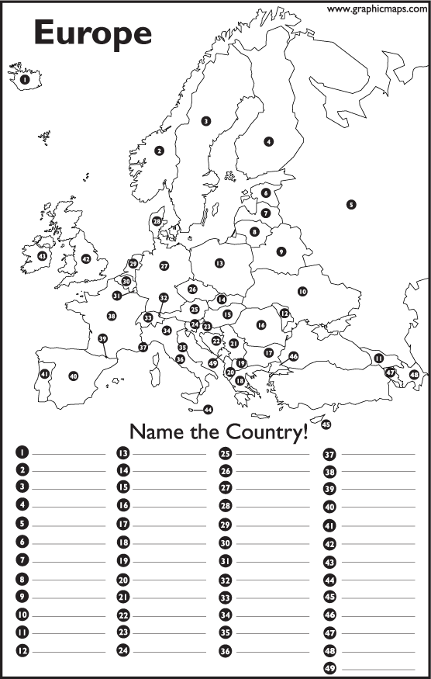
CAPITALS MAP
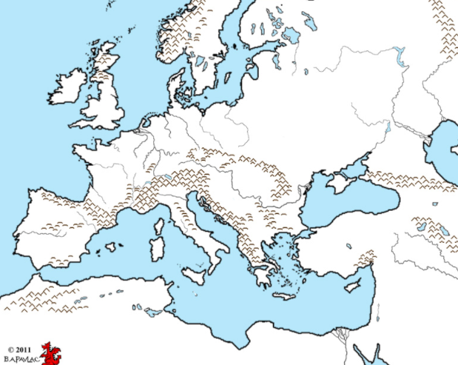
PHYSICAL MAP OF EUROPE
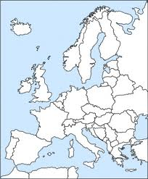 | THE HISTORY HERALD  August, 2025  AP EURO  www.MrDuncansHistoryClass.com | 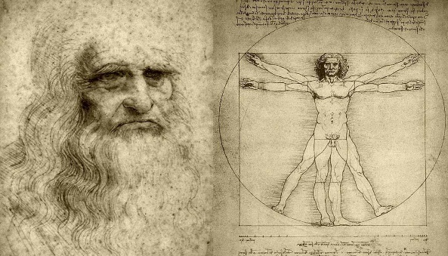

IMPORTANT DATES:  June 2nd – Join Google Classroom  Class Code: qqzwzevh  Our textbook is online also at the class website under the chapter heading if you want to get ahead  July 27th – Registration for classes GET TEXTBOOK  THIS WEEK  TUES 4th – First Day of class  Syllabus and Intro to World Lit Only by Fire  WED 5th SUMMER READING DUE  Come prepared and Read Chap 11 pg 283-290  Thurs and Fri NO SCHOOL  NEXT WEEK  Mon 11th Hiring a Plaque Doctor  What does 30 minutes look like  Bring book and blank NOTECARDS for class  Tues 12th Chapter 11 pg 291 – 300  Wed 13th Chap 11 pg 300 – 310  Thurs 14th Medici Documentary I / Chapter 12  Fri 15th – Art / Architecture  Over the weekend Chapter 11 EXAM ( online )  Reading Questions  1) What was the Black Death? What were the preexisting conditions in Europe that allows it to be so devastating?  2) What are the short and long term effects on European religion and society? (i.e. What were the changes that resulted from the Black Death?)  3) Discuss factors that led to the urban and rural revolts in the 14th century. Was desperate poverty a chief cause? Why or why not?  4) What were the causes of the 100 Years War (make sure to use specific examples to explain your answer)? How was France changed politically as a result of the war?  5) What were the problems facing the governments of England, France, and the German lands at the end of the Middle Ages?  6) Describe how and why the Church was declining in power in the 14th century. How did the religious leaders respond?  7) What were the effects of the Church’s declining power on European culture, popular religion, and literature?  MAP EXERCISES  1. The Spread of the Black Death. MAP 11.1. What areas were largely spared from the impact of the plague, and was geography, including distance from the eastern Mediterranean, the primary explanation? (page 285)  2. The Hundred Years’ War. MAP 11.2. Compare the lands in France controlled in England in 1360 with those held in 1429. How do they differ? What part did geographical proximity to England as well as the regions in France historically and traditionally under English control play in England’s successes during the war? (page 294) | Identifications Chapter 11  1. “little ice age”  2. Black Death  3. bubonic plague  4. Yersina pestis  5. pneumonic plague  6. Giovanni Boccaccio’s Decameron  7. flagellants  8. pogroms  9. Statute of Laborers  10. the Jacquerie  11. Wat Tyler and John Ball  12. Florence’s ciompi  13. the longbow  14. the Battle of Crecy  15. Henry V  16. the Battle of Agincourt  17. Joan of Arc  18. Orleans  19. Charles the dauphin/VII  20. gunpowder  21. the gabelle and the taille  22. dukes of Burgundy and Orleans  23. Golden Bull of Charles IV  24. Italian communes  25. the Visconti and the d’Este  26. condottieri  27. grandi and popolo grasso  and popolo minuto  28. Council of Ten and the doge  29. Pope Boniface VIII’s Unam Sanctam  30. Avignon  31. Catherine of Siena  32. Great Schism  33. the Antichrist  34. Conciliarism  35. Marsiglio of Padua  36. Council of Constance  37. purgatory  38. good deeds and pilgrimages  39. Meister Eckhart  40. Modern Devotion  41. Brothers of the Common Life  42. William of Occam and nominalism  43. the vernacular  44. Dante’s Divine Comedy  45. Petrarch’s sonnets  46. Chaucer’s Canterbury Tales  47. Christine de Pizan  48. Giotto  49. the “four humors”  50. clocks, eyeglasses, and paper
QUESTIONS FOR THE PRIMARY SOURCES (BOXED DOCUMENTS)
1. “’The Black Death’ from Giovanni Boccaccio, Decameron”: What evidence does this excerpt provide on the total collapse of Italian urban civilization as it was structured before the advent of the plague? What role does religion and the Church play in Boccaccio’s story of the Florentine plague? (page 287)

2. “A Medieval Holocaust: The Cremation of the Strasbourg Jews”: What were the specific reasons stated in the document that led to the cremation of the Strasbourg Jews? What were the several possible motives–religious, economic, and others–that led to the killing of many Jews during the Middle Ages, particularly in the aftermath of the Black Death? (page 288)

3. “A Revolt of French Peasants”: Why did the peasants react so strongly against their noble lords? What seem to be the principal motivations of their action? How reliable do you believe this source to be as an accurate account of what happened? Are there any possible connections between the onset of the Black Death in 1347 and the revolt of the French peasants in 1358? If so, what are they? (page 290)

4. “A Feminist Heroine: Christine de Pizan or Joan of Arc”: Is Christine de Pizan’s poem about the triumphs of Joan of Arc a “feminist” literary work? Why or why not? (Define “feminist.”) What are the religious references and allusions in the poem? What are the references to the classical world? In subject matter, is there anything “modern” in the poem? Does the work better reflect the waning Middle Ages or the waxing Renaissance? How and why? (page 295)

5. “Dante's Vision of Hell”: What realism does Dante convey with this scene? How would this piece of literature compare with earlier medieval works? Why would the church oppose this work? What lessons do you think this work was intended to teach its readers? (page 305)

6. “The Legal Rights of Women”: What socioeconomic and socio-political conditions in late medieval Europe conjoined, in your opinion, to “infantize” women and severely limit their legal rights as these documents show? Were these attitudes new to the High and Later Middle Ages? If so, why? Who would benefit the most from the legal disempowerment of women? (page 308)

